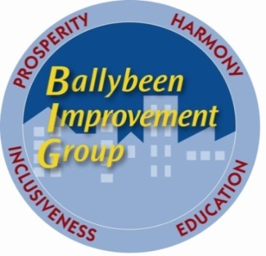
Ballybeen Improvement Group
Unit 7 Enler Complex
Craigleith Drive
Ballybeen
BT16 2QP
Tel: 02890 489990

Community Development Manager, Ballybeen
Job Description

Job Title: Community Development Manager

Background: The position of Community Development Manager was created through support from DSD/BRO under their Areas at Risk Programme (AaR) to support Ballybeen Improvement Group (BIG) to develop work with the communities in the Ballybeen area of East Belfast.

Accountability: Accountable to the Board of Directors of the Ballybeen Improvement Group (BIG), through regular meetings with Line Management appointed by the Board.

Main Purpose of Job
- to develop and manage the Board of Directors’ community development strategy for the estate
- to develop the goals and aims of the Ballybeen Improvement Group
- to play a key role in supporting communities within Ballybeen
- to promote a more coordinated approach to the provision of services in local Ballybeen, to ensure that the skills and effectiveness of local community groups are developed
- to promote appropriate mechanisms for local networking and create opportunities for joint working
- and to maintain a comprehensive information resource to assist local organisations in action planning and group development

Main duties of the Post
- assisting the Board of Directors in implementing and developing the organisation’s strategies
- identifying community skills, assets, issues and needs
- producing plans, reports and publications for and on behalf of the Ballybeen Improvement Group when necessary
- developing and implementing policies
- identifying funding streams and new resources that could benefit BIG and its member groups
- securing funding for BIG by completing relevant applications and then ensuring compliance with all funders’ requirements
- preparing financial statements, tracking income and expenditure, and maintaining accurate accounting records
- liaising with key stakeholders, interested groups and individuals to set up new services
- planning, attending and coordinating meetings and events
- building links with other groups and agencies
- raising public awareness on issues relevant to Ballybeen by newsletter or social media
- encouraging community participation in activities
- preparing relevant reports and performance related data and monitoring current methods and approaches with a view to improvement, as well as the preparation of claims to funders as required
- ensuring that programmes and services are monitored, evaluated and audited adequately
- to manage bookings and payments relating to any assets overseen by BIG, including the Sports and Wellbeing Hub
- participating in relevant training
- dealing with admin as required by the post or on behalf of BIG
- and any other duties as designated by the board of BIG

Time Commitment
This job will be for 37.5 hrs per week Monday to Friday. Given the nature of community development work and volunteers working in various communities, from time to time the Ballybeen Community Development Manager may be required to work evenings, weekends and additional hours. Time off in lieu will be available for such hours worked.

Remuneration
The salary for the duration of the post will be £28,000 – 30,000 per annum. Entrants are typically expected to join at the bottom of the scale however this is negotiable dependent on the level of experience of the candidate.

Period of Appointment
This is a funded post by DfC, and the position will initially be until March 31, 2025. It is the expectation that BIG will seek to secure further funding to extend this post.

Location
The post holder will be based in the Ballybeen Improvement Group office in the Enler Centre, Ballybeen. The board of big may consider hybrid working and this will be discussed with potential candidates who may be interested.

Holiday Entitlement
25 days holiday per year plus 11 Public / Bank Holidays.

Closing date for applications
Monday 16th December 2024, 12 noon. Shortlisting will take place the week of 16 December, and interviews will take place the week of 6 January 2025.

