**INFORMATION FOR THE APPOINTMENT OF**

**REPRESENTATIVES TO THE BOARD OF**

**COMHAIRLE NA GAELSCOLAÍOCHTA**

**Further information:**

Maria Thomasson

Chief Executive and Board Secretary

Email: [mariathomasson@comhairle.org](mailto:mariathomasson@comhairle.org)

Telephone: 028 90321475

**Welcome and Introduction from the Chair**

Thank you for your interest in becoming a Board member of Comhairle na Gaelscolaíochta (or CnaG). In addition to two general vacancies on the Board we are also seeking a representative from each of the following stakeholder bodies:

* Parent representative
* Post Primary School sector
* School Governor

Our current representatives have given outstanding service on a voluntary basis, over the last eight years and their positions on the Board are being recruited so that we have three replacements in post within the next 12 months.

The information in this document is designed to let you understand the role of the Board and the kind of skills that we need to augment the current skills and experience of the Board.

Being a Board Member of CnaG can be a most satisfying and rewarding experience for a number of reasons:

* Exposure to the strategic outlook and corporate governance of a relatively small but important organisation.
* Opportunity to help shape education policy and development of a growing sector.
* Help to make an impact on people’s lives and their life opportunities.
* Contribute to an important public and community service.

For these reasons, I would encourage you to express your interest in being a representative nominee for one of the above groups.

I am happy to discuss your interest in becoming a Board Member of Comhairle na Gaelscolaíochta. Please feel free to contact me via Becky Nic Ainmhire on Email: Oifig@comhairle.org or telephone:028 9089 7316.

Any applications, or general queries about the nomination/appointment process, can be made to Maria Thomasson the Board Secretary, who is also the CnaG Chief Executive. Maria can be contacted on Email: [mariathomasson@comhairle.org](mailto:mariathomasson@comhairle.org) or telephone: 028 90321475.

Thanks and best wishes



Seosamh Ó Coinne

Chair

**CnaG and the role of the Board**

There are currently over 90 schools providing Irish-medium education to almost 7,500 students at pre-school, primary and post primary levels and CnaG wants to build upon success to date. Our long-term vision for CnaG is to see an established network of vibrant Irish-medium schools at the heart of local communities.

To realise our vision, we focus our activities on our primary purpose to help ensure access to high quality Irish-medium education to those of any background or ability who desire it in order to assist the development of Irish speaking communities. The scope of this includes those pupils who have special educational needs and their families.

****The Board of CnaG is the representative body for Irish-language medium education in Northern Ireland. Including the Chairperson, there are 14 members of the Board consisting of representatives of the statutory sector (8), voluntary sector (1) as well as nominations from stakeholder groups (5). This includes school representatives at nursery, primary and secondary levels as well as parent and school governor representatives.

Constituted as a limited company, a registered charity and a public body, the Board is the governing body of CnaG and is required to comply with its legal, public benefit and public accountability requirements to operate to the highest corporate governance standards.

The Board has corporate responsibility for ensuring that CnaG fulfils its aims and objectives. To this end, and in pursuit of its wider corporate responsibilities, the Board is responsible for:

* Establishing the overall strategic direction.
* Overseeing our performance to help achieve our intended outcomes.
* Bringing independent experiences and insight to constructively challenge the executive team in its planning, target setting and delivery of services.
* Promoting the highest standards of financial management ensuring that all requirements for the proper use of public funds are met.
* Ensuring that the Board receives and reviews regular financial information.
* Being informed in a timely manner about any risks or concerns about CnaG’s activities providing assurances to the Department (and other stakeholders as required) that appropriate action has been taken on such concerns.
* Demonstrating high standards of corporate governance at all times, including using the independent audit committee to help identify and address any risks that CnaG faces as well as helping to embed generally accepted public service values (i.e. the ‘Nolan’ Principles of standards in public life).

In addition, CnaG Board Members should in particular:

* Contribute to the development of the strategy
* Challenge and work for consensus in the decision making processes of the board
* Act in good faith and in the best interests of CnaG, effectively managing any conflicting interests that may occur.
* Undertake induction and further training, and make the commitment of time necessary to fulfil the Member role;
* Comply at all times with the Code of Conduct for board Members and abide by the Seven Principles of Public Life, set by the Committee on Standards in Public Life;
  + Not misuse information gained in the course of their public service for personal gain or for political profit.

**Personal specification - skills, knowledge and experience**

Board Members should possess the skills, knowledge and experience necessary to perform effectively as a board member of a public body. Board Members who do not have Irish can be supported by providing translations of the meetings and documents as required. It is not essential but desirable that candidates and representatives to the Board have the following skills and experience (experience can come from their working life or from their personal life including any voluntary or community work):

* Experience of sitting on a governing body.
* Irish language skills.
* Irish Medium education sector experience.

Candidates and nominees with experience of one of the following would be particularly welcome:

* Business skills.
* Legal or company secretary experience.
* Marketing/PR/communications and lobbying skills.
* IT or data management/security experience.
* Finance skills, especially professional accountancy.

As the Seven Principles of Public Life (outlined below) apply to anyone with a role in public office, candidates and nominees are required to demonstrate their commitment to upholding these as well as how they will help to embed the values of CnaG.

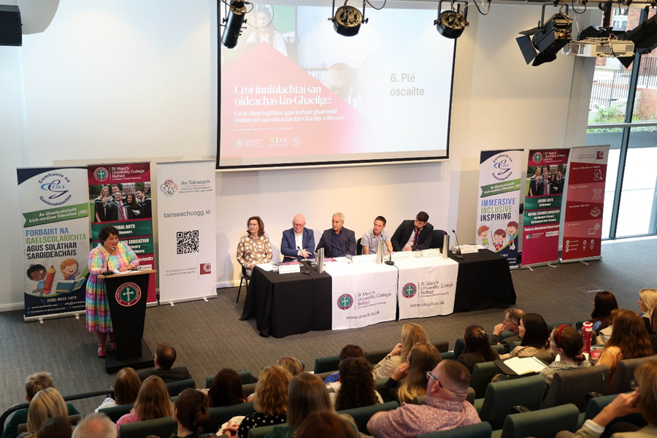

**Terms of appointment**

All CnaG Board Members are voluntary and unremunerated although reasonable out of pocket expenses are reimbursed upon approval.

The time commitment required is equivalent to preparation and attendance at four Board meetings and four committee meetings per annum plus any strategy development, ceremonial or other ambassadorial events.

The appointment is for an initial period of four years which may be extended for a further four years upon the Chair’s review of the effectiveness of the contribution by the Board Member.

Induction training will be provided which successful nominees are expected to attend. Other training needs will also be considered e.g. those identified by the annual review.

In the case of disability, every effort will be made by CnaG to provide whatever reasonable support any Member of the Board may need to help them carry out their duties.

**Our Values and the Seven Principles of Public Life (‘Nolan’ Principles)**

Our objectives are based upon a number of principles (equally weighted with no hierarchy of merit) that we value in our work, which are:

* Putting **education of young people** up front to help achieve their full potential at their level.
* Advocating for **equality of opportunity** for young people attending Irish-medium schools.
* Being **inclusive and catering for all abilities**, including those with special educational needs.
* Being **open to all in the community** within the jurisdiction in which we operate.
* Helping to **develop Irish speaking communities**.
* Contributing to the **wider strategic objectives** of the Assembly, the Department of Education, the Education Authority and others with whom we work.
* Ensuring strong foundations in **leadership and governance** expected of a public body.

The Seven Principles of Public Life apply to anyone with a role in public office. All public office-holders are both servants of the public and stewards of public resources. The Principles also have application to all those in other sectors delivering public services.

* **Selflessness** - Holders of public office should act solely in terms of the public interest.
* **Integrity** - Holders of public office must avoid placing themselves

under any obligation to people or organisations that might try inappropriately to influence them in their work. They should not act or take decisions in order to gain financial or other material benefits for themselves, their family, or their friends. They must declare and resolve any interests and relationships. Conflicting interests is explained further below.

* **Objectivity** - Holders of public office must act and take decisions impartially, fairly and on merit, using the best evidence and without discrimination or bias.
* **Accountability** - Holders of public office are accountable to the public for their decisions and actions and must submit themselves to the scrutiny necessary to ensure this.
* **Openness** - Holders of public office should act and take decisions in an open and transparent manner. Information should not be withheld from the public unless there are clear and lawful reasons for so doing.
* **Honesty** - Holders of public office should be truthful.
* **Leadership** - Holders of public office should exhibit these principles in their own behaviour. They should actively promote and robustly support the principles and be willing to challenge poor behaviour wherever it occurs.

**Conflicts of interest**

CnaG Board Members are required to act in the interests of CnaG at all times and manage any conflicting interests in line with our policy and procedures.

Public office requires the highest standards of propriety, involving impartiality, integrity and objectivity, in relation to the stewardship of public funds and the oversight and management of all related activities. This means that any private, voluntary, charitable or political interest which might be material and relevant to the work of the body concerned should be declared.

**Board recruitment timetable and process**

|  |  |
| --- | --- |
| **Process** | **Planned date** |
| Promotion of recruitment exercise | 9 October 2024 to 29th November 2024 |
| Closing date for applications | 29 November 2024 |
| Short listing applications | W/C 2 December 2024 (day/timings TBC) |
| Notification of outcomes | W/C 9 December 2024 |
| Interviews | W/C 6 January 2025 (day/timings TBC) |
| Board consideration and ratification | January 2025 |
| Notification of outcomes | January 2025 |
| Issue of appointment letters confirming start dates | January 2025 |

CnaG personnel involved in the recruitment process**:**

* Seosamh Ó Coinne, Chairman
* Chairs (or representatives) of Corporate services; Audit Risk and Assurance; and Strategy & Development Committees
* Maria Thomasson, Board Secretary & CEO
* Stephen Mungavin, Advisor to the Board, Chief Executives’ Forum