



**Candidate Information Brochure**

**PEACEPLUS PROJECT**

**Resilience Programme Co-ordinator**

**Closing Date**

Tuesday 3rd December 2024: 1pm

A project supported by PEACEPLUS, a programme managed by the Special EU Programmes Body (SEUPB)

**Job Description**

**Job Title:** PEACEPLUS Project Resilience Programme Co-ordinator

**Organisation:** The Ely Centre

**Location:** Markethill, Portadown, or Enniskillen

**Salary:** £36,124

**Hours:** 37 hours per week

**Reports to:** Director of Services

**Background**

The PEACEPLUS Programme is a unique cross-border structural funding programme aimed at reinforcing progress towards a peaceful, stable, and prosperous society in Northern Ireland and the border counties of Ireland. PEACEPLUS has been designed to build upon the achievements of the previous PEACE IV programme.

The PEACEPLUS Programme is supported by the European Union, the UK Government, the Northern Ireland Executive, and the Irish Government. It is managed by the Special EU Programmes Body (SEUPB). PEACEPLUS comprises six themes, which are outlined below:



VSS is delighted to have been named as the **Lead Partner** for **Theme 4 (Investment Area 3 – ‘Victims and Survivors’)** of the newPEACEPLUS Programme**.**

Investment Area 3 (Victims and Survivors) of Theme 4 (Healthy and Inclusive Communities) aims to further build on the health and wellbeing support and services delivered to victims and survivors of the Troubles/conflict as part of our previous PEACE IV project.

The **objective** of this Theme & Investment Area is tocontribute to the creation of a more cohesive society through an increase in the provision of **Health and Wellbeing** and **Advocacy Support** for victims and survivors.

This post has been developed as part of the PEACEPLUS **VSS PULSE (Partnership for Understanding Learning Support and Education)** project to improve the health and wellbeing of victims and survivors by increasing and improving access to high quality, trauma informed services across, Northern Ireland, Great Britain, and the Republic of Ireland, through the continuation, development, and enhancement of an integrated, outcomes based, holistic community led support programme.

**Resilience Programme**

The Resilience Programme delivered through the VSS – PULSE will deliver a range of health and wellbeing and resilience building interventions such as social isolation programmes, in collaboration with other community and voluntary organisations within the local community

The Ely Centre is a Registered Charity providing multi-disciplinary support services for civilians, security force personnel and their families, who have experienced bereavement and injury as a result of the “Troubles”

The Ely Centre is committed to serving innocent victims and survivors, ex service personnel, their families and carers by providing evidenced based outcome focused treatments, prevention and support services that address issues of declining psychological, physical health, social and financial difficulties arising as a result of terrorism.

For further information please visit [www.elycentre.com](http://www.elycentre.com)

**Organisational Structure**

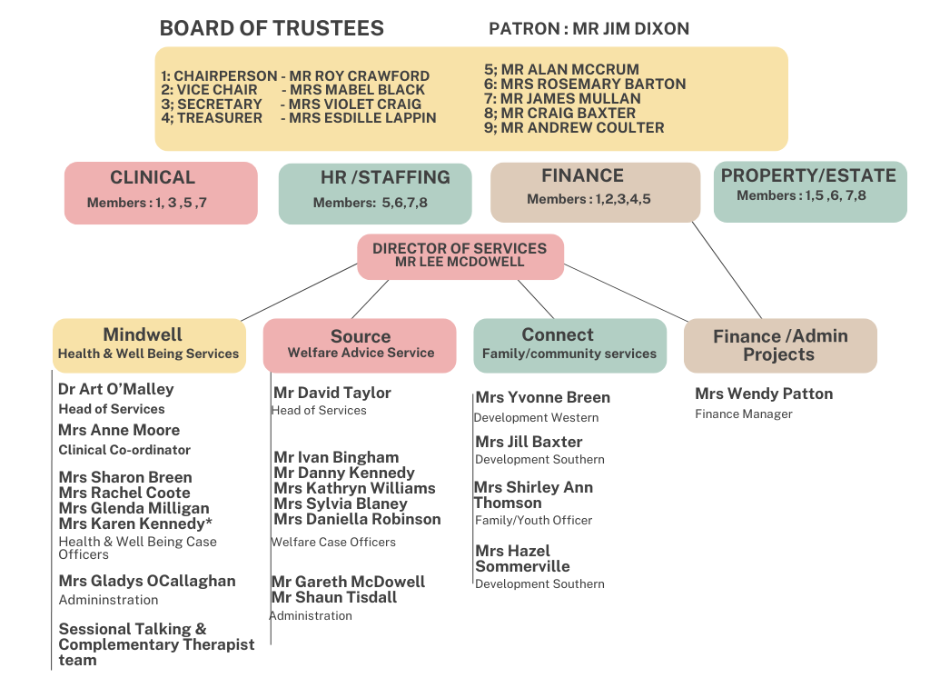

**Purpose of the Role**

Project Co-ordinators in collaboration with VSS - PULSE Partners, our cross-border partner POBAL and the wider community and voluntary sector working with victims and survivors will develop community development plans, co-designed with organisations supporting victims and survivors, to deliver resilience programmes that meet the needs of victims and survivors in a bespoke way.

The PEACEPLUS Resilience Programme Co-ordinator will be one of 5 Resilience Co - Ordinator’s across the VSS – PULSE Partnership responsible for the Co-Design, collaboration and implementation of the VSS – PULSE Resilience programme.

**Responsibilities**

* Develop a co-designed Resilience Programme in collaboration with VSS – PULSE Project Partners and organisations funded through the Victims and Survivors Service (VSS)
* Work in partnership with key stakeholders including the VSS funded organisations and the wider community and voluntary sector, to prepare annual resilience action plans and be responsible for the plans implementation including monitoring and evaluation of agreed targets and outcomes.
* Work in collaboration with Lead Health and Wellbeing Caseworkers to identify individuals who would benefit from participation in resilience activities.
* Prepare reports for management on the achievements of the resilience programme and make recommendations for continuous development and improvement.
* Attend and contribute working group meetings associated with the delivery of the resilience programme.
* Maximise the success of the overall Resilience Programme and annual delivery plans by being response and solution focused.

**Role Competencies**

**Essential Criteria:**

By the closing date for applications, candidates must have:

A relevant University degree, or equivalent qualification

**AND**

**Demonstrate 2 years’ experience in the following areas:**

**(For candidates who do not hold a University Degree they must demonstrate 5 years’ experience in the following areas)**

1. Practical project or programme management within the community and voluntary sector
2. Practical experience of working in collaboration with a range of key stakeholders to achieve a common goal
3. Practical experience of project monitoring and evaluation against key outcomes.
4. Experience of analysing financial and non-financial information and producing recommendations to management.
5. Hold a full license valid in the UK with access to a car. This criterion will be waived in the case of an applicant whose disability prohibits driving but who is able to make alternative arrangements.

**Application Process**

Following the deadline for receipt of applications the selection process will operate as follows:



**Guidance for Making Your Application**

Application should consist of a completed application form and a completed equality and opportunities monitoring form.

These are available from www.communityni.org and the company website.

**Application Submission**

Completed applications can be submitted as follows before the deadline by

* Posted or hand delivered to Unit 2/3 Geddis Square, Markethill, Co Armagh

BT60 1PN OR

* Emailed to director@elycentre.co.uk

**Deadline:**

We will not accept incomplete application forms; application forms received after the closing deadline or reformatted application forms. Incomplete application forms will be removed during the sifting process.

Applicants sending application by post should note that 1st class mail does not guarantee next day delivery. It is the responsibility of the applicant to ensure that sufficient postage has been paid to return the form to meet the required deadline.

Should you have any queries please contact info@elycentre.co.uk

**Interview Guidance for Applicants**

Final dates for interview have not been scheduled but will take place soon after close of applications

At the interview, the selection panel will assess candidates against the behavioural competences, qualifications and experience for the post.

**Disability Requirements**

If reasonable adjustments are required by candidates on account of disability the organisation will make every effort reasonable to accommodate such.

**Vetting Procedures**

For vetting procedures candidates will be required to produce the following for interview:

* Passport;

OR

Document verifying your permanent National Insurance number (e.g.P45, P60 or National Insurance card); AND Birth certificate which includes the names of your parents (long version);

* Proof of qualifications (original certificates);
* 2 satisfactory references (References will not be sought until after the final stage of the assessment process);
* Enhanced Access NI criminal record check (unspent convictions only). Successful candidates will not be appointed to post prior to this being completed.