

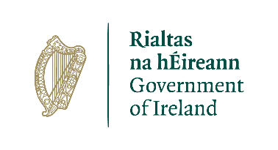

**Candidate Information Brochure**

**PEACEPLUS PROJECT**

**Lead Health and Well Being Case Officer**

**Closing Date**

Tuesday 3rd December 2024 : 1pm

A project supported by PEACEPLUS, a programme managed by the Special EU Programmes Body (SEUPB)

**Job Description**

**Job Title:** PEACEPLUS Project Lead Health and Well Being Case Officer

**Organisation:** The Ely Centre

**Location:** Markethill

**Salary:** £35,235

**Hours:** 37 hours

**Reports to:** Head of Clinical Services

**Background**

The PEACEPLUS Programme is a unique cross-border structural funding programme aimed at reinforcing progress towards a peaceful, stable, and prosperous society in Northern Ireland and the border counties of Ireland. PEACEPLUS has been designed to build upon the achievements of the previous PEACE IV programme.

The PEACEPLUS Programme is supported by the European Union, the UK Government, the Northern Ireland Executive, and the Irish Government. It is managed by the Special EU Programmes Body (SEUPB). PEACEPLUS comprises six themes, which are outlined below:



VSS is delighted to have been named as the **Lead Partner** for **Theme 4 (Investment Area 3 – ‘Victims and Survivors’)** of the newPEACEPLUS Programme**.**

Investment Area 3 (Victims and Survivors) of Theme 4 (Healthy and Inclusive Communities) aims to further build on the health and wellbeing support and services delivered to victims and survivors of the Troubles/conflict as part of our previous PEACE IV project.

The **objective** of this Theme & Investment Area is tocontribute to the creation of a more cohesive society through an increase in the provision of **Health and Wellbeing** and **Advocacy Support** for victims and survivors.

This post has been developed as part of the PEACEPLUS **VSS PULSE (Partnership for Understanding Learning Support and Education)** project to improve the health and wellbeing of victims and survivors by increasing and improving access to high quality, trauma informed services across, Northern Ireland, Great Britain, and the Republic of Ireland, through the continuation, development, and enhancement of an integrated, outcomes based, holistic community led support programme.

The Ely Centre is a Registered Charity providing multi-disciplinary support services for civilians, security force personnel and their families, who have experienced bereavement and injury as a result of the “Troubles”

The Ely Centre is committed to serving innocent victims and survivors, ex service personnel, their families and carers by providing evidenced based outcome focused treatments, prevention and support services that address issues of declining psychological, physical health, social and financial difficulties arising as a result of terrorism.

For further information please visit [www.elycentre.com](http://www.elycentre.com)

**Organisational Structure**

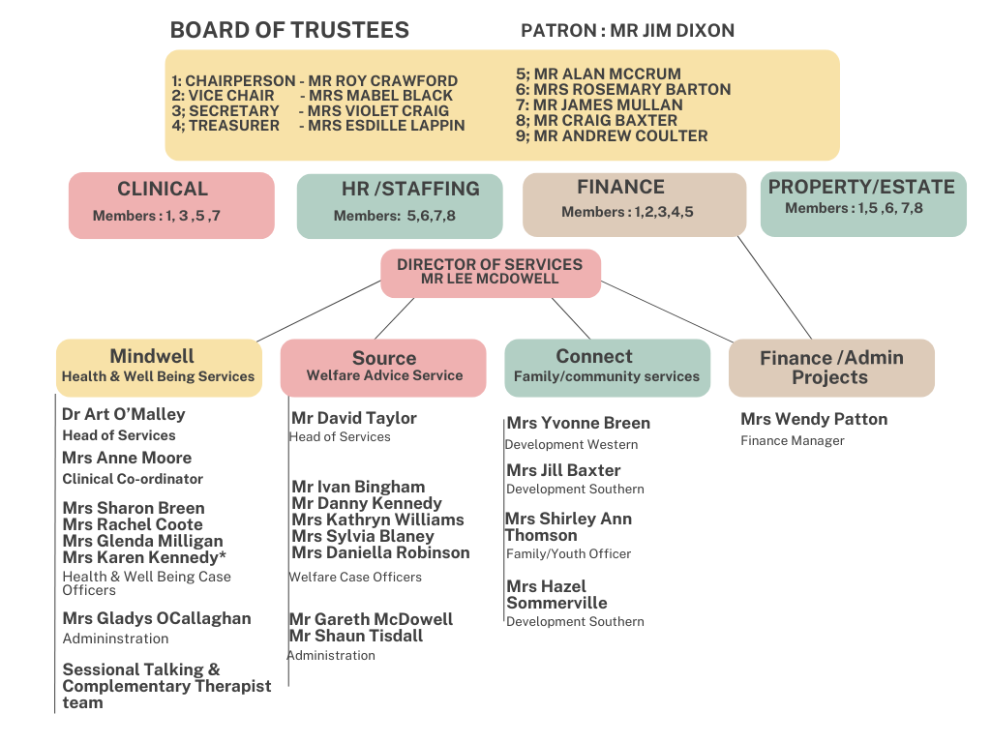

**Purpose of the Role**

The Lead Health & Wellbeing Caseworker will provide management and supervision to a team of Health and Wellbeing Caseworkers funded through the VSS – PULSE a project funded through Investment Area 3 (Victims and Survivors) of Theme 4 of PEACEPLUS (Healthy and Inclusive Communities)

Together, they will directly support individual Victims and Survivors and their families in a pro-active and innovative way to facilitate targeted engagement with services and activities within the statutory, community and voluntary sector in keeping with their needs.

This will include close liaison with the VSS - PULSE project partnership in order to provide a holistic package of support to victims and survivors of the troubles/conflict.

**Responsibilities**

* Day-to-day management of a team of Health and Wellbeing Caseworkers

* Allocate and monitor the workload of Health and Wellbeing Caseworkers.
* Develop and manage the systems for ensuring that all key VSS – PULSE Partner targets are met, with respect to agreed outputs and results.
* Develop and manage the systems for monitoring and reporting on the VSS – PULSE project to both SEUPB and VSS Health and Wellbeing Team.
* Provide reports to senior management in relation to the implementation of the VSS- PULSE project and provide briefing material as required.
* Manage the day-to-day operationalisation of the VSS- PULSE Health and Wellbeing programme through the use of appropriate systems, processes, policies, procedures and practices to meet the needs of Victims and Survivors.
* Have extensive knowledge of services available to Victims and Survivors and their families
* Demonstrate a high level of personal integrity and maintain professional standards throughout the organisation.
* Undertake further training as required.

**The foregoing is not an exhaustive list of duties.**

**Role Competencies**

Essential Criteria:

By the closing date for applications, candidates must

1. Possess a University Degree, Professional Qualification or equivalent qualification in a relevant area.

OR

Possess 5 GCSE’s grades A – C, including English language AND have 2 years voluntary/paid experience equivalent to 16 hours per week in a community/voluntary/statutory environment working with individuals with mental health and/or physical health issues.

OR

NVQ Level 3 or equivalent AND have 1 year’s voluntary/paid experience equivalent to 16 hours per week in a community/voluntary/ statutory environment working with individuals with mental health and/or physical health issues.

AND

1. A minimum of 2 years’ practical experience collating information, writing reports and analysing complex information.
2. A minimum of 2 years’ practical experience of effectively managing complex client interactions.
3. A minimum of 2 years’ experience working and building relationships with multiple stakeholders.
4. A minimum of 1 years’ experience of staff management including the allocation and management of workloads.
5. Demonstrate experience of liaising between clients and a broad range of service providers
6. Demonstrate an ability to successfully participate in further training relating to this area of work.
7. Hold a full license valid in the UK with access to a car. This criterion will be waived in the case of an applicant whose disability prohibits driving but who is able to make alternative arrangements.

**Application Process**

Following the deadline for receipt of applications the selection process will operate as follows:



**Guidance for Making Your Application**

Application should consist of a completed application form and a completed equality and opportunities monitoring form.

These are available from www.communityni.org and the company website.

**Application Submission**

Completed applications can be submitted as follows before the deadline by

* Posted or hand delivered to Unit 2/3 Geddis Square, Markethill, Co Armagh

BT60 1PN OR

* Emailed to director@elycentre.co.uk

**Deadline:**

We will not accept incomplete application forms; application forms received after the closing deadline or reformatted application forms. Incomplete application forms will be removed during the sifting process.

Applicants sending application by post should note that 1st class mail does not guarantee next day delivery. It is the responsibility of the applicant to ensure that sufficient postage has been paid to return the form to meet the required deadline.

Should you have any queries please contact info@elycentre.co.uk

**Interview Guidance for Applicants**

Final dates for interview have not been scheduled but will take place soon after close of applications

At the interview, the selection panel will assess candidates against the behavioural competences, qualifications and experience for the post.

**Disability Requirements**

If reasonable adjustments are required by candidates on account of disability the organisation will make every effort reasonable to accommodate such.

**Vetting Procedures**

For vetting procedures candidates will be required to produce the following for interview:

* Passport;

OR

Document verifying your permanent National Insurance number (e.g.P45, P60 or National Insurance card); AND Birth certificate which includes the names of your parents (long version);

* Proof of qualifications (original certificates);
* 2 satisfactory references (References will not be sought until after the final stage of the assessment process);
* Enhanced Access NI criminal record check (unspent convictions only). Successful candidates will not be appointed to post prior to this being completed.