

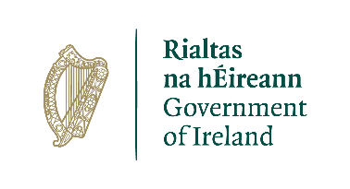

**Candidate Information Brochure**

**PEACEPLUS PROJECT**

**Health and Well Being Case Officer**

**Job Share – 2 Days P/W**

**Closing Date**

Tuesday 3rd December 2024 : 1pm

A project supported by PEACEPLUS, a programme managed by the Special EU Programmes Body (SEUPB)

**Job Description**

**Job Title:** Health and Well Being Case Officer (Part Time 2 days)

**Organisation:** The Ely Centre

**Location:** Markethill

**Salary:** £32,115 (pro rata)

**Hours:** 15 hours per week

**Reports to:** Lead Health and Well Being Case Officer

**Background**

The PEACEPLUS Programme is a unique cross-border structural funding programme aimed at reinforcing progress towards a peaceful, stable, and prosperous society in Northern Ireland and the border counties of Ireland. PEACEPLUS has been designed to build upon the achievements of the previous PEACE IV programme.

The PEACEPLUS Programme is supported by the European Union, the UK Government, the Northern Ireland Executive, and the Irish Government. It is managed by the Special EU Programmes Body (SEUPB). PEACEPLUS comprises six themes, which are outlined below:



VSS is delighted to have been named as the **Lead Partner** for **Theme 4 (Investment Area 3 – ‘Victims and Survivors’)** of the newPEACEPLUS Programme**.**

Investment Area 3 (Victims and Survivors) of Theme 4 (Healthy and Inclusive Communities) aims to further build on the health and wellbeing support and services delivered to victims and survivors of the Troubles/conflict as part of our previous PEACE IV project.

The **objective** of this Theme & Investment Area is tocontribute to the creation of a more cohesive society through an increase in the provision of **Health and Wellbeing** and **Advocacy Support** for victims and survivors.

This post has been developed as part of the PEACEPLUS **VSS PULSE (Partnership for Understanding Learning Support and Education)** project to improve the health and wellbeing of victims and survivors by increasing and improving access to high quality, trauma informed services across, Northern Ireland, Great Britain, and the Republic of Ireland, through the continuation, development, and enhancement of an integrated, outcomes based, holistic community led support programme.

The Ely Centre is a Registered Charity providing multi-disciplinary support services for civilians, security force personnel and their families, who have experienced bereavement and injury as a result of the “Troubles”

The Ely Centre is committed to serving innocent victims and survivors, ex service personnel, their families and carers by providing evidenced based outcome focused treatments, prevention and support services that address issues of declining psychological, physical health, social and financial difficulties arising as a result of terrorism.

For further information please visit [www.elycentre.com](http://www.elycentre.com)

**Organisational Structure**

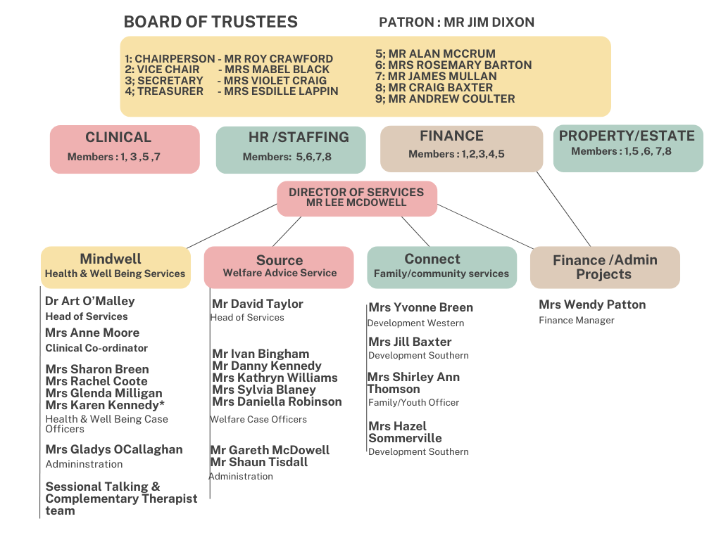

**Purpose of the Role**

The key elements that constitute the role of Health and Wellbeing Caseworker are as follows:

**Co-ordination and Delivery of Health and Wellbeing Services**

* Proactively and innovatively engage with vulnerable and marginalised individuals.
* Keep up to date with relevant statutory, private and voluntary sector services available to victims and survivors and their families and work to ensure pathways are seamless, responsive and mitigate against duplication of services.
* Identify any barriers to victims and survivors accessing the care and support they need and work with the individual and relevant agencies to remove or mitigate any adverse effect such barriers may pose.
* The first point of contact for stakeholder enquiries, liaising with other agencies in a professional manner, ensuring that complex and sensitive information is communicated with empathy and reassurance and within the boundaries of Data Protection legislation.
* Advocate on behalf of and if necessary, accompany individuals to services/appointments/activities where low confidence, low motivation and diminished trust may have left them isolated and marginalised.
* Facilitate the process for victims and survivors to access personalised support e.g. one to one literacy tutoring or a physical activity of choice.
* Introduce victims and survivors and their families to shared spaces and services.

**Business Improvement and Quality Management**

* Ensure adequate and appropriate record keeping and that relevant databases are updated on a regular basis.
* Record, monitor and evaluate client progress according to measurable goals described in their individual support plan.
* Ensure that all support plans, records and associated processes are maintained to the standard required for auditing and monitoring and evaluation by VSS.
* Manage the security/processing of sensitive and confidential client information in keeping with the requirements of the Data Protection Act.
* Report any risks, issues and/or concerns to (employing organisation).
* Actively encourage participation of victims and survivors and their families in reviewing and modernising current services and in service development.
* Promote a culture of continuous service improvement through the appropriate sharing of constructive feedback and work with relevant statutory, private and voluntary sector organisations to implement improvements.

**Personal Development, Performance and Professionalism**

* Ensure the ongoing confidence of the public by maintaining high standards of personal accountability and ethical practice.
* Facilitate liaison with professional and senior management within stakeholder organisations.

**The foregoing is a broad range of duties and is not intended to be a complete description of all tasks. It is important to note that the responsibilities may change to meet the evolving needs.**

**Role Competencies**

Essential Criteria:

By the closing date for applications, candidates must:

1. Possess a University Degree, Professional Qualification or equivalent qualification in a relevant area.

OR

Possess 5 GCSE’s grades A – C, including English language AND have 2 years voluntary/paid experience equivalent to 16 hours per week in a community/voluntary/statutory environment working with individuals with mental health and/or physical health issues.

OR

NVQ Level 3 or equivalent AND have 1 year’s voluntary/paid experience equivalent to 16 hours per week in a community/voluntary/ statutory environment working with individuals with mental health and/or physical health issues.

AND

1. Demonstrate experience of effectively engaging with and building positive relationships with clients in situations where they have been vulnerable.
2. Demonstrate experience of liaising with a broad range of service providers.
3. Demonstrate experience of providing progress reports and management information in clear and agreed formats, in line with a reporting schedule.
4. Demonstrate experience of successfully prioritising and managing your own workload while also communicating effectively with colleagues and management.

Desirable Criteria:

1. Demonstrate experience of at least 1 year working with or in the interests of victims and survivors of the Conflict/Troubles.
2. Demonstrate experience of using or contributing to outcomes focussed monitoring and evaluation processes.

**Application Process**

Following the deadline for receipt of applications the selection process will operate as follows:



**Guidance for Making Your Application**

Application should consist of a completed application form and a completed equality and opportunities monitoring form.

These are available from www.communityni.org and the company website.

**Application Submission**

Completed applications can be submitted as follows before the deadline by

* Posted or hand delivered to Unit 2/3 Geddis Square, Markethill, Co Armagh

BT60 1PW OR

* Emailed to director@elycentre.co.uk

**Deadline:**

We will not accept incomplete application forms; application forms received after the closing deadline or reformatted application forms. Incomplete application forms will be removed during the sifting process.

Applicants sending application by post should note that 1st class mail does not guarantee next day delivery. It is the responsibility of the applicant to ensure that sufficient postage has been paid to return the form to meet the required deadline.

Should you have any queries please contact info@elycentre.co.uk

**Interview Guidance for Applicants**

Final dates for interview have not been scheduled but will take place soon after close of applications

At the interview, the selection panel will assess candidates against the behavioural competences, qualifications and experience for the post.

**Disability Requirements**

If reasonable adjustments are required by candidates on account of disability the organisation will make every effort reasonable to accommodate such.

**Vetting Procedures**

For vetting procedures candidates will be required to produce the following for interview:

* Passport;

OR

Document verifying your permanent National Insurance number (e.g.P45, P60 or National Insurance card); AND Birth certificate which includes the names of your parents (long version);

* Proof of qualifications (original certificates);
* 2 satisfactory references (References will not be sought until after the final stage of the assessment process);
* Enhanced Access NI criminal record check (unspent convictions only). Successful candidates will not be appointed to post prior to this being completed.