



**Candidate Information Brochure**

PEACEPLUS PROJECT FINANCIAL ADMINISTRATOR

**Closing Date**

Tuesday 3rd December 2024 : 1pm

A project supported by PEACEPLUS, a programme managed by the Special EU Programmes Body (SEUPB)

**Job Description**

**Job Title:** PEACEPLUS Project Financial Administrator

**Organisation:** The Ely Centre

**Location:** Markethill, Portadown, or Enniskillen

**Salary:** £36,124

**Hours:** 37 hours

**Reports to:** Resilience Programme Co-ordinator

**Background**

The PEACEPLUS Programme is a unique cross-border structural funding programme aimed at reinforcing progress towards a peaceful, stable, and prosperous society in Northern Ireland and the border counties of Ireland. PEACEPLUS has been designed to build upon the achievements of the previous PEACE IV programme.

The PEACEPLUS Programme is supported by the European Union, the UK Government, the Northern Ireland Executive, and the Irish Government. It is managed by the Special EU Programmes Body (SEUPB). PEACEPLUS comprises six themes, which are outlined below:



VSS is delighted to have been named as the **Lead Partner** for **Theme 4 (Investment Area 3 – ‘Victims and Survivors’)** of the newPEACEPLUS Programme**.**

Investment Area 3 (Victims and Survivors) of Theme 4 (Healthy and Inclusive Communities) aims to further build on the health and wellbeing support and services delivered to victims and survivors of the Troubles/conflict as part of our previous PEACE IV project.

The **objective** of this Theme & Investment Area is tocontribute to the creation of a more cohesive society through an increase in the provision of **Health and Wellbeing** and **Advocacy Support** for victims and survivors.

This post has been developed as part of the PEACEPLUS **VSS PULSE (Partnership for Understanding Learning Support and Education)** project to improve the health and wellbeing of victims and survivors by increasing and improving access to high quality, trauma informed services across, Northern Ireland, Great Britain, and the Republic of Ireland, through the continuation, development, and enhancement of an integrated, outcomes based, holistic community led support programme.

The Ely Centre is a Registered Charity providing multi-disciplinary support services for civilians, security force personnel and their families, who have experienced bereavement and injury as a result of the “Troubles”

The Ely Centre is committed to serving innocent victims and survivors, ex service personnel, their families and carers by providing evidenced based outcome focused treatments, prevention and support services that address issues of declining psychological, physical health, social and financial difficulties arising as a result of terrorism.

For further information please visit [www.elycentre.com](http://www.elycentre.com)

**Organisational Structure**

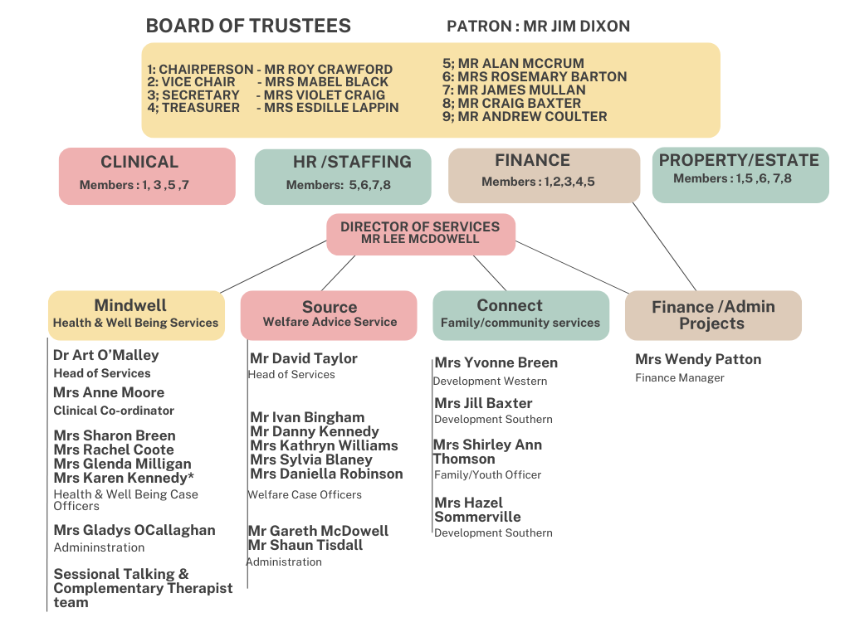

**Purpose of the Role**

The Project Financial Administrator is responsible for providing financial management, oversight and administrative support in relation to the VSS – PULSE Project. They must m**anage, plan and provide financial support services for all VSS PULSE activities, ensuring that there is a robust system of risk management, control and governance in place throughout the project.**

**The Finance and Administration Officer will serve as the central point for advice and guidance to the organisation on all financial and administrative matters pertinent to the project and must work closely with VSS and SEUPB to ensure that all required project deliverables are achieved to a high-quality standard.**

**Responsibilities**

* Financial management of the VSS PULSE funded project, including budgeting, cashflow management, project reporting and claim submission.
* Ensure the appropriate financial procedures, controls and structures are adhered to for the safe, effective, efficient and economic management of public funds.
* Assist with organisational month end closure to include production of monthly management accounts for the VSS PULSE project, including analytical review and variance analysis.
* Ensure data integrity and oversee reconciliations of all balance sheet and profit and loss accounts.
* Preparation of monthly, quarterly and annual returns to SEUPB and VSS as required.
* Liaison with VSS and external controllers to submit all claims for verification within required timescales.
* Management of all VSS PULSE funded procurement to ensure adherence to SEUPB procurement rules, and provision of advice, direction and guidance on the key principles of public sector procurement, ensuring value for money is embedded within the organisation.
* Support the annual budgeting process, liaising with VSS PULSE Network budget holders to report on actual, forecast and budget expenditure.
* Ensure the timely distribution of payments to corporate suppliers in line with PEACEPLUS Programme policies and procedures.

**Role Competencies**

Essential Criteria:

By the closing date for applications, candidates must be able to demonstrate:

1. By the closing date for applications, candidates must be a part-qualified member of one of the professional bodies listed below:

• The Chartered Institute of Management Accountants

• Chartered Accountants Ireland

• The Institute of Chartered Accountants in Scotland

• The Institute of Chartered Accountants in England and Wales

• The Association of Chartered Certified Accountants

• The Chartered Institute of Public Finance and Accountancy

• The Institute of Certified Public Accounts in Ireland; or equivalent

OR

• A Fully Qualified Accounting Technician

AND

1. A minimum of 2 years’ practical experience in all of the following areas:

FOR THOSE CANDIDATES WHO CANNOT MEET THE QUALIFICATIONS LISTED ABOVE - PLEASE DEMONSTRATE A MINIMUM OF **5 YEARS** IN THE FOLLOWING AREAS:

* Budget management including analysis of variances and preparation of reports for senior management.
* Use of Microsoft Excel for data manipulation and reporting.
* Month end closure to include reconciliation of control accounts and compilation of month end management accounts.
* Internal or external audit processes.
* Working with non-financial departments within an organisation to provide finance support and analysis.
* Developing processes and procedures to include implementation of best practice arrangements.

**Application Process**

Following the deadline for receipt of applications the selection process will operate as follows:



**Guidance for Making Your Application**

Application should consist of a completed application form and a completed equality and opportunities monitoring form.

These are available from www.communityni.org and the company website.

**Application Submission**

Completed applications can be submitted as follows before the deadline by

* Posted or hand delivered to Unit 2/3 Geddis Square, Markethill, Co Armagh

BT60 1PN

* Emailed to director@elycentre.co.uk

**Deadline:**

We will not accept incomplete application forms; application forms received after the closing deadline or reformatted application forms. Incomplete application forms will be removed during the sifting process.

Applicants sending application by post should note that 1st class mail does not guarantee next day delivery. It is the responsibility of the applicant to ensure that sufficient postage has been paid to return the form to meet the required deadline.

Should you have any queries please contact info@elycentre.co.uk

**Interview Guidance for Applicants**

Final dates for interview have not been scheduled but will take place soon after close of applications

At the interview, the selection panel will assess candidates against the behavioural competences, qualifications and experience for the post.

**Disability Requirements**

If reasonable adjustments are required by candidates on account of disability the organisation will make every effort reasonable to accommodate such.

**Vetting Procedures**

For vetting procedures candidates will be required to produce the following for interview:

* Passport;

OR

Document verifying your permanent National Insurance number (e.g.P45, P60 or National Insurance card); AND Birth certificate which includes the names of your parents (long version);

* Proof of qualifications (original certificates);
* 2 satisfactory references (References will not be sought until after the final stage of the assessment process);
* Enhanced Access NI criminal record check (unspent convictions only). Successful candidates will not be appointed to post prior to this being completed.