APPLICATION FORM

PROGRAMME MANAGER

PEACE PLUS CHANGE MAKER FUNDS

CONFIDENTIAL

IMPORTANT – Before completing this form, please read the Candidate Information Booklet carefully. CVs will not be considered. Please complete each Section within the parameters given. Do not attach additional pages.
CI/PMCMFNI/1124

Please return your completed application form to vacancies@cooperationireland.org

Completed forms must be returned by 12pm Friday 29th November 2024 CVs and late applications will not be accepted.

Co-operation Ireland is an Equal Opportunities Employer.

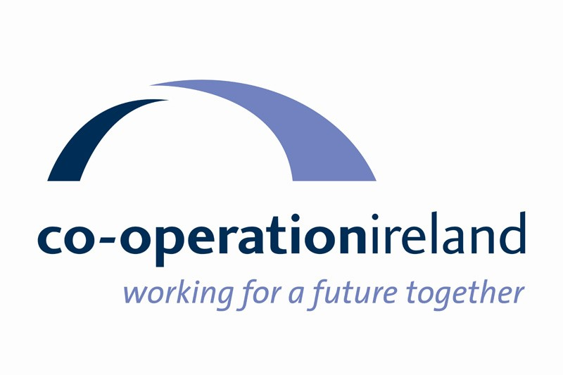


POST DETAILS:
Title of Post | Programme Manager – Peace Plus Change Maker Funds
Reference | CI/PMCMFNI/1124

PERSONAL DETAILS
Title Mr / Mrs / Ms / Miss / Other
Surname
Forename(s)
Address
Postcode
Email Address
Contact Telephone Numbers
Do you need a work permit to take up employment in the UK?
Do you hold a current full driving licence?

CURRENT SALARY
Current Basic Salary
Other Emoluments (bonuses etc.)

PREVIOUS EMPLOYMENT (maximum 2 pages)
Please list details of ALL previous employment starting with your most recent post.
Name and address of employer | Job title and main responsibilities | Dates  From To | Reason for leaving

EDUCATIONAL AND PROFESSIONAL QUALIFICATIONS (maximum 1 page)
Essential Criteria
(Please list all third level qualifications with grade and year attained)
Awarding Body | Course Title/Subject | Qualification | Grade | Year

The following section asks you to demonstrate how you meet Essential Criteria for the role as detailed in the Person Specification contained in the Candidate Information Pack. Please ensure that you give full details including dates as appropriate. If you do not meet the criteria, please be explicit in your response e.g. I do not have an Accounting, Financial or IT related qualification.
EDUCATIONAL AND PROFESSIONAL QUALIFICATIONS
PREVIOUS EXPERIENCE / TRAINING

OTHER

The following section asks you to demonstrate how you meet Desirable Criteria for the role as detailed in the Person Specification contained in the Candidate Information Pack. Please ensure that you give full details including dates as appropriate. If you do not meet the criteria, please be explicit in your response e.g. I do not have an Accounting, Financial or IT related qualification.
EDUCATIONAL AND PROFESSIONAL QUALIFICATIONS

PREVIOUS EXPERIENCE / TRAINING

OTHER

REFERENCES
Please give the name and addresses of two referees; one of whom should be your current/most recent employer.
 | REFEREE 1 | REFEREE 2
Name
Designation / Position
Address
E-mail Address
Telephone Number
Referees will not be contacted until a provisional offer of employment is made.

DISABILITY DISCRIMINATION ACT 1995
This Act protects people with disabilities from unlawful discrimination. We actively encourage applications from people with disabilities. The Disability Act defines a disabled person as someone who has a physical or mental impairment which has a substantial and adverse long term effect on his or her ability to carry out normal day to day activities.

Do you have a disability which is relevant to your application? | Yes |  | No
If yes, please give details:

Do we need to make any specific arrangements in order for you to  attend the interview. | Yes |  | No

If yes please give details:

REHABILITATION OF OFFENDERS ACT 1974
Certain posts required that you disclose any conviction, caution or binding over under the terms of the Rehabilitation of Offenders Act 1974.
Do you have any criminal convictions, which are not regarded as ‘spent’ under the Rehabilitation of Offenders Act 1974?

YES / NO (please delete as appropriate)

If yes, please give details:

EQUAL OPPORTUNITIES POLICY STATEMENT
Co-operation Ireland is an equal opportunities employer and is committed to promoting equality of opportunity, good relations and respect for diversity in the workplace. This involves creating and sustaining an inclusive environment that values and celebrates the diversity of our staff. Co-operation Ireland seeks to be a place where all staff feel safe and welcome regardless of their identity or background, and to be a place where diverse perspectives are respected. Co-operation Ireland aims to create a culture that respects and values difference, promotes equality, diversity and dignity, and encourages individuals to achieve their full potential.

It is the aim of Co-operation Ireland that no member of staff, or job applicant receives less favourable facilities or treatment (either directly or indirectly) in recruitment, employment, training and development or service delivery on grounds of age, disability, gender identity /expression, marital or civil partnership status, whether or not they have dependents (including caring responsibilities) pregnancy or maternity status, race, religious belief or political opinion, sex, or sexual orientation.

Directors, employees and those acting on behalf of Co-operation Ireland are responsible for implementing the policy and have a continuing duty to challenge all forms of discrimination.

DATA PROTECTION
We use the information you provide to process your application and to produce anonymised monitoring statistics.

STATEMENT
I declare that I have read and understood all the information provided with this application.

I understand that any offer of appointment and subsequent employment is dependant upon this declaration and information contained within this application. To the best of my knowledge and belief the information I have provided in this form is accurate. I understand that any deliberately false statements or omission may prejudice my employment.

SIGNED: _________________________________________

DATE: _________________________________________

