

Job Description, Personnel Specification & Application Form

Corporate Fundraising Coordinator

Full Time: 35 hours per week

Permanent position

Employees of Action Cancer must support its Mission, Values and Behaviours:



Values and Behaviours:

Our strengths are that we are a Values driven charity with people being at the very centre of everything we do. Our services are proven to make a difference, we are a Northern Ireland charity run and controlled by local people, raising money, spending money, and supporting people only here in Northern Ireland.
We have three stated Values which are supported by seven expected behaviours.

Value 1: Putting People First - People are at the centre of everything we do.

Value 2: Making a Difference - Having a positive impact on everything we do.
Value 3: Having Integrity – Operating with full transparency,honesty and fairness in everything we do. Our Values are supported by seven Behaviours. We Will…

Treat people with respect, care, dignity and consideration.
- Listen, hear and respond positively to what people say.
- Work together, supporting, adding value, learning from and sharing with others.
- Embrace and develop new ideas, and ways of working.
- Nurture, support, develop and equip our people to reach their full potential
- Learn from the past, build upon and celebrate our success
- Welcome scrutiny, taking ownership and responsibility for our actions.

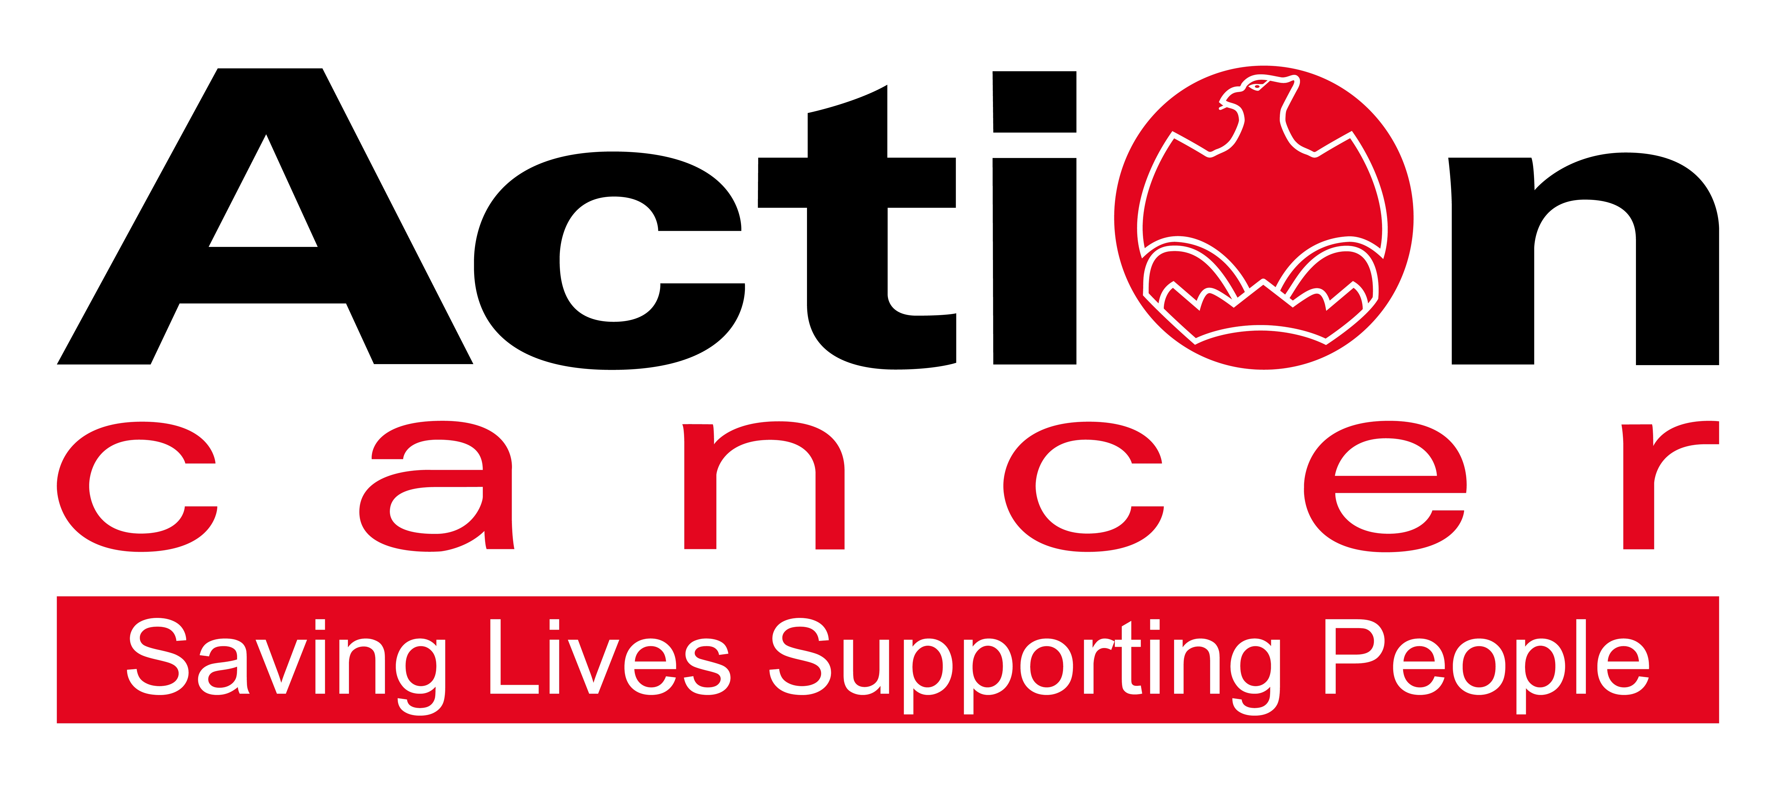

Title of Post: Corporate Fundraising Coordinator

Location: Based at Action Cancer House (hybrid)

Salary: NJC scale points 5-7: £23,500 - £24,294 (£12.91 - £13.35ph)

We also offer:

- 20 days leave increasing to 25 days
- 11 Public Holidays
- 1 extra leave day at Christmas
- Christmas closure
- Enhanced sickness, maternity, paternity, and adoption leave and pay
- 6% contributory pension scheme
- NHS Top-Up Cash Plan
- Staff care and support services, including access to Action Cancer services
- Training and development

In addition to a competitive salary, Action Cancer offer the Total Reward Package (enclosed), which focuses on what our staff value, and includes a flexible mix of rewards designed to meet staff needs, their lifestyle, and their stage in life, including a time-off-in-lieu accrual system, training, flexible family-friendly working arrangements, pension contributions, and excellent professional development opportunities.

Action Cancer is a local Northern Ireland charity - all our money is raised to provide services for local communities. Our dedicated team of staff and volunteers work across the whole of Northern Ireland helping to save lives and support people affected by cancer. To operate our services we must raise circa £4 million every year.

We provide early detection and health promotion services, and counselling and support services for cancer patients and their families, thereby making a real difference to people who are affected by or living with cancer.

Action Cancer staff - a mix of highly skilled professionals - are the most valuable asset to our charity. We offer a wide variety of training and development opportunities, and family friendly initiatives to enhance work-life balance, and to value and support individuals and family life. In recognition of this we were awarded Employer of the Year 2018 in the Business Eye and First Trust Awards, Best Learning and Development Organisation in Ireland - Not for Profit Sector, and were winners of The Irish News ‘Best Place to Work’ Award, Employers for Childcare “Childcare Works Award” and Employers for Childcare Family Friendly Employer Award - Social Enterprise/Charity of the Year.

We are also very proud to have achieved Investors in People Gold Champion status, Investors in People Health & Wellbeing Good Practice accreditation, and Investors in Volunteers accreditation. These awards are testament to our continued commitment to “have highly valued, trained, enthusiastic, focused and committed people who work together and engage with others to make a positive impact on our community”.

Corporate Fundraising Coordinator - Job Description

Overall Responsibility:

To support and help coordinate the activities of the Corporate Fundraising Team in raising the maximum amount of funds from the areas of responsibility within the corporate fundraising area. In conjunction with the Corporate Fundraising Manager the post holder will assist with the fundraising engagement with corporate supporters and in income generation through various activities.

Key Responsibilities

- To assist with and help coordinate the delivery of all corporate fundraising activity. This may include but is not limited to design and production of fundraising packs, assisting with presentations to corporates, offering advice and assistance with fundraising ideas, distributing materials and related PR.

- Co-ordinating corporate fundraising activity on social media on a daily basis, in line with the organisational communications plan and updating website content.

- Assist with developing strong relationships and sustainable income streams from schools

- follow-up on school booking subscriptions to provide excellent customer care to schools receiving Health advice via our schools hub

- Supporting the needs of corporate partners involved in the sponsorship of schools programmes

- The marketing, promotion and coordinating of Action Cancer’s “Donations in lieu” campaign including Wedding Favours, Birthday/Celebration/Anniversary and Memorial Gifts.

- Attending fundraising and corporate events, representing Action Cancer, acknowledging donors, receiving donations and occasional public speaking etc.

- Support the development of seeking out new fundraising activity and leads – Conducting research and assisting with approaches to potential new contacts.

- Assist and support in the planning and organisation of established Action Cancer campaigns including The Builders Tea Campaign

- Admin duties relating to all areas of corporate fundraising including the management and maintenance of an up to date donor database.

- Assisting with social media posts relating to events and activity within the wider fundraising department.

- Supporting the wider Fundraising Team as required at busy periods.

Other Responsibilities

- To provide excellent client support to all Corporates and individuals.

- Attend cheque/donation presentations etc, promoting the work of the charity as necessary and following brand guidelines.

- Ensure Action Cancer Health and Safety Policy is adhered to, including lone working requirements.

- Deputise for the Corporate Fundraising Executive/ Manager in the event of their absence.

- Undertaking any other duties, which may from time to time be requested by the Corporate Fundraising Manager and/or Head of Fundraising and Communications, which are commensurate with the duties and responsibilities of the post.

General Responsibilities

Members of staff are expected at all times to provide the appropriate service and to treat those with whom they come into contact with in a courteous and respectful manner

All staff must comply with Action Cancer’s No Smoking Policy on Action Cancer Premises and also while on duty for the charity.

Action Cancer is an Equal Opportunities Employer. You are required to adhere to Action Cancer’s Equal Opportunities Policy throughout the course of employment.

All duties are carried out in compliance with Action Cancer’s Health and Safety Policy and Statutory requirements.

All staff must comply with Action Cancer Data Protection Policy and Procedures.

To ensure the ongoing confidence of the public in the staff of Action Cancer, staff must ensure they maintain the high standards of personal accountability.

This job description will be subject to review in the light of changing circumstances and is not intended to be rigid and definitive, but should be regarded as providing guidelines within which the individual works. Other duties of a similar nature and appropriate to the grade may be assigned from time to time. It is important to note that the responsibilities of the post may change to meet the evolving needs of the services that the charity provides.

Terms and Conditions of Employment

- 2 satisfactory written references are required direct from a current / previous employer covering the preceding two years of employment.
- Successful applicants must evidence their right to work in the UK (under the Asylum and Immigration Act).This will be evidenced in the first instance by a passport or other forms of ID that will be outlined if no passport is available.
- 6 months probationary period
- Evidence of relevant academic and professional qualifications
- Evidence of appropriate vehicle documentation
- All potential employees may be asked to attend a pre-employment medical

Action Cancer is an Equal Opportunities Employer.

PERSON SPECIFICATION

Essential

- Third level qualification, Level 3 Diploma or a Foundation Degree in a relevant discipline

- Computer literate and good knowledge of MS Office and Social Media platforms.

- Excellent organisational skills.

- Proven team player.

- Prepared to work flexible hours at events throughout the year.

- First class communication and interpersonal skills including experience of interacting with people at all levels, and the ability to speak in public.

- Proven ability to multi-task, prioritise and work to deadlines.

- The ability and willingness to travel extensively throughout Northern Ireland, a current full driving licence, business insurance and access to a car or some other form of transport to allow the post holder to carry out the duties of the post in full.

Desirable Requirements

- Experience working in a Fundraising or Events role

- A minimum of 2 years’ experience in one of the following work environments - Fundraising, Business, Events, Social Media/ PR/Marketing.

- Customer/Relationship/Account Management experience

- Experience in designing promotional materials eg leaflets, posters.

Appendix 1: Action Cancer Total Reward Statement
Training and Development
- Organisation Wide Training Budget
- Paid Tailored Training and Development Support
- Comprehensive In-House Training Courses and External Development Opportunities linked to Role, Strategic Plan, Individual Requests, and Competencies
- Comprehensive Induction Program
- Continued Professional Development Support
- Structured Interim and Annual Performance Reviews
- Regular All Staff and Department Teambuilding Away Days and Events
- Cross Departmental Working Opportunities/ Workplace Shadowing
- Overseas Challenge Opportunities

Work Life Balance
- Standard 35 hour working week
- Flexible Working - hybrid working, compressed hours, staggered start times
- Enhanced paid annual leave - 11 annual statutory days, up to 25 days annual leave (depending on role), Additional Day Paid Leave at Christmas
- Fixed Christmas closure throughout the entire organisation
- Christmas staff and family events
- Time Off In Lieu in compensation of additional hours worked
- Additional leave purchase scheme
- Sabbatical, Discretionary and Dependant care leave
- People and Family Friendly Policies
- Enhanced maternity, paternity and adoption leave and pay subject to eligibility.

Social, Physical and Mental Health and Wellbeing
- WPA - NHS Cash Back Plan and Employee Assistance Program.
- Health and Menopause Support Policies and Return to Work programs
- Therapeutic supports – counselling, complementary therapies, acupuncture
- External care and support services – Staffcare & DAS confidential counselling helpline services
- AIG Smart Health - digital GPs, health checks, nutrition consultation, fitness programme, mental health support, myStrength app, 24/7 mental health helpline, legal and financial support.
- External Occupational Health Service, health checks, screening, and vaccinations
- Regular Staff Health and Wellbeing and Awareness and Opinion Surveys, and Staff Wellness Week
- Mediation services
- Staff kitchen facilities, free tea and coffee, and shower facilities
- Christmas family party and subsidised Christmas departmental celebrations
- Staff pool car
- Clear Policies and Procedures
- CSER Team representing staff opinion and arranging events throughout the year.

Financial Reward and Recognition
- Sector competitive salaries
- Action Cancer 6% pension contribution + 3.2% employee contribution + tax relief = 10% contribution to pension pot
- Salary Sacrifice for Annual Leave, Pension, and Bike to Work Schemes
- Work related professional membership fees paid
- Mileage Allowance at the Prevailing HMRC Rate
- Additional Day Paid Leave at 10,15,and 20 Years’ service for staff on NJC payscales
- Free staff uniforms
- Free car parking
- Death-in-service benefit of £50,000 lump sum payable to nominee.

Where such references are unavailable, and in respect of employee(s) joining directly from school or government sponsored youth training schemes, character references will be required.
Marketing, Events, Social Media, Fundraising, Travel & Tourism, Hospitality, Business or similar

