Contact: Pauline McMullan  Lisburn YMCA  Mobile: 07591852724  Email:Pauline@lisburnymca.com | 28 Market Square,  Lisburn,  BT28 1AG | 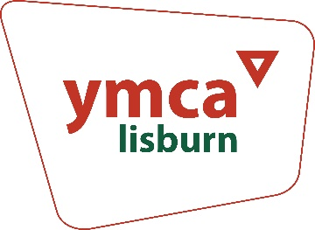

Press Release
YMCA Recruiting New Members for Board of Directors

The YMCA is currently recruiting Board Members to oversee the Association’s work with individuals, families and communities across the Lisburn and surrounding area.

Lisburn YMCA is a faith-based charity, affiliated to YMCA Ireland and a part of the worldwide YMCA movement. The Association delivers a range of youth work development, health, community, and family support programmes. Employing 25 staff, working alongside over twenty volunteers, Lisburn YMCA is locally governed by its Board of Directors who are responsible for shaping its future direction and strategic plan.

Pauline McMullan, General Secretary of Lisburn YMCA, stated, “We are keen to recruit new faces to our Board who have an understanding of our areas of work or skills to support governance functions. Whilst we are always looking to add fresh skills, we would especially welcome interest from individuals with expertise in finance and accounting, business development and PR/communications. We are also particularly keen to recruit more women and those from ethnic minority backgrounds onto our Board.”

For more information on becoming a Board Member of Lisburn YMCA, please complete the attached Expression of Interest by Friday 25th October or contact Pauline McMullan by telephone (07591852724) or email (Pauline@LisburnYMCA.com). Shortlisted candidates will be invited for an interview with a panel of board members.

https://forms.office.com/r/ZgD9Mf7grA

END

