

JOB DESCRIPTION

POST: Lifeline Helpline & Community Counsellor

LOCATION:
- Belfast Office (Helpline Counsellor) – Bank & Substantive posts
- Community Locations (Ballymena, Armagh, Coleraine, Eniskillen) - Bank

BAND: Band 5

REPORTS TO: Team Leader, Lifeline

RESPONSIBLE TO: Service Manager, Lifeline

Job Summary / Main Purpose
The Lifeline service provides immediate crisis intervention, taking into account potential or existing mental health diagnoses. Lifeline Counsellors work across both the Helpline (providing 24/7 crisis support to callers from our main office in Belfast) and in the Community (providing a course of therapeutic intervention on a one to one basis). Callers to Lifeline self-refer or are referred by third parties including statutory and community services. Lifeline counsellors assess caller’s situation & risk, and promote protective factors and support networks. Lifeline aim to provide appropriate, tailored support to the individual via a needs-based approach. Counsellors must adhere to the BACP code of ethics and practice to the highest professional standard. Lifeline is a 24/7 service and as such staff are expected to work all shifts including evenings, nights and weekends.

Main Duties / Responsibilities

Helpline
For each of the following, the postholder will;

- To provide a crisis intervention service to Lifeline callers
- To deliver a crisis intervention service requiring decision making determined by shift supervisor in accordance with Lifeline policy for clients presenting via telephone call
- To actively work to de-escalate and assure client safety based on immediate client presentation
- Being aware of barriers to effective communication including callers whose first language is not English, callers with hearings impairments and callers who face any other communication difficulties.
- To carry out initial risk assessment and continuously monitor client safety during call in order to assess client presentation with supported consultation from shift supervisor.
- To establish and record client information including current location on all relevant systems.
- To assess client information and to liaise with shift supervisor to determine appropriate action or assistance from third parties including emergency services or mental health professionals.
- To establish and sustain a therapeutic relationship with the client at first point of contact providing reassurance and support until help can be provided, ensuring client safety.
- To develop and maintain professional working relationships with relevant referral agencies to Lifeline, maintaining ongoing information-sharing and referral pathways with support of shift supervisor.
- To record and when directed by the shift supervisor to forward appropriate information to relevant agencies, in real time and on live calls including information sharing with medical professionals, emergency services, social services and other stakeholders.
- To access support and consultation structures for all clinical issues relating to safeguarding, including children and vulnerable adults, suicide risk and disclosures of criminal acts in accordance with relevant legislation and Trust policies.
- To record comprehensive client notes to ensure continuity of care and appropriate treatment/ intervention in the Lifeline service, for the purposes of client safety management.
- To deliver short-term crisis interventions appropriate to client presenting issues and risk indicators as directed by shift supervisor.
- Ensure effective, timely, safe and responsive service delivery to clients.
- To attend and actively participate in relevant training on a regular basis in order to maintain Continuous Professional Development.
- To attend monthly clinical supervision from a suitably qualified individual.
- To attend line management supervision for practitioner development.
- To actively participate in annual Staff Development Review and performance management meetings as required
- To participate in surveys and audits, as required by Belfast Trust and other stakeholders.
- To remain focused in the management and care of high-risk clients both via telephone, seeking clinical support from the shift supervisor as necessary.
- Support colleagues whilst on shift within the counselling team when they are dealing with high risk and emergency calls.
- To use clinical outcome measures to evaluate effectiveness of individual intervention with clients.
- To effectively manage potentially hostile, antagonistic or highly emotive conversations with callers to the Lifeline service with support of shift supervisor if necessary.
- To be responsible for Trust property which is issued to them including but not limited to computers, mobile phones and laptops.

Community Counselling
For each of the following, the postholder will;
- Plan and deliver short-term crisis counselling appropriate to client presenting issues and risk indicators
- Commit to weekly sessions and work effectively in managing own community client caseloads under the supervision of Lifeline Team Leader and Community Coordinator whilst continually risk assessing and monitoring clients in order to reduce risk of self-harm and/or suicide.
- Being aware of barriers to effective communication including clients whose first language is not English, clients with hearing impairments and clients who face any other communication difficulties.
- Monitor client progress and adjust their treatment plan as needed
- Liaise with clinical consult and community coordinator to determine appropriate action or assistance from third parties including emergency services or mental health professionals.
- Develop and maintain professional working relationships with relevant referral agencies to Lifeline, maintaining ongoing information-sharing and referral pathways.
- To access support and consultation structures for all clinical issues relating to safeguarding, including children and vulnerable adults, suicide risk and disclosures of criminal acts in accordance with relevant legislation and Trust policies.
- Record comprehensive client notes to ensure continuity of care and appropriate treatment/ intervention in the Lifeline service, for the purposes of client safety management.
- Ensure effective, timely, safe and responsive service delivery to clients.
- Attend and actively participate in relevant training on a regular basis in order to maintain Continuous Professional Development.
- Attend monthly clinical supervision from a suitably qualified individual.
- Participate in surveys and audits, as required by Belfast Trust and other stakeholders.
- Remain focused in the management and care of high-risk clients both face to face and via telephone, seeking clinical support from the on call consult or shift supervisor as necessary.
- Use clinical outcome measures such as CORE-10 to evaluate effectiveness of individual intervention with clients
- Be responsible for Trust property which is issued to them including but not limited to computers, mobile phones and laptops.
- Submit timesheets as per Trust processes and timescales

General Responsibilities

Employees of the Trust are required to promote and support the mission and vision of the service for which they are responsible and:
- At all times provide a caring service and to treat those with whom they come into contact in a courteous and respectful manner.
- The post holder will promote and support effective team working, fostering a culture of openness and transparency. The post holder will ensure that they take all concerns raised with them seriously and act in accordance with Belfast Trust’s Whistleblowing Policy and their professional code of conduct, where applicable.
- Demonstrate their commitment by their regular attendance and the efficient completion of all tasks allocated to them.
- Comply with the Trust’s Smoke Free Policy.
- Carry out their duties and responsibilities in compliance with the Health and Safety Policies and Statutory Regulations.
- Adhere to Equality and Good Relations duties throughout the course of their employment.
- Ensure the ongoing confidence of the public in-service provision.
- Maintain high standards of personal accountability.
- Comply with the HPSS Code of Conduct.

Information Governance

All employees of Belfast Health & Social Care Trust are legally responsible for all records held, created or used as part of their business within the Belfast Health and Social Care Trust, including patient/client, corporate and administrative records whether paper based or electronic and also including e-mails. All such records are public records and are accessible to the general public, with limited exceptions, under the Freedom of Information Act 2000, the Environment Regulations 2004, the General Data Protection Regulation (GDPR) and the Data Protection Act 2018. Employees are required to be conversant and to comply with the Belfast Health and Social Care Trust policies on Information Governance including for example the ICT Security Policy, Data Protection Policy and Records Management Policy and to seek advice if in doubt.

For further information on how we use your personal data within HR, please refer to the Privacy Notice available on the HUB or Your HR

Environmental Cleaning Strategy

The Trusts Environmental Cleaning Strategy recognises the key principle that “Cleanliness matters is everyone’s responsibility, not just the cleaners” Whilst there are staff employed who are responsible for cleaning services, all Trust staff have a responsibility to ensure a clean, comfortable, safe environment for patients, clients, residents, visitors, staff and members of the general public.

Infection Prevention and Control

The Belfast Trust is committed to reducing Healthcare associated infections (HCAIs) and all staff have a part to play in making this happen. Staff must comply with all policies in relation to Infection Prevention and Control and with ongoing reduction strategies. Standard Infection Prevention and Control Precautions must be used at all times to ensure the safety of patients and staff.
This includes:-
- Cleaning hands either with soap and water or a hand sanitiser at the appropriate times (WHO ‘5 moments’);
- Using the correct ‘7 step’ hand hygiene technique;
- Being ‘bare below the elbows’ when in a clinical environment;
- Following Trust policies and the Regional Infection Control Manual (found on intranet);
- Wearing the correct Personal Protective Equipment (PPE);
- Ensuring correct handling and disposal of waste (including sharps) and laundry;
- Ensuring all medical devices (equipment) are decontaminated appropriately i.e. cleaned, disinfected and/or sterilised;
- Ensuring compliance with High Impact Interventions.

Personal Public Involvement

Staff members are expected to involve patients, clients, carers and the wider community were relevant, in developing, planning and delivering our services in a meaningful and effective way, as part of the Trust’s ongoing commitment to Personal Public Involvement (PPI).

Please use the link below to access the PPI standards leaflet for further information.

http://www.publichealth.hscni.net/sites/default/files/PPI_leaflet.pdf

Clause: This job description is not meant to be definitive and may be amended to meet the changing needs of the Belfast Health and Social Care Trust.

PERSONNEL SPECIFICATION

JOB TITLE / BAND: Lifeline Counsellor (Helpline) Band 5

DEPT / DIRECTORATE: Mental Health and Learning Disability

Notes to applicants:
- You must clearly demonstrate on your application form under each question, how you meet the required criteria as failure to do so may result in you not being shortlisted. You should clearly demonstrate this for both the essential and desirable criteria.
- Shortlisting will be carried out on the basis of the essential criteria set out below, using the information provided by you on your application form. Please note the Trust reserves the right to use any desirable criteria outlined below at shortlisting. You must clearly demonstrate on your application form how you meet the desirable criteria.
- Proof of qualifications and/or professional registration will be required if an offer of employment is made – if you are unable to provide this, the offer may be withdrawn.

ESSENTIAL CRITERIA

The following are ESSENTIAL criteria which will initially be measured at shortlisting stage although may also be further explored during the interview/selection stage.
You should therefore make it clear on your application form whether or not you meet these criteria. Failure to do so may result in you not being shortlisted. The stage in the process when the criteria will be measured is stated below.
Factor | Criteria | Method of Assessment
Qualifications  Registration  Experience | - Minimum Level 5 qualification, higher Diploma, postgraduate counselling diploma or counselling degree (or equivalent) in counselling from a recognised awarding body.  - Registered Member Counselling and Psychotherapy professional body. Eg, BACP, NCS, IACP, HCPC  AND  - Either Accredited OR a commitment to achieving accreditation within the first 12 months of employment (to a Counselling and Psychotherapy professional body. Eg, BACP, NCS, IACP, HCPC)  - Experience working in a crisis environment supporting people at risk or with psychological distress and despair across the lifespan. | Shortlisting by Application Form
Other (e.g. Driving etc.) | - Willingness to work flexible hours (including nights and weekends) as required to meet the needs of a 24/7 service. | Shortlisting by Application Form
Knowledge  Skills  Abilities | - Excellent oral and written communication skills and IT skills including Microsoft Office. | Shortlisting by Application Form

DESIRABLE CRITERIA

Desirable criteria will ONLY be used where it is necessary to introduce additional job related criteria to ensure files are manageable. You should therefore make it clear on your application form how you meet these. Failure to do so may result in you not being shortlisted.
Factor | Criteria | Method of Assessment
Qualifications  Registration  Experience | - For Community Counselling at least 200 hours post-qualifying, clinically supervised counselling practice in a formal setting, within the last 24 months OR at least 1 years counselling, clinically supervised experience in a formal setting totalling a minimum of 150 hours clinically supervised counselling practice  - Experience of liaising with statutory, voluntary and community organisations.  - Experience of working with a diverse range of presenting issues and evidenced based therapeutic techniques.  - Completion of ASSIST or similar training | Shortlisting by Application Form
Knowledge  Skills  Abilities | - Awareness of Pisani Risk formulation Awareness of Child and Adult Safeguarding and related issues. | Shortlisting by Application Form

NOTE:
Where educational/professional qualifications form part of the criteria you will be required, if shortlisted for interview, to produce original certificates and one photocopy of same issued by the appropriate authority. Only those certificates relevant to the shortlisting criteria should be produced. If educational certificates are not available an original letter and photocopy of same detailing examination results from your school or college will be accepted as an alternative.

If successful you will be required to produce documentary evidence that you are legally entitled to live and work in the United Kingdom. This documentation can be a P45, Payslip, National Insurance Card or a Birth Certificate confirming birth in the United Kingdom or the Republic of Ireland. Failure to produce evidence will result in a non-appointment.

Where a post involves working in regulated activity with vulnerable groups, post holders will be required to register with the Independent Safeguarding Authority.

HSC Values

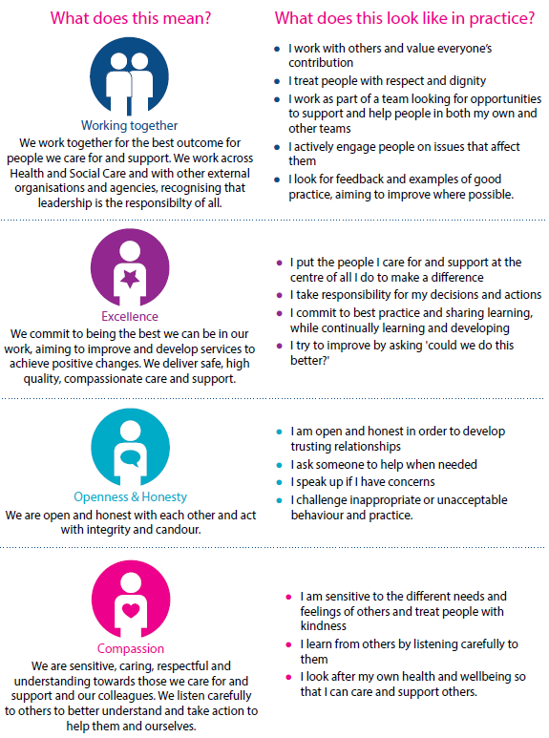
Whilst employees will be expected to portray all the values, particular attention is drawn to the following values for this role

