

**Candidate Information Booklet**

Clinical Co-ordinator

Closing date for applications:

*Friday 15th November - 1pm*







**Clinical Co-ordinator Job Description**

###### **Job Description**

Job Title: Clinical Coordinator

**Responsible to:** **Head of Clinical Services**

Location: Opportunity to be based in Enniskillen/ Portadown/ Markethill Office with travel, as required to Ely/Partner Offices

Hours: 30 Hours per Week

Salary: P01 Pt 27 + Er Pension Contribution

*JOB BACKGROUND*

The Ely Centre is a Registered Health and Well Being Charity (NIC101144) providing multi-disciplinary support services for Civilians, Security Force personnel and their families, who have experienced bereavement and injury as a result of the “Troubles”.

The Ely Centre is committed to serving innocent victims and survivors, ex service personnel, their families and carers by providing evidenced based outcome focused treatments, prevention and support services that address issues of declining psychological, physical health, social and financial difficulties arising as a result of terrorism.

Ely have offices in Enniskillen, Portadown and Markethill and the post holder will provide support to clients from across these offices and our partners.

This post has been funded by the Victims and Survivors Service.

**Main purpose of job:** The Clinical Coordinator will be required to support the Clinical Lead in the clinical administration/ operational and audit functions of Mindwell NI- The Ely Centre BACP Accredited Counselling Service. The post holder will play a key role in the organizational triage and assessment process of referred Ely Clients.

**Main Duties and Responsibilities**

1. To provide ongoing support to the Clinical Lead to ensure the highest quality of service delivery to all clients.
2. To carry out initial triage assessments of referrals made to the project to assess suitability for counselling and other needs based on clinical risk strategy.
3. To ensure adherence to all processes and procedures of the department by sessional practitioners.
4. To oversee the clinical administration of sessional practitioners and to be responsible for the completion and recording of third party correspondence.
5. To maintain and manage the use and completion of all evaluation systems and processes such as Corenet and Measure Your Own Medical Outcome Profile (MYMOP) by members of the team.
6. To manage a small caseload providing one to one counselling to victims of the conflict and their dependants who have been affected by transgenerational, conflict related trauma
7. To maintain confidential, professional and appropriate records of all client contact on paper / and within Elys CRM system.
8. To work ethically and professionally within the available contractual time frame with clients.
9. To attend regular team meetings and line management.
10. To attend external clinical supervision on a monthly basis
11. To maintain current membership with BACP
12. To maintain adequate records of clinical work and provide appropriate statistical returns and to assist with the completion of reports where necessary.
13. To maintain a professional attitude at all times towards clients, staff and all those in contact with The Ely Centre.
14. To provide clinical support to practitioners and colleagues as and when required. To line-manage a team of sessional complementary therapists.
15. To promote services and attend meetings in the absence of the Clinical Lead.
16. To liaise with and work in partnership with Local Trust Partners to ensure the continued development of the Regional Trauma Network.
17. To undertake recruitment process to ensure a satisfactory level of sessional practitioners.
18. To work in collaboration with external community counselling organisations to assist in creating community partnerships for the betterment of clients and organisational signposting.
19. Alongside the SMT, identify funding opportunities for the continued development of the counselling service.
20. Undertake CPD opportunities for the development of the Service.

**This job description is not incorporated into the employee’s employment contract. It is intended as a guide and should not be viewed as an inflexible specification and it may be varied from time to time in the light of strategic developments following discussion with the post holder.**

**The post holder will be expected to work to objectives agreed with the line manager.**

**This post is subject to completion of an Enhanced Access NI check.**

**Organisational Structure**

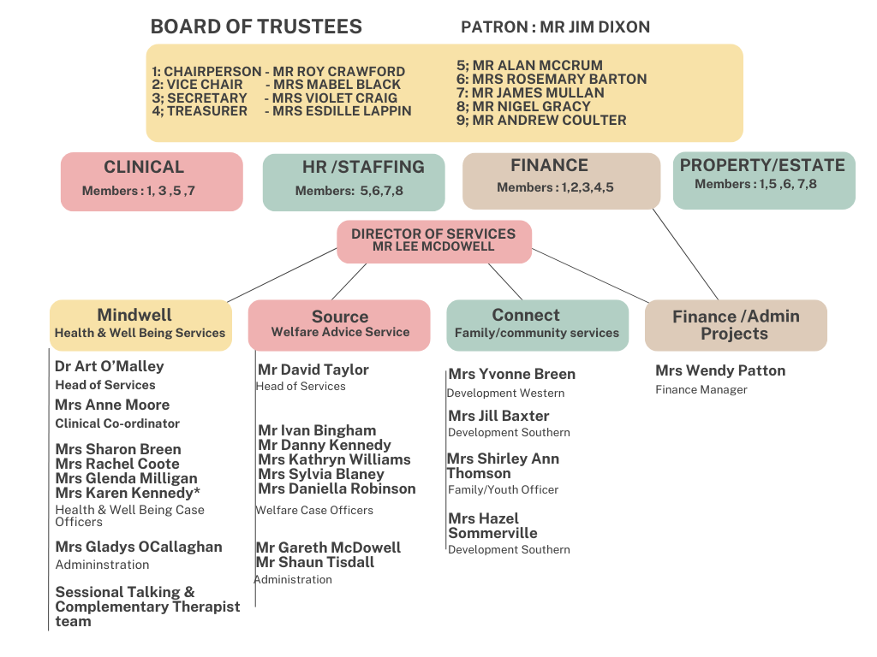

**Person Specification**

**Essential Criteria**

1. To be accredited with BACP (or equivalent) **OR** working towards accreditation (with a clearly identified intended date for submission) with a minimum of 450 post-qualification supervised counselling hours and BACP Certificate of Proficiency (or equivalent).
2. Knowledge and experience of managing client risk, and maintaining boundaries and confidentiality appropriately.
3. Knowledge and experience of working with trauma.
4. Ability to establish and maintain professional relationships with other statutory/community/voluntary groups.
5. Working knowledge and experience of monitoring and evaluating clinical outcomes inc CORE
6. An understanding of a range of presenting issues and suitable interventions within a community counselling setting.
7. Experience of providing direct line management to sessional practitioners.

**Desirable**

1. Previous experience of providing Clinical Supervision within a community counselling environment.
2. Previous experience of delivering training
3. CBT Level 5 – or working towards or EMDR Part 1 & 2
4. Previous experience of using computerised management information systems.

**Skills and Abilities Essential**

1. Ability to work flexible hours (including evening work and weekend work)
2. Willingness to undertake training required for the post.
3. Ability to work under own initiative, including effective prioritisation of tasks and ability to work to agreed aims and objectives.
4. Ability to create and sustain effective working relationships and build consensus with key stakeholders
5. Excellent written and oral communication skills
6. Sound knowledge of ICT including all Microsoft Office applications (word, excel, outlook, internet etc.)
7. Excellent interpersonal skills to work within a team and build good working relationships.
8. Excellent organisational skills

**Application Process**

Following deadline for receipt of applications the selection process will continue as follows:



**6. Guidance for Making Your Application**

Application should consist of a completed application form together with the completed monitoring form.

**Application Submission**

Completed applications can be submitted by 1pm on Friday 15th November 2024

• Posted or hand delivered to The Ely Centre, Markethill Office, 2 Geddis Square, Markethill, Co Armagh. BT60 1PN

• Or Emailed to info@elycentre.co.uk

We will not accept incomplete application forms; application forms received after the closing deadline or reformatted application forms.

Applicants using Royal Mail should note that 1st class mail does not guarantee next day delivery. It is the responsibility of the applicant to ensure that sufficient postage has been paid to return the form to meet the required deadline.

Should you have any queries please contact art@elycentre.co.uk

**Interview Guidance for Applicants**

Final dates for interview have not been scheduled but will take place during week commencing Monday 2nd December 2024

At the interview, the selection panel will assess candidates against the essential and desirable criteria for the post.

**Further Appointments from this Application**

Where a further position in the Organisation is identified which is considered broadly similar to that outlined in this candidate information booklet, consideration will be given to filling the position from this competition. The reserve list resulting from this competition will be valid for a period of up to one year.

**Disability Requirements**

If reasonable adjustments are required by candidates on account of disability the organisation will make every effort reasonable to accommodate such.

**Vetting Procedures**

For vetting procedures candidates will be required to produce the following for interview:

• Passport;

**OR**

Document verifying your permanent National Insurance number (e.g.P45, P60 or National Insurance card);

**AND**

Birth certificate which includes the names of your parents (long version);

• Specimen signature;

• Proof of qualifications (original certificates);

• 2 satisfactory references (References will not be sought until after the final stage of the assessment process);