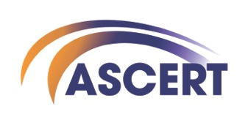

***Reducing Harm and Supporting Positive Change***

**ASCERT is a Northern Ireland charity and leading provider of services addressing drug and alcohol related issues.**

**Why join the ASCERT team?**

* 28 Days Annual Leave plus 11 Bank/Public Holidays
* Christmas Shopping Day
* Time off for Mental Health Awareness
* Time off in Lieu Policy
* Hybrid Working Options
* Investors in People GOLD employer
* Ongoing training & study opportunities
* Competitive Pension contributions from ASCERT
* Staff Wellbeing Programme
* Employee Assistance Programme through Inspire Workplaces
* Staff Working Groups to give staff a say in Organisational Development
* Staff Representatives
* Staff Reward & Recognition Programme

**We are currently looking to expand our team and are recruiting for the following position:**

**Counsellor (SHIP) Self Harm Intervention Programme**

As a counsellor within ASCERT’s SHIP service you will be part of a team that provides Tier 2 psychological interventions and support services to individuals that have self-harmed, ages 11+, including support for their family/carer or other support person(s).

The SHIP service is commissioned by the Public Health Agency and complements the provision of services by Health and Social Care (HSC) Trusts and primary care teams across the Belfast and Northern areas.

**JOB Title Counsellor (SHIP) Self Harm Intervention Programme**

**RESPONSIBLE TO Service Manager**

**LOCATION ASCERT Belfast Office. Operating across Belfast and Northern Health & Social Care Trust areas.**

**LENGTH OF POST This post is funded to October 2027 (with possible extension)**

**HOURS 35 hours per week**

**SALARY SCP Point 23 £32,076 plus 4% pension**

Please send your CV along with a cover letter of no more than 500 words detailing how you meet the essential criteria to nualaa@ascert.biz

**12noon on Monday 21st of October 2024**

ASCERT are an equal opportunities employer