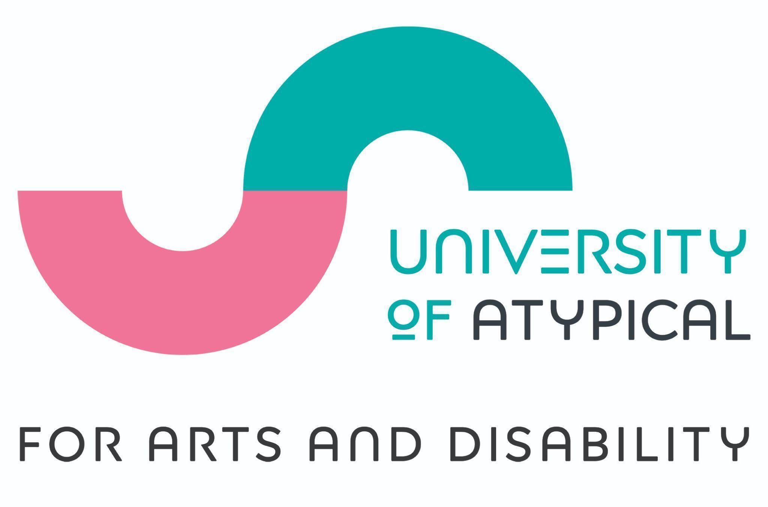

September 2024

Dear Applicant,

Thank you for your interest in the role of Volunteer Coordinator. I am delighted to be offering this part-time position to coordinate our volunteer programme with University of Atypical for Arts and Disability (UofA).

We have an existing team of volunteers - most of whom identify as d/Deaf, disabled or neurodivergent - and this role will support and train them as volunteers at our events and activity through the year. It is also an opportunity for the right person to help sustain and grow this volunteer programme, and to develop University of Atypical as an organisation which can be a model for accessible volunteering. If you are passionate about the arts, the value of volunteering, the disability sector, and want to contribute your skills to making a real difference, then I want to hear from you.

As a disabled-led organisation UofA has a focus in supporting people who identify as d/Deaf, disabled and neurodivergent to work with us and so I encourage those with and without disabilities to apply.

Wishing you all the best of luck and I look forward to receiving your application.

Sincerely

Edel Murphy - CEO and Artistic Director

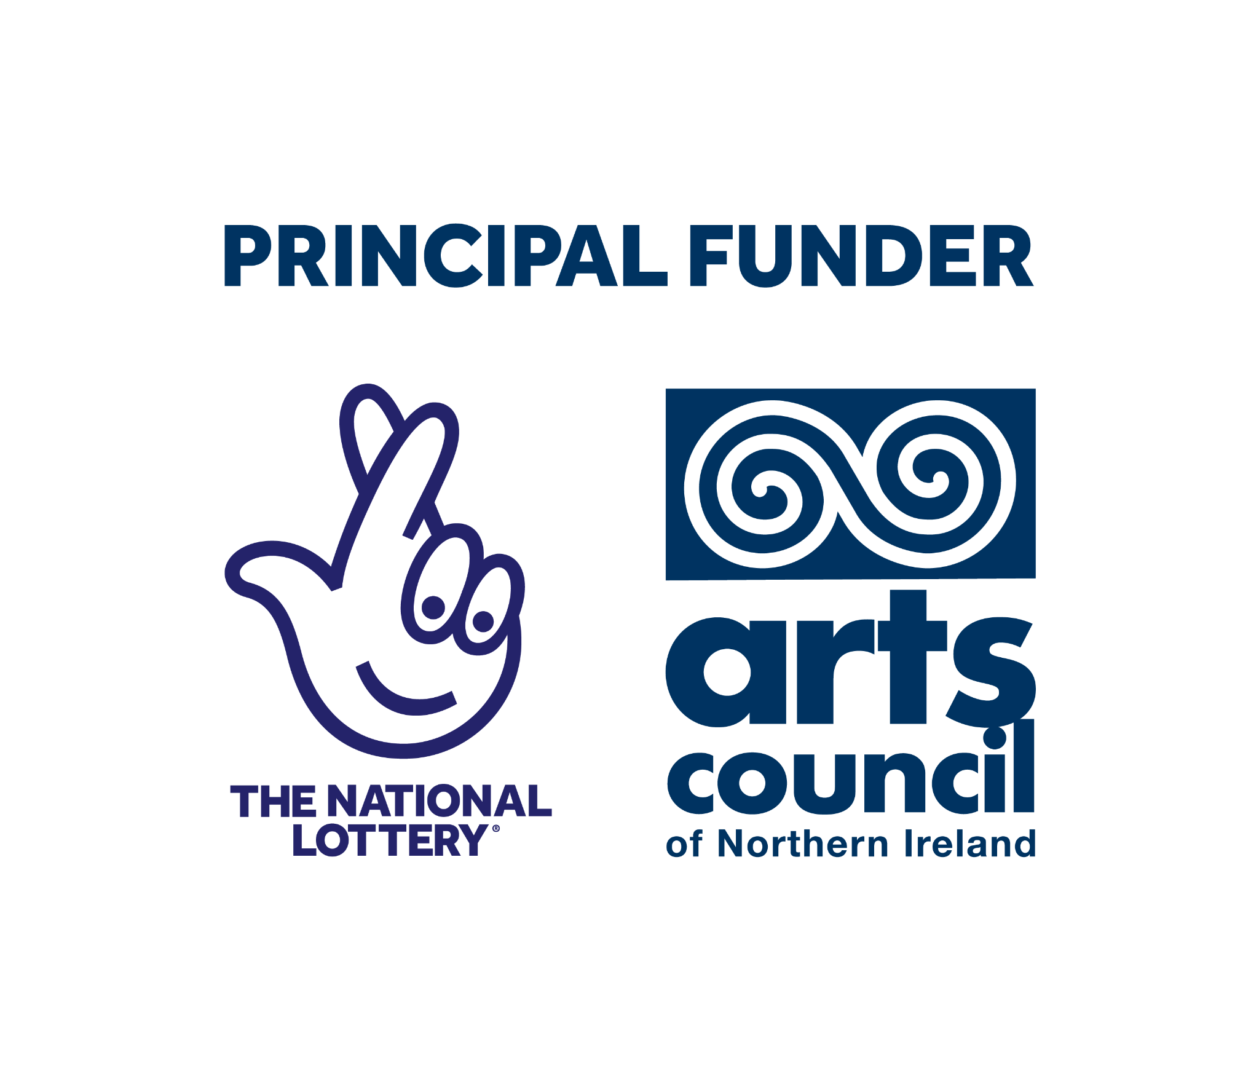

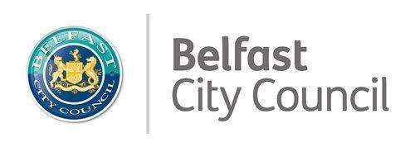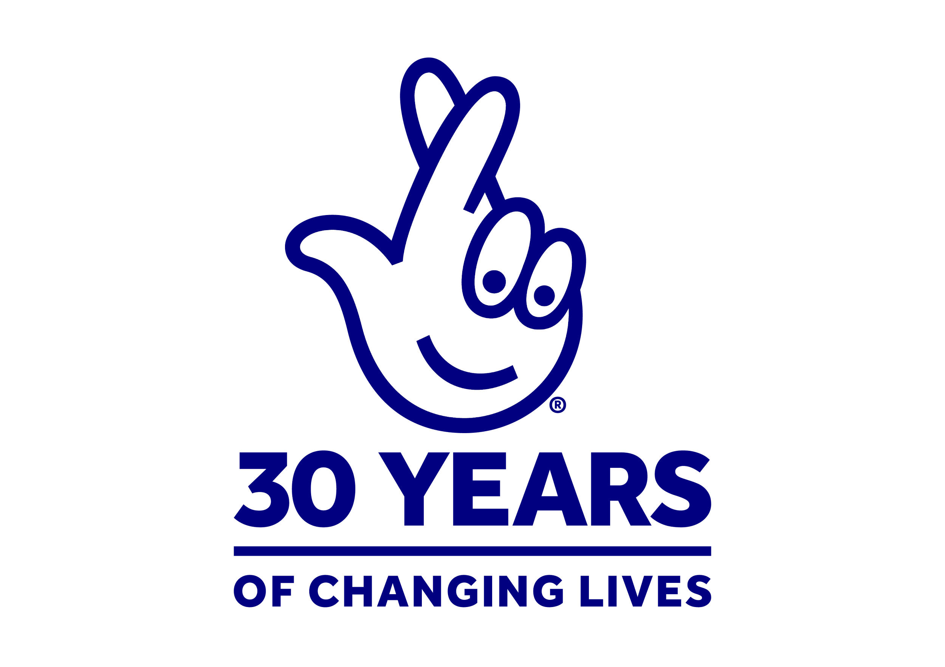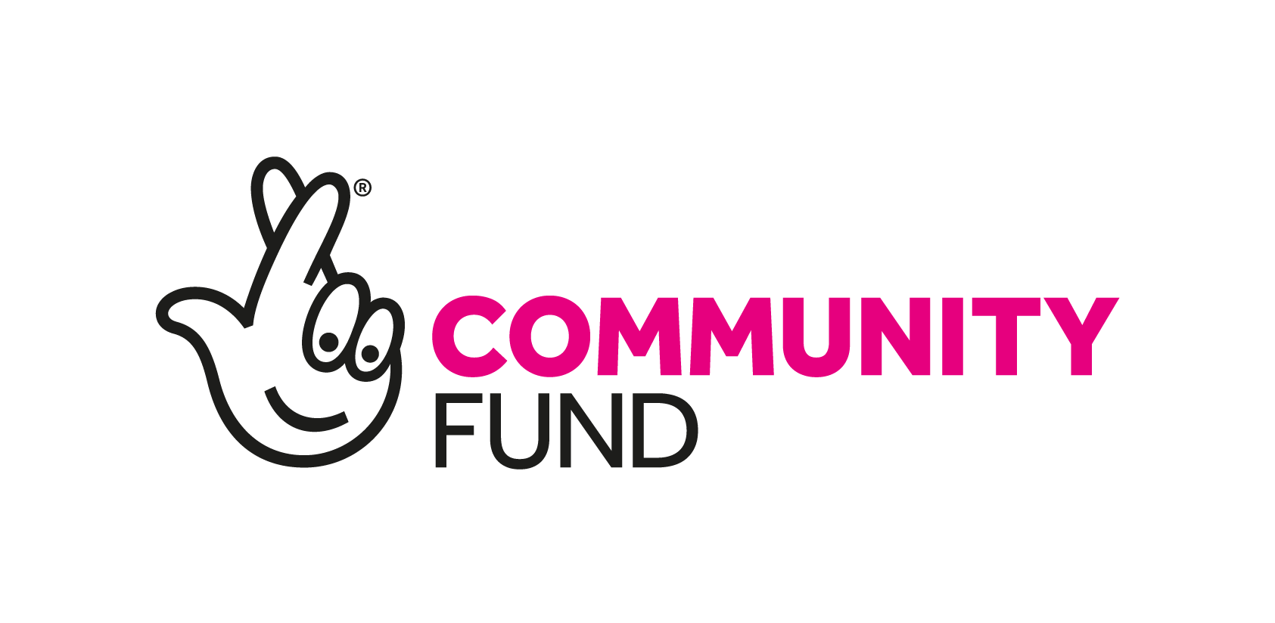



**University of Atypical for Arts and Disability**

[**www.universityofatypical.org**](http://www.universityofatypical.org)

**Recruitment Pack for the post of Volunteer Coordinator**

**Salary:** £10,400 annually, for 16 hours per week (£26,000 full-time equivalent)

**This is a sixteen-month role* funded by an Awards for All grant from The National Lottery Community Fund**

(*subject to continued funding on a yearly basis)

**Apply for this role**

* Other formats of the application can be provided including Braille.
* Application deadline: **1:00 pm on Thursday 10 October 2024**.
* It is anticipated interviews will take place on **Tuesday 22 October 2024** and applicants are asked to keep this date open as they may be invited to interview.
* It is hoped that the successful applicant will take up the role within 8 weeks of the offer.

## About Us

***University of Atypical for Arts and Disability*** (UofA) was established in 1993 as the leading sectoral organisation on arts and disability in Northern Ireland.

UofA takes an empowerment-based approach towards d/Deaf, disabled and neurodivergent people’s involvement in the arts as audience members and as creative practitioners. UofA specialises in developing and promoting the work of d/Deaf, disabled and neurodivergent artists and in doing so engages with d/Deaf, disabled and neurodiverse audiences in a direct and meaningful way.

We aim to increase opportunities for d/Deaf, disabled and neurodivergent people to engage with the arts, working on a pan-disability basis providing participative and networking opportunities; exhibitions; the Bounce Arts Festival; the Ledger Studio arts and performance space; training; and other sectoral developments in equality, access and inclusion.

***Our Purpose:***

We want to improve the creative lives of d/Deaf, disabled, and neurodivergent people and help them access the arts.

***Our Vision:***

We want a society where everyone can positively explore and express their creativity, curiosity and talents through the arts.

***Our Values:***

The following values underpin every aspect of UofA’s culture and activities:

* **Inclusion** - we believe that a healthy and stable society needs to be built by all its people working together. We will be open to those of all abilities and disabilities and celebrate the diversity of the society in which we live. UofA operates under the social model of disability which says that people are disabled by barriers in society, not by their impairment or difference. We will oppose injustice and anything that excludes or marginalises d/Deaf, disabled and neurodivergent people and others who are considered to be different.
* **Disabled-led** - UofA is driven by d/Deaf, disabled and neurodivergent artists who understand the needs, rights and aspirations of other d/Deaf, disabled and neurodivergent artists and acts as an independent voice.
* **Parity** - everyone has an equal right to be treated with dignity and respect, to learn and develop, to access the arts in all its forms and to have their voice heard.
* **Human Rights** - we believe that everyone has inalienable human rights which should be upheld. In particular, we support the UN’s Convention on the Rights of Persons with Disabilities and will work to promote and defend these rights.
* **Excellence** - everyone has the right to expect that all aspects of UofA’s work are carried out to the highest standard. UofA will also support artists to work towards achieving the highest artistic standards.
* **Collaborative** - we believe the organisation is much more effective when working in partnership with its key stakeholders. We value meaningful collaboration and partnership working.

### What we do

**UofA has a lead sectoral role in Northern Ireland for:**

* enhancing the experience d/Deaf, disabled and neurodivergent people have of the arts
* promoting work produced by d/Deaf, disabled and neurodivergent artists
* elevating the public’s experience of art created or presented by d/Deaf, disabled and neurodivergent artists
* improving arts organisations’ understanding of access requirements of d/Deaf, disabled and neurodivergent people
* showcasing excellence in art created by d/Deaf, disabled and neurodivergent artists

**UofA delivers a year-round programme including:**

* Atypical Gallery programme of visual arts and crafts exhibitions and events
* The Ledger Studio programme of training, workshops, rehearsals and performances
* Partnership work with mainstream arts and Arts & Disability organisations, festivals and creatives
* The Arts & Disability Access Awards (ADAA, formerly EASI), supporting arts and cultural venues and organisations to commit to enhancing access to venues and programming with input from d/Deaf, disabled and neurodivergent people
* Sectoral training programme including Disability Awareness; Neurodiversity Awareness; Equality, Access and Inclusion Training; and Sign Language courses
* The annual D/deaf and Disabled Artists Support Fund (DDASF) scheme for artists who are d/Deaf, disabled, or neurodivergent, managed on behalf of the Arts Council of Northern Ireland
* Bounce Arts Festival, showcasing the best creative practice of work created by local, national and international d/Deaf, disabled and neurodivergent artists

**Key communities UofA works with:**

* Professional and emerging artists, across all art form areas, who identify as d/Deaf, disabled or neurodivergent
* Arts sector and community organisations who engage and seek to engage artists and audiences who are d/Deaf, disabled or neurodivergent
* Professionals in disability support including translators, audio describers and professional support for disabled people
* People with lived experience of disability and neurodiversity, and the d/Deaf Community
* Professionals in administration, policy, or the provision of services for people or communities who are d/Deaf, disabled, or neurodivergent

## Organisational Context of the Role

University of Atypical (UofA) is undergoing a time of great change and development and we are looking for a team member to take on the role of Volunteer Coordinator to support our volunteer programme at this exciting time. This role is funded by an Awards for All grant from The National Lottery Community Fund.

The Volunteer Coordinator role will support the organisation in recruiting, supporting and matching volunteers to events across our programmes and our Bounce Arts Festival. Managing a budget, writing simple reports, giving presentations and gathering feedback from existing and new volunteers are examples of tasks that are part of this role.

We are looking for someone who has relevant experience working with volunteer programmes or in arts and disability and disability arts engagement, and who has some experience in administration and reporting.

You will be part of a team. The role will involve you working closely with the Community Engagement Manager, the Creative Programmes & Studio Lead, the Gallery Coordinator, and the Access & Inclusion team.

This is an exciting opportunity to help contribute to accessible volunteering opportunities and support programmes for the d/Deaf, disabled and neurodivergent arts community.

**Reporting to:** Community Engagement Manager of University of Atypical

**Salary:** £10,400 annually, for 16 hours per week (£26,000 full-time equivalent)

**Hours:** Expectation of working pattern inside the core office hours Monday to Friday, with some weekend and evening work. Firm working pattern to be agreed between the CEO/Artistic Director and the successful candidate.

**Post duration:** This is a sixteen-month contract commencing on the employee’s start date. The role may be extended beyond March 2026 subject to funding.

**Location:** University of Atypical, Ground Floor, Cathedral Quarter Workspaces, 109-113 Royal Avenue, Belfast BT1 1FF. Some travel will be required in Northern Ireland; travel and other costs associated with travel will be covered (excluding travel to work).

**KEY RESPONSIBILITIES:**

| **Volunteer Management** | * Promote volunteering opportunities to existing volunteers, ensuring all University of Atypical activity is appropriately supported * Maintain records of volunteers including their access needs and volunteering interests * Recruit and interview new volunteers to the team * Communicate regularly with volunteers and pass on any relevant feedback to the rest of the UofA team * Handle all volunteer information in line with organisational policies and confidentiality requirements |
| --- | --- |
| **Financial Management and record keeping** | * Hold responsibility for managing programme budget in line with organisational and funder requirements * Manage expenses forms from volunteers and track all other receipts and programme expenditure * Ensure compliance with the UofA Financial Procedures policy |
| **Funding** | * Maintain and collate information required for internal and external monitoring reports, including volunteer feedback and demographics * Ensure information required for monitoring reports is collated and provided to the Community Engagement Manager and Business Development Manager in line with requests * Provide regular updates to Community Engagement Manager and Business Development Manager on activity in line with funder requirements * Review and monitor programmes in line with funder terms and conditions |
| **Administration, Data and Governance** | * Hold responsibility for own administration across all areas of volunteer programme (emails, telephone, photocopying, filing and reporting) * Contribute to the review and update of relevant segments of business/operational plans and policies * Manage the data capture/feedback/evaluations on the quality and effectiveness of the volunteer programme * Ensure compliance with UofA Governance at all times * Ensure compliance with all statutory requirements e.g. Health and Safety, Public and Employer Liability, Covid-19 restrictions, Disability Discrimination Act, Equalities law/Section 75 |
| **Support**  **and Supervision** | * Work as part of an organisational team, under the direction of the Community Engagement Manager and alongside other team members to support the events and creative programmes * Management of volunteers * Actively engage in staff training, team meetings, staff away days and supervision |
| **Representation, and campaigning** | * Work in partnership with the relevant staff to ensure the UofA website and media channels are updated with news and updates about the volunteer programme * Act as an ambassador promoting the importance of d/Deaf, disabled, and neurodiverse artists and culture, and d/Deaf, disabled, and neurodiverse inclusion in the volunteering sector * Work with our marketers to increase the profile and awareness of University of Atypical for Arts and Disability, and our volunteer programme in particular |

**PERSON SPECIFICATION**

| **Essential Criteria** | Qualifications and experience   1. Minimum of 2 years’ experience in developing, planning and managing volunteer programmes OR community/participation activities 2. Lived and/or professional experience of disability, the d/Deaf community or neurodiversity 3. Knowledge and experience of the arts and cultural sector in NI 4. Experience of working as part of an organisational team 5. Experience of managing volunteers or other teams of people 6. Experience of recruiting volunteers, freelance staff, artists, tutors or performers   Skills   1. Evidence of administration skills and proficiency in the use of IT and social media 2. Evidence of project coordination skills and delivering against outcomes, including tracking budgets 3. Evidence of planning and organising skills 4. Evidence of good time management skills and handling competing priorities 5. Evidence of effective communication i.e. verbal, written and presentation skills 6. Evidence of problem-solving skills   Other   1. Willingness to travel as an essential part of the role e.g. to events, conferences, project site visits, etc. 2. Willingness to work flexible hours as required to accommodate some evenings and weekends - this will be as part of the events or training programme and communicated to you in advance 3. Willingness to complete an Access NI check if required |
| --- | --- |
| **Desirable Criteria** | 1. Awareness of and participation in disability rights, advocacy and campaigning 2. Experience of working directly with d/Deaf, disabled and neurodivergent volunteers, artists or participants 3. Experience of mentoring or facilitating training 4. Experience of Access and Inclusion measures, especially for arts events and workshops 5. Experience of working with other communities where barriers to participation exist |

**Terms and conditions of employment**

* Contract subject to satisfactory probationary term of 6 months
* 1 month notice period required to terminate the contract by the employee
* 28 annual leave days (allocated on a pro-rata basis)
* Statutory bank holiday leave allocation (allocated on a pro-rata basis)
* Flexible working conditions including flexileave, Toil in place
* Hybrid working arrangements to be agreed on an individual basis
* Sick Leave entitlement - 2 weeks full pay (or equivalent pro-rata) within first 6 months of employment or while on initial probationary period; 4 weeks full pay and 4 weeks half pay (or equivalent pro-rata) with 6-24 months continuous employment; 8 weeks full pay and 4 weeks half pay (or equivalent pro-rata) with more than 24 months continuous employment
* Auto-enrolment in the contributory pension scheme

### How to apply:

* The online application form and the monitoring form are available to download from our website [www.universityofatypical.org](http://www.universityofatypical.org) or by contacting us by email to request a copy
* Alternative formats of the application and monitoring form are available:
* Braille
* Large text

1. Complete the application form and monitoring form
2. Submit the application form and monitoring form by email or by post on or before the closing date and time
3. Applications can be made using audio visual formats e.g. an applicant who has the preference for sign language as their first language may submit an application using sign language recorded using an audio visual format
4. Email submissions should be sent to [laura@universityofatypical.org](mailto:laura@universityofatypical.org). Please put ***‘Volunteer Coordinator’*** in the subject line
5. Postal applications are also accepted. If choosing this option, it is advised that you send by recorded delivery and address your envelope:

***CONFIDENTIAL: Volunteer Coordinator post application****,* University of Atypical for Arts and Disability, Ground Floor, Cathedral Quarter Managed Workspaces, 109-113 Royal Avenue, Belfast BT1 1FF

**Closing Date for applications:**

* Application deadline: **1:00 pm on Thursday 10 October 2024**
* No responsibility can be taken by UofA for applications not received by the closing date and time

**Interview**

* Successfully shortlisted candidates will be invited to an interview; we aim to give applicants 1 week notice of the interview
* It is anticipated interviews will take place on **Tuesday 22 October 2024** and applicants are asked to keep this date open as they may be invited to interview
* If invited for an interview you will be asked to attend up to an hour before your interview time. You will be provided with a task to complete and a preview of the questions that you will be asked in the interview. You will have an opportunity to prepare a response to the task and to read and think about your interview answers
* The interview will normally last between 45 minutes to 1 hour
* You will meet up to three people at the interview
* We will set the interview room out as an informal round-table space
* In line with the informal style we hope to create, please dress as you feel comfortable; formal clothing is not required
* If you have any questions or access requirements, please contact us on [laura@universityofatypical.org](mailto:laura@universityofatypical.org)

**Equal Opportunities Employer**

University of Atypical is an Equal Opportunities Employer. All eligible applicants will be considered for employment without discrimination due to race, religion, sex, sexual orientation, gender identity, political opinion, national origin, caring responsibilities, age or disability.

**Access**

If you have any access requirements for the interview process, please let us know in a cover letter/email with your application.

**Legal status of company**

'University of Atypical for Arts and Disability' operates under the legal name of 'Arts and Disability Forum'. Registered office address is Ground Floor, 109-113 Royal Avenue, Belfast, Co Antrim, BT1 1FF. Company Registration Number is NI051776. Charity number 101588