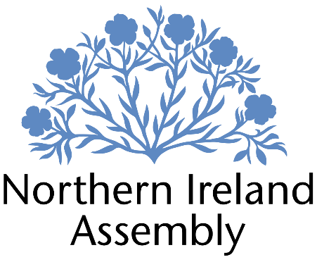

**Michelle Guy MLA**

*Alliance Party Member of the Northern Ireland Assembly for Lagan Valley Constituency*

**POLICY AND CONSTITUENCY MANAGER (PART-TIME)**

|  |  |
| --- | --- |
| Report to: | Michelle Guy MLA |
| Office Location: | Lagan Valley Constituency Office primarily, Parliament Buildings Stormont as required. |
| Hours: | Part-time (min 20hrs up to 30hrs) |
| Holidays: | As per determination |
| Salary: | £41,023 Salary Grade 3 pro-rata |
| Pension: | A central Assembly-approved pension scheme is provided. If enrolled an amount equivalent to 10% of employee’s salary will be paid into the pension scheme. |
| Duration: | Permanent.  Employment contingent upon member remaining an MLA or until legislation is introduced to change Constituency expense provision. Six-month probation period shall apply. |
| Closing Date | Noon, Friday 27th September |
| Interview dates: | It is anticipated that shortlisted candidates will be interviewed during week beginning 30th of September 2024 |

# JOB DESCRIPTION

This role requires an individual with a strong background in a policy role and demonstrable experience of managing people and constituency case work. They will be the key link within the constituency for the MLA and will be expected to scan for and identify local issues with a policy dimension and be comfortable with tasks such as drafting and tabling Assembly Questions on behalf of the MLA, will have the background to quickly determine which internal and external stakeholders to engage with to progress matters effectively and have the right experience and skills to adapt their personal communication style to deal with senior officials and constituents.

**Policy**

* Reading and scrutinising consultations, legislation and government decisions at a local and regional level to assist with progressing and resolving complex casework for Michelle Guy MLA
* Able to identify opportunities to develop relevant policy or legislation as appropriate interventions to further the work of Michelle Guy MLA
* Take the lead on producing robust and informed responses to policy consultations.
* Can use policy and legislation effectively to produce evidenced based responses to complex planning cases and other complex cases work
* Can build relationships with key stakeholder and lead on high level meetings on behalf of the MLA as appropriate
* Provide policy proposals that align to manifesto
* Monitoring the business of the Assembly and Committees, and providing detailed briefings for the Member
* Responding to correspondence and enquiries from constituents, media, lobbyists, businesses and community groups in line with the Member’s requirements
* Maintaining up to date knowledge of relevant legislation, policy and wider political and industry developments

**Constituency**

* This role will be based mostly at Michelle Guy’s constituency office in Lagan Valley. The Policy and Constituency Manager will allocate casework to the team as appropriate to ensure a first-class service
* The Policy and Constituency Manager will establish appropriate systems to manage casework, policy priorities and office resources for the MLA
* The postholder will have a key role in team building for Michelle Guy both in the office and with appropriate stakeholders in the Lagan Valley constituency
* The Policy and Constituency Manager will ensure that Constituency Office staff log, progress and monitor casework to ensure all identified actions are taken and comply with GDPR and data management. They will also be expected to contribute to casework as appropriate to meet demands
* They will be responsible for overseeing the management of office equipment, resources and operational expenses as per NI Assembly Determination rules
* Attending work related training and networking meeting to develop skills
* Other duties as required in support of the MLA carrying out their Assembly duties

**PERSON SPECIFICATION**

|  |  |  |
| --- | --- | --- |
|  | **Essential Criteria** | **Desirable Criteria** |
| **Professional / Technical Qualifications** | * Five GCSE’s / O’ Levels or equivalent at Grade C or above including both English Language and Mathematics * Degree in Law or Masters Degree * Proficiency in the use of Microsoft Outlook, Word and Excel packages | * ICT Qualification |
| **Experience / Job Knowledge** | * Minimum five years’ experience in a policy role * Experience of drafting and or responding to public consultations with an understanding of relevant impact assessments and human rights standards. * Knowledge of policy related to education, children and young people. * Experience of handling complex casework queries that involve multiple stakeholders * Understanding of legislation and can apply to casework or provide analysis of new legislation for the MLA * Proficiency using key social media platforms such as Facebook, Instagram and X (Twitter). * Knowledge of Northern Ireland political scene * Experience of managing a team to achieve objectives. * Experience of setting up and maintaining database systems. | * Knowledge of the workings of the Northern Ireland Assembly * Experience of dealing with sensitive and confidential information (both verbal and written) in line with the Data Protection Actand GDPR * Experience of using casework or similar software package. * Knowledge of planning policy in the Lagan Valley area. |
| **Personal Qualities /**  **Skills** | * Flexible and professional approach to work. * Excellent written communication skills. * Excellent verbal communication skills in person and on the phone with capacity to adapt techniques in differing contexts * Experience if developing and delivering presentations to stakeholders. * Ability to engage with members of the public, sometimes in challenging circumstances * Understanding of Alliance Party objectives | * Ability to work as part of a small team * Good time management * Ability to multi task |
| **Circumstances** | * This is a part-time position with a minimum of 20 hours, maximum of 30 hours. * Able to work unsupervised and as lone worker in office or at home when required | * May be required to travel to meetings |

Applicants must demonstrate clearly on their application form how they meet the criteria.