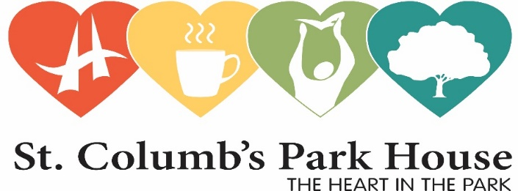

**INFORMATION PACK FOR CANDIDATES FOR THE**

**POST OF PROJECT WORKER**

**COMMUNITIES COMING TOGETHER PROJECT**

Dear Applicant,

Please find enclosed an application pack for the post of **Project Worker**, which contains the following items:

Section 1: Job Description

Section 2: Personnel Specification

Section 3: Application Form

Section 4: Monitoring Form

**PLEASE READ THE FOLLOWING INFORMATION CAREFULLY**

Our application pack contains information about the job vacancy and the person required. You should read these carefully to ensure that the job and conditions are suitable.

1. You must complete the application form accurately and return it by email by the date and time below.

**2. It is your responsibility to ensure that sufficient information and examples, demonstrating your experience are provided to enable a short-listing panel to assess your suitability for this post.**

3.. Applications, and attached sheets:

* Applications must be completed legibly and returned by email to [sharon@stcolumbsparkhouse.org](mailto:sharon@stcolumbsparkhouse.org) on or before **30th September 2024.**
* Applications received after this deadline will not be considered.
* Only information provided on the application form will be considered by the Short-listing panel **– CVs** **will not** be considered.
* Attached sheets will only be considered where they are continuation sheet of a section of the application form where insufficient room was available to include all the necessary details. However, candidates should aim to be concise in completing the application form.

4. It is the responsibility of the applicant to ensure that **the application form**  is fully and clearly completed and returned. Your Equal Opportunities Monitoring form must also be completed and returned

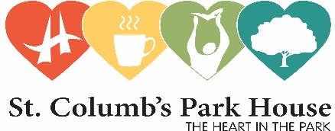

**Title:** Project Worker

(1 to be based at Tullyally Community Partnership and 1 based with Currynierin Community Association

**Project:** Communities Working Together (Peace Impact programme)

**Reports to:** Managing Director

**Salary range: £19000** 24hrs per week, fixed-term contract ending 31st July 2026

**Purpose and function of post:** Employed by St Columb’s Park House**,** the Project Worker will work closely with the Tullyally Community Partnership and Currynierin Community Association to design and deliver the Communities Working Together Programme in both areas.

**Duties and tasks:**

* To develop in consultation with the local community the programmes contained with the application.
* To establish a joint Safety Forum that includes the Community Associations and statutory bodies to improve the well-being and safety of local residents at the interface
* To develop each community centre as a Service Centre Hub to deliver a range of support services in partnership with statutory agencies, support service agencies
* To establish a sports based programme for young people aged 16+
* To support the delivery of a summer youth programme in partnership with YMCA and other statutory agencies
* To support the delivery of a capacity building programme for Women in both Communities
* To maintain appropriate monitoring records, and to assist external evaluation as well as document its progress
* To seek opportunities to disseminate information regarding good practice to other practitioners, funders, academics, etc.
* To report to the MD and funders on a regular basis.
* Any other reasonable duties as requested by the Director and relevant to the above post.



Person Specification

|  |  |
| --- | --- |
| **Essential** | |
| ***Work experience:***  ***Skills & Abilities:***  ***Other:***  **Desirable** | 2 years experience of working in a relevant field within community development in a paid or voluntary capacity.  GCSE English and Maths A-C grade.  Minimum of 1 year experience paid experience in a community development setting.    Knowledge of Tullyally and Currynierin and the wider Waterside area.  Availability to work flexible hours including Evenings and Weekends  Proven experience of working on community projects with a wide range of stakeholders.  Ability to work cooperatively and supportively with a range of agencies and support organisations  Ability to facilitate discussions around contentious issues relevant to conflict, diversity and sensitive personal development issues.  Strong organisational skills, prioritising workload.  Self-motivation; ability to work on own initiative.  Effective written and oral communication skills, eg. report-writing and presentation skills. Well organised and able to keep and manage records relating to the project.  Strong IT skills.  Ability to monitor project budget  Highly motivated creative self starter with the ability to work on own initiative, manage diverse activities and make decisions  Flexibility and ability to work unsociable hours, including weekends  Commitment to empowering and co-operative ways of working  Access to transport that will enable the post-holder to meet the requirements of the post in full.  Commitment to empowerment of all people regardless of class, gender, religion or race.  A Community Development Qualification at Level 3 or above  Experience of collaborative working with wide range of statutory and voluntary organizations and agencies  Proven track record of positive community engagement |

**The successful candidate will be expected to attend identified appropriate training and mentoring sessions designed to enhance personal skill levels in relation to understanding of Community Development process, programme planning, financial and staff management, fundraising, monitoring and evaluation and health and safety.**