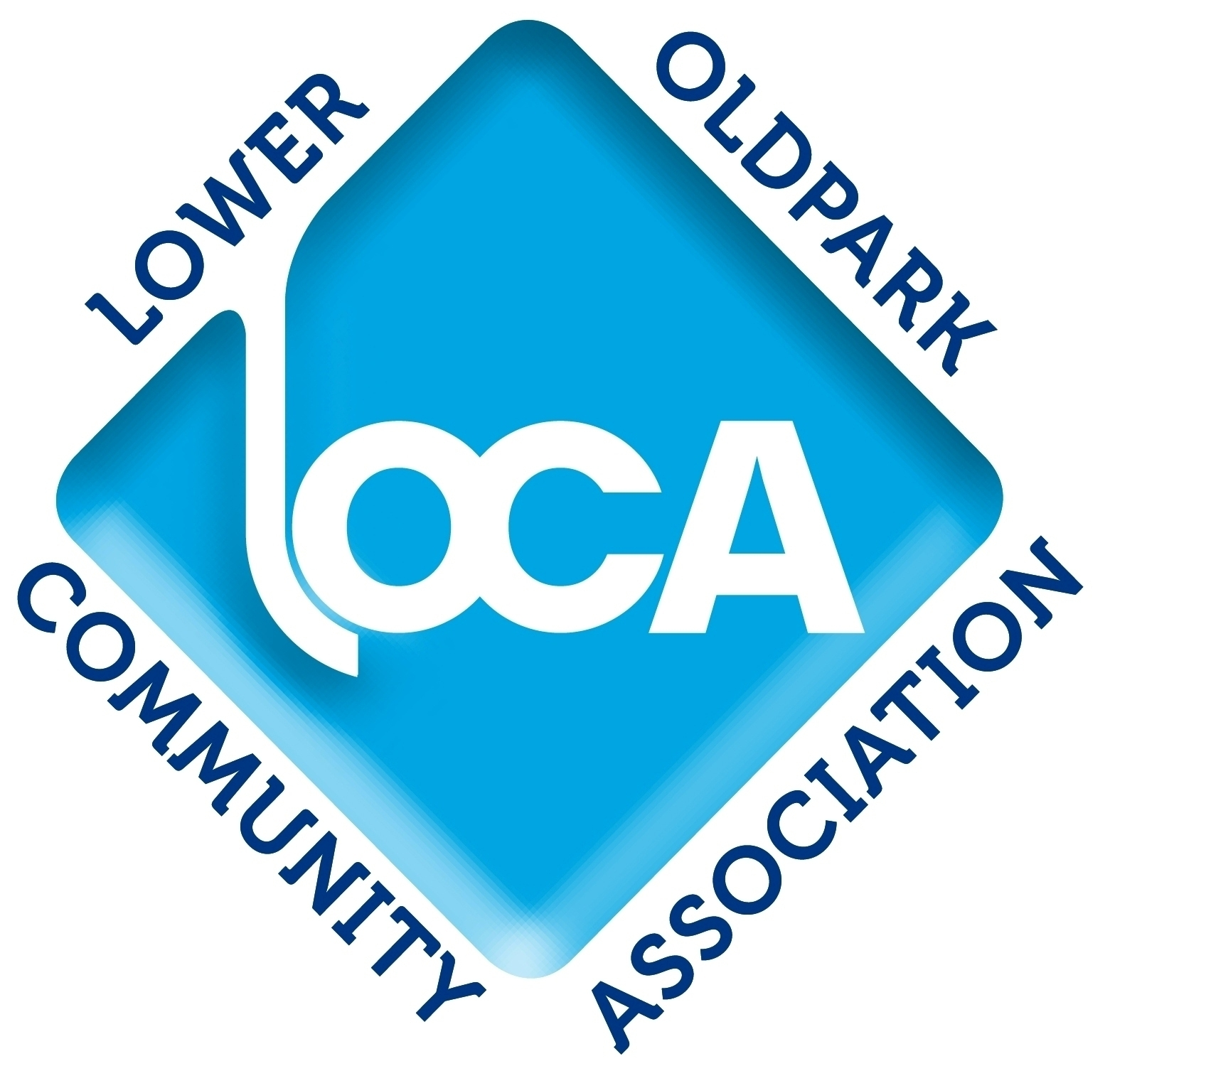

LOWER OLDPARK COMMUNITY ASSOCIATION

APPLICATION FORM

Closing date for applications is 12 Noon on Monday 23rd September 2024.
Interviews will take place on the afternoons of Thursday 26th September 2024.

Post: Housing & Regeneration Worker

Please complete this Application Form in detail and ensure that the required information is provided. Please complete this form in your own handwriting in black ink or in type.

PERSONAL DETAILS

Surname ________________________________________

First Names(s) ____________________________________________

Home Address ________________________________________

___________________________________________

Postcode ________________________________________

Home Tel No ________________________________________

Mobile No ________________________________________

Email Address ________________________________________

National
Insurance No ________________________________________

Employment History:

Detail your work history, starting from the most recent post held, including employers’ names and addresses, commencement and leaving dates, posts held, the main duties and responsibilities in those posts, and reasons for leaving.

Employers’ Name & Address | Dates | Position Held | Duties | Reason For Leaving

QUALIFICATIONS

Demonstrate that you meet the essential requirement of:

- A degree or professional qualification in Housing.
Or
- 5 years relevant experience in working in housing or housing-related field.

SKILLS AND EXPERIENCES

- Describe your knowledge and experience of social and affordable housing, housing regeneration, environmental issues and improvements, and partnership working with the statutory organisations and local stakeholders involved in these fields.

- Describe your knowledge and experience of communities and neighbourhoods characterised by high levels of social and economic deprivation.

- Demonstrate your ability and experience of producing work in written form to a high standard of literacy, clarity and effectiveness.

- Demonstrate your skill and experience of supporting people in need, through listening, identifying problems and pointing to possible solutions.

- Demonstrate your ability and experience of prioritising tasks and working effectively on your own initiative without constant supervision and direction.

- Provide any other relevant information that may indicate your suitability for this post.

DISABILITY

Do you consider yourself to have a disability? YES/NO

If yes, is there anything we need to know about your disability in order to ensure you have equality of opportunity.

________________________________________________________________

________________________________________________________________

_______________________________________________________________

REFERENCES

Please provide the names of two referees who can supply direct information on your experience, work record and ability to carry out the duties of this post.
References will only be taken up with your permission if you are offered the position.

Name:  Organisation  Position:  Address:  Phone Number:  E-mail Address: | Name:  Organisation  Position:  Address:  Phone Number:  E-mail Address:

PERSONAL DECLARATION

- I declare that all the foregoing statements are true, complete and accurate.

- I understand that if I give wrong information or leave out important information I could be dismissed if I take up this job.

- I understand that to take up this job I must provide satisfactory references.

- I understand that I will be asked to show formal identification and evidence of qualifications if invited for interview.

- I confirm that, as far as I know, there are no medical or other reasons which would prevent me from carrying out the duties of this post.

- I consent to LOCA making any necessary and relevant enquiries during the recruitment and selection process.

- I understand that canvassing will disqualify me from the selection process for this post.

Signed___________________________________________

This application form is to be returned to:

Manager
Lower Oldpark Community Association
9-23 Avoca Street
Belfast BT14 6EN

The closing date for applications is 12 Noon on
Monday 23rd September 2024

Interviews will take place on the afternoons of
Thursday 26th September 2024

FAIR EMPLOYMENT (NORTHERN IRELAND) ACT 1989

In accordance with the above legislation Lower Oldpark Community Association require applications to provide information for monitoring purposes.

Lower Oldpark Community Association is committed to equality of opportunity based solely on the merit principle. This means selecting the best person for the job without regard to sex, marital status, religious belief, political opinion or disability.

