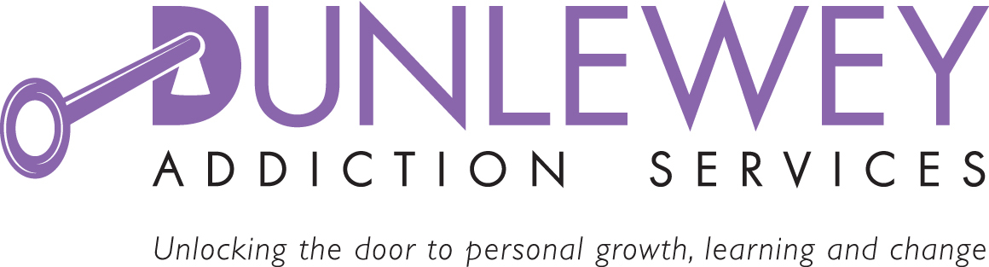

JOB DESCRIPTION

Job Title: Counsellor.

Reporting To: Gambling Services Coordinator

Location: Portadown

Grade / Salary: £26421

Hours: 37.5 hours

Role Purpose:

Main Purpose
Dunlewey Gambling Service provides counselling and other services to individuals experiencing issues with problem gambling Ireland wide.

The Counsellor will work with the Coordinator to provide a high-quality counselling service for individuals experiencing problem gambling issues and concerned family members

MAIN DUTIES:

Provide comprehensive assessment, care plans, cognitive therapy, structured counselling, coaching, enhanced brief interventions, structured family work and self help programmes for individuals experiencing problem gambling issues and concerned family members

Create and provide literature and support materials to promote the service across Ireland

To liaise with other agencies to promote joint working, including a common assessment form, risk assessment and referral protocols.

To liaise with appropriate external agencies and organisations as appropriate

Maintain full accurate records of all service activity in line with service specification.

To ensure all data collected and kept compiles with GDPR

Ensure service users are involved in the design and delivery of materials and services.
Establish strong links with local communities and related services to maximise benefit to individual and their family.

Ensure services are delivered in premises that are safe, respectful and accessible, physically and with regard to appointment times for individuals and families.
Attend all agreed monthly meetings, supervision, forums, and training as prescribed for project staff.

Any other duties deemed reasonable for the post

PERSONNEL SPECIFICATION

Criteria |  | Essential | Desirable
Qualifications | A Counselling Diploma from a recognised awarding body | √
 | Accreditation with a professional body or a time framed action plan | √
 | Accreditation with a professional body or a time framed action plan | √
Knowledge and Experience | Practical experience of working as a counsellor within the field of addiction. | √
 | Experience of working as part of a multi-disciplinary team |  | √
 | Experiencing of working with groups |  | √
 | Practical experience in delivery of health/wellbeing programmes |  | √
 | Possess excellent verbal, written communication skills. | √
 | Possess excellent interpersonal and organisational skills | √
 | Ability to engage and motivate individuals in therapeutic programmes | √
 | Proficient in the use of a variety of IT packages | √
 | Experience of report writing, maintaining records and providing accurate timely written reports on caseload. | √
 | Possession of clean valid driving licence and access to a form of transport to enable you to meet the requirements of the post | √

