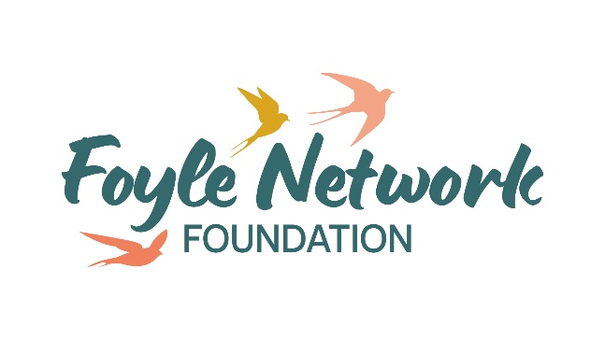
Fundraising Officer
JOB DESCRIPTION & PERSONNEL SPECIFICATION

Job Description

Job Title: Fundraising Officer

Responsible To: Director

Based at: Unit 15 Springtown Industrial Estate

Hours of Duty: 35 hrs Per Week

Contract: 2-year funded post

Salary: £35,754 NJC Scale P01 point 27 gross per annum

Foyle Network Foundation formerly Foyle Foodbank and a member of the Trussell Trust.
Role outline and purpose
This is an exciting opportunity to help Foyle Network Foundation realise it’s vision and ambition of bringing about the end to the need for foodbanks by working collaboratively with a wide range of stakeholders.
Through this new organisational role, you will proactively create and grow fundraising income opportunities with individuals, community groups and grant giving trusts and foundations. You will be at the heart of our local community, bringing our cause to life and building lasting donor relationships.
Through your fundraising expertise, you will have a proven track record of building relationships with individuals, community groups, trusts and foundations and other donors to achieve and exceed annual income targets and key performance indicators. You will have the capacity to create and craft compelling proposals and appeals that successfully engage and attract donations from new and existing supporters.

Key Responsibilities:
- Develop a Fundraising Strategy, identifying and contributing specifically to sustainable and ambitious growth in line with the charity’s financial ambitions and strategic objectives.
- Conduct effective annual planning and budgeting in close collaboration with colleagues from across the organisation, setting, measuring, and reporting against an agreed budget, KPIs and objectives.
- Through the design and delivery of excellent, engaging and regular stewardship communications and powerful fundraising appeals, grow our income and pool of individual supporters making one off or monthly donations. Explore and implement ways of promoting Foyle Network Foundation across the community to successfully attract an ever-greater number of individual donors.

- Engage with local community groups, associations, events, schools and businesses to grow Foyle Network Foundation community fundraising reach and income. Increase cash and gift-in-kind income.

- Through excellent, comprehensive and considered research, identify and prioritise a pool of potential Trusts and Foundations funders for Foyle Network Foundation and, work with colleagues to develop authentic, compelling, creative and winning funding bids that can successfully engage new and existing Trusts and Foundations funders.

- Develop, monitor and manage a fundraising portfolio. Establish a fundraising pipeline that can be tracked and that will enable informed projections regarding future income.

- Forge strong relationships with colleagues across the wider Trussell Trust network, sharing best practice and learning from other charities across the network. You will proactively take advantage of any fundraising training and skills development opportunities and engage with any joint fundraising opportunities.

Skills
- Experience of corporate partner fundraising and a proven track record of securing funding from Trusts, Foundations and others.
- Experience of individual giving and community fundraising
- Experience of setting, managing and reporting.
- Excellent written and verbal communication and relationship management skills, you will inspire and motivate existing and prospective supporters, providing excellent stewardship and crafting compelling and winning funding proposals and appeals.
- Experience of working with, supporting and overseeing external consultants.
- Organised, proactive, and a self-starter who can self-motivate.
- Able to demonstrate empathy for people from disadvantaged, marginalised or socially-excluded backgrounds.

Other
- To observe strictly the policy and principle of confidentiality.

- To create and maintain good working relations with staff, volunteers, board of trustees, Trussell Trust and stakeholders.

- To take part and access relevant ongoing training.

- To carry out any other reasonable duties required by the Director.

Key Stakeholders
- Director, staff and volunteers.
- Fundraising department at Trussell Trust.
- NICVA, funding bodies, trusts and foundations.
- Businesses and donors.

What we offer
- 25 days annual leave + 12 bank holidays
- 6% Employers Contribution Pension

This job description will be subject to review in the light of changing circumstances and may include any other duties and responsibilities as may be determined in consultation with the jobholder. It is not intended to be rigid or inflexible but should be regarded as providing guidelines within which the individual works.

PERSONNEL SPECIFICATION
Post: Fundraising Officer

Location: Foyle Network Foundation, Unit 15 Springtown Ind Estate

Factors | Essential | Desirable
QUALIFICATIONS  AND/OR  EXPERIENCE | A Degree or equivalent and 2 years’ experience in a Fundraising role  A proven track record of strategic fundraising.  Experience of developing strategies to build new relationships and increasing income.  Excellent communicator, passionate about our work and able to represent at the highest levels.  Good project management skills, able to balance a range of priorities. | Understanding of the rules, regulations and best practices across fundraising.  Demonstrate a commitment to the values of the Trussell Trust and Foyle Network Foundation.
KNOWLEDGE OF | Excellent understanding of fundraising or sales and marketing strategies to drive income/revenue.  Budgeting  Creative and innovative solutions and digital marketing. | Knowledge of Foyle Network Foundation and Trussell Trust’s vision, aims and objectives.
SPECIAL APTITUDES | Excellent communication skills verbal and written  Excellent organisation and time management skills  Excellent interpersonal skills  Passionate about tackling poverty  Ability to work independently and unsupervised
SPECIAL  CIRCUMSTANCES | Current full driving licence and access to a car OR can demonstrate mobility to carry out the functions of the job  Can work flexible hours.

Application Process and Resources
We only accept applications through our application form.

Closing date: Thursday 26th September 2024 at 12noon

Applications forms to be returned to Seanan by email seananwalker@foyle.foodbank.org.uk

If you are shortlisted for interview, we will be in touch soon after the closing date.
We will request as part of the interview that you bring along an example of your most recent fundraising activities.

More information on our work and services can be found at:

https://foyle.foodbank.org.uk/

https://www.trusselltrust.org/

