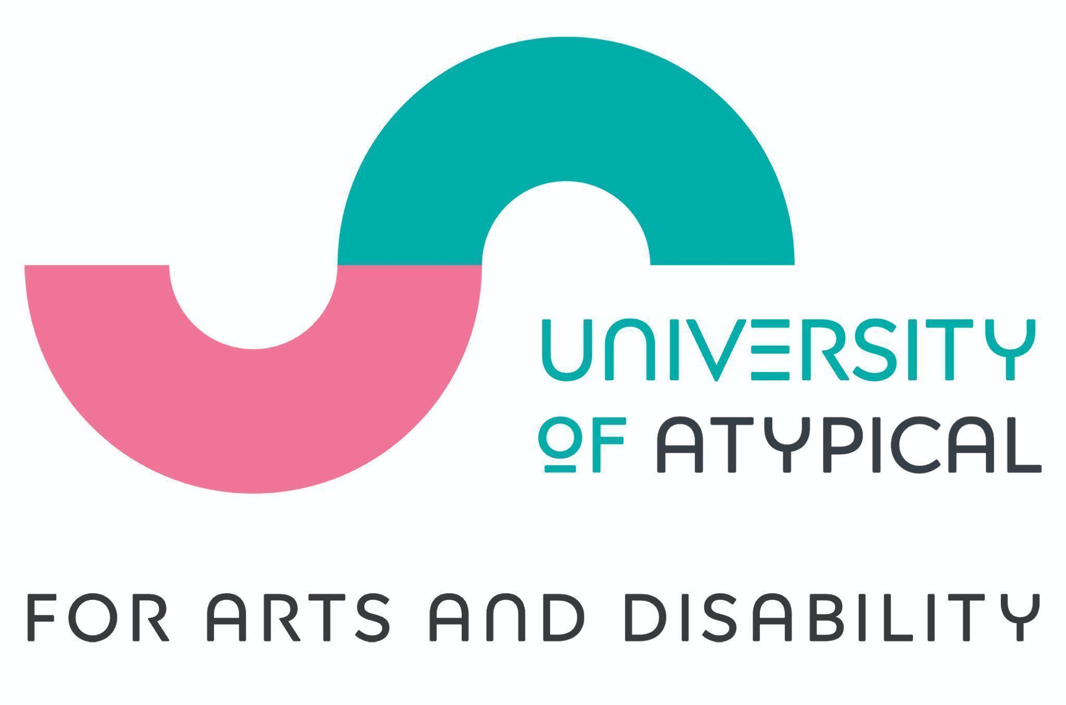

September 2024

Dear Applicant,

Thank you for your interest in the role of Freelance Access Advisor with University of Atypical for Arts and Disability. I am delighted to be offering 6 freelance Access Advisor positions to support our Arts and Disability Access Awards programme funded by the Paul Hamlyn Foundation.

We are seeking 6 exceptional people to work with us in a sustained freelance capacity for at least one year. The roles may continue beyond that time subject to funding and contract renewal. We particularly are seeking to identify advisors who identify as d/Deaf, disabled or neurodivergent. We will support and train the advisors to support the access and inclusion development of regional arts and cultural sector organisations.

If you are passionate about the arts, the disability sector, and want to contribute your skills to making a real difference, then I want to hear from you.

Sincerely

Edel Murphy - CEO and Artistic Director

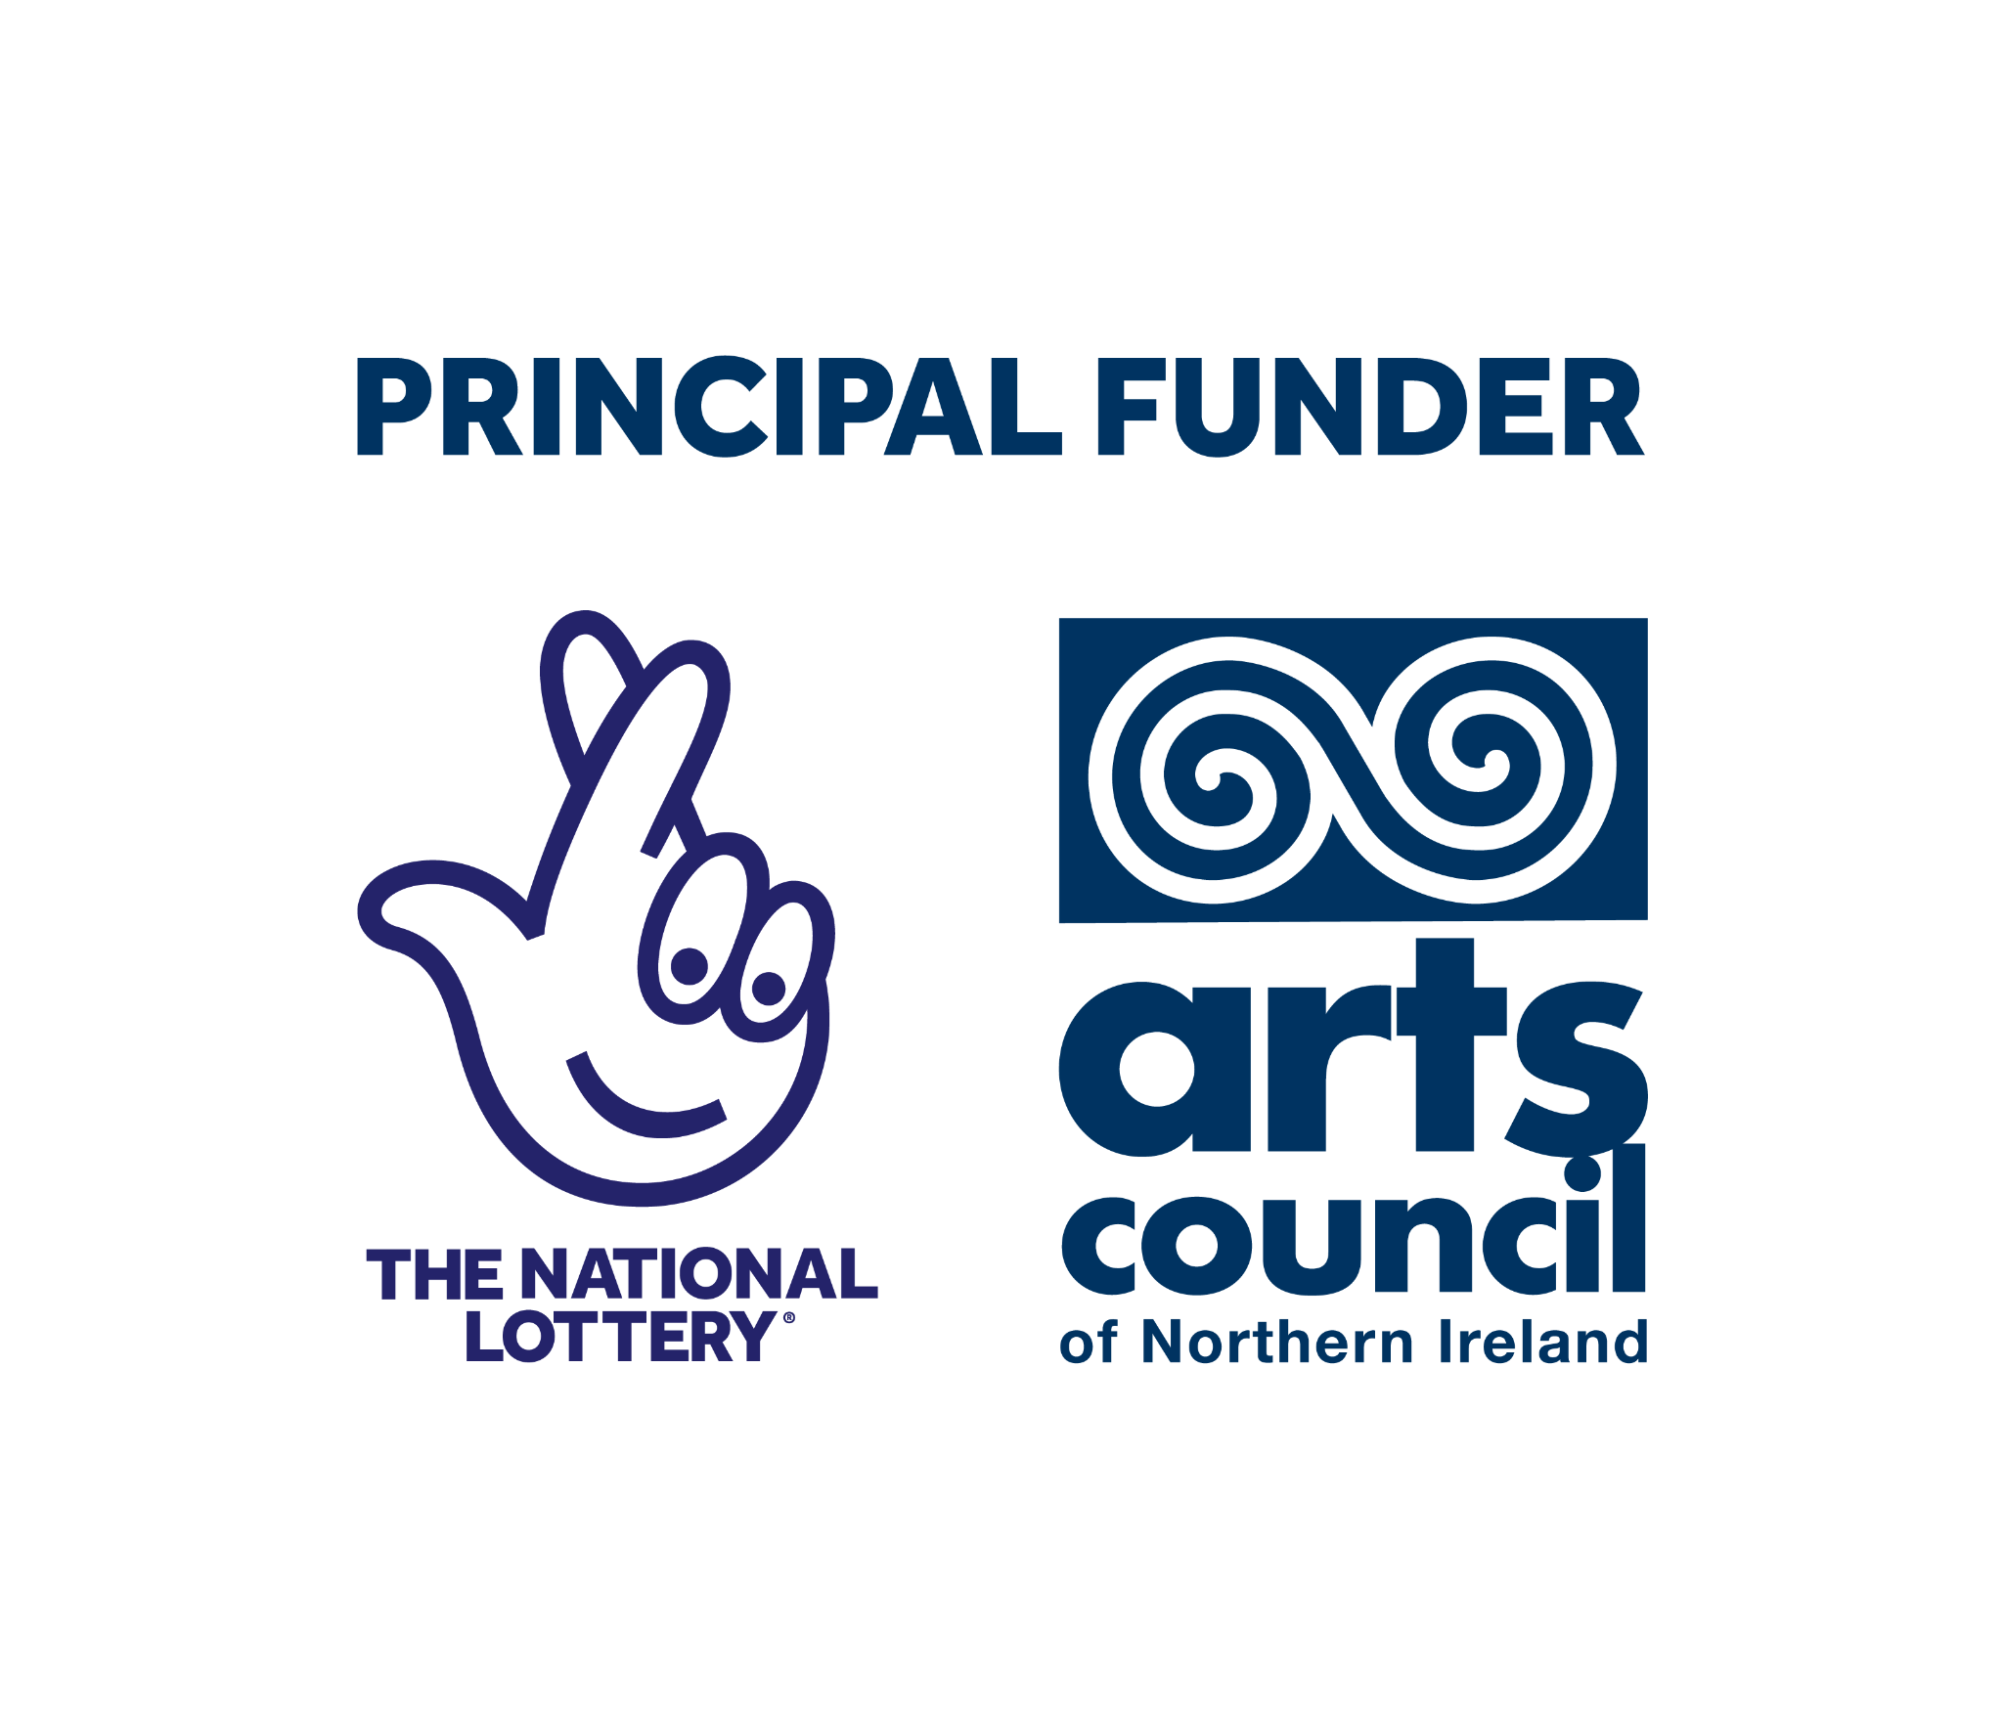

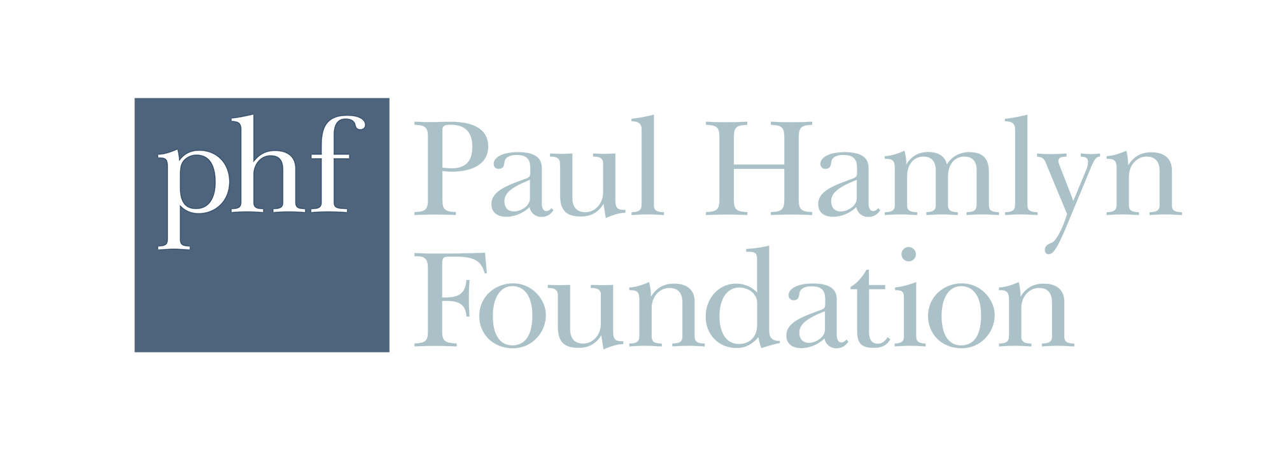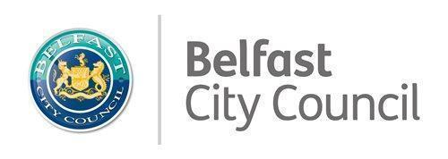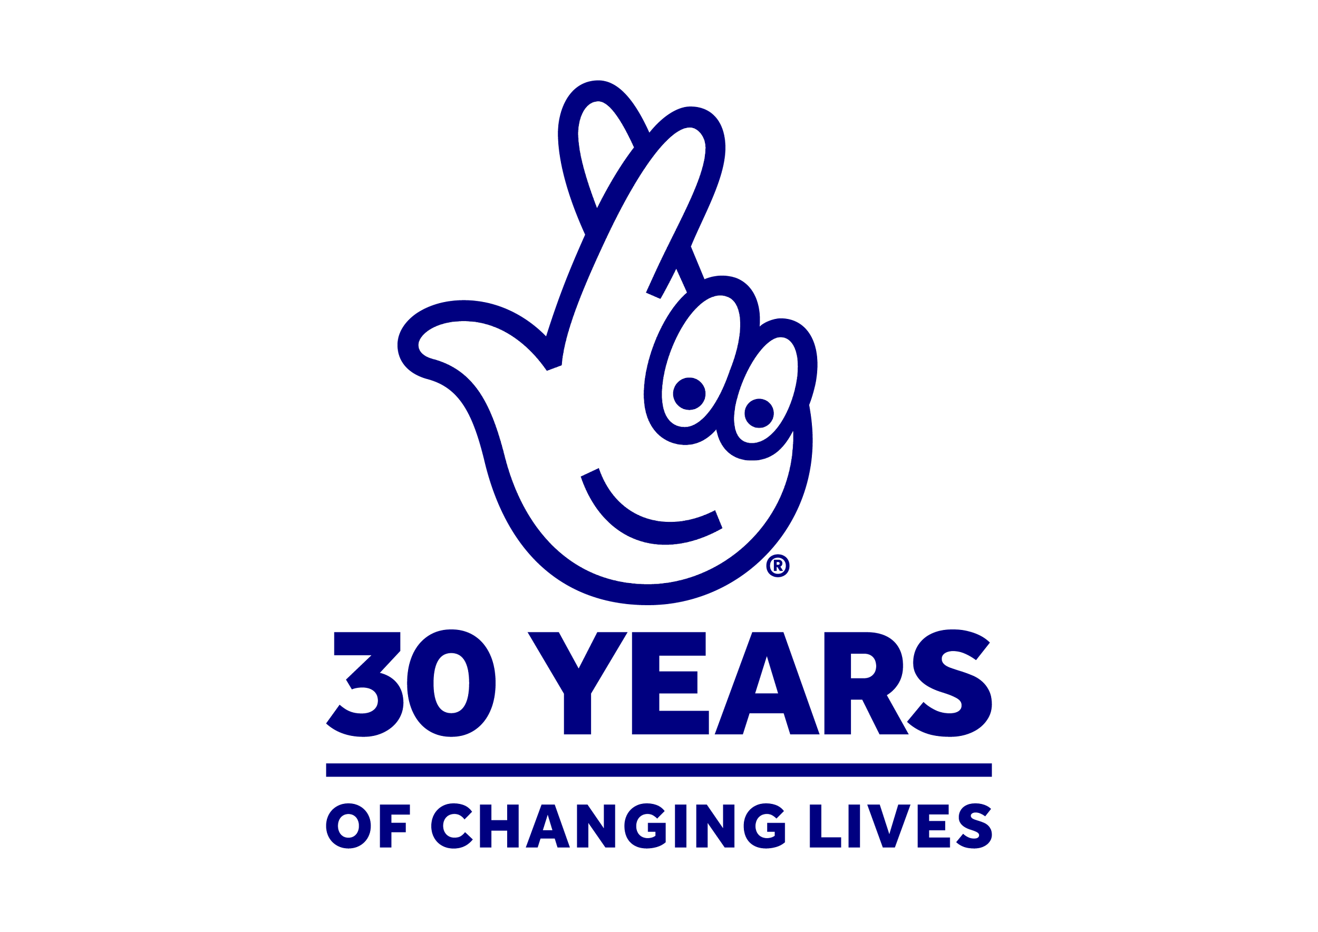



**University of Atypical for Arts and Disability**

[**universityofatypical.org**](http://www.universityofatypical.org)

Recruitment Pack for six Access Advisor positions

Remuneration: £15 per hour on a freelance contract. Estimated hours per week will fluctuate, but the estimated commitment is between 16 and 21 hours per month.

This is a freelance position that is home based. There is some requirement to travel. Agreed travel expenses will be paid.

Training days will be part of the contract, and will be paid.

**This is a 12 month role* funded by the Paul Hamlyn Foundation**

(*subject to contract renewal on a yearly basis)

# Apply for this role

* We can provide the application in other formats, including Braille.
* Application deadline: 4:00 pm on **Thursday 24 October 2024**.
* It is anticipated that interviews will take place on **Monday 4 November 2024**. Applicants should keep this date open as they may be invited to interview.
* It is required that the successful applicants will take up the role within 4 weeks of the offer.
* Commencement in the role and a commitment to the Advisor induction and training programme in December and January is a requirement of the role and all applicants who apply should take note of the training days.

# About Us

**University of Atypical for Arts and Disability** (UofA) was established in 1993 and is now the leading sectoral organisation on arts and disability in Northern Ireland.

UofA takes an empowerment-based approach towards d/Deaf, disabled and neurodivergent people’s involvement in the arts as audience members and as creative practitioners. UofA specialises in developing and promoting the work of d/Deaf, disabled and neurodivergent artists and in doing so engages with d/Deaf, disabled and neurodiverse audiences in a direct and meaningful way.

We aim to increase opportunities for d/Deaf, disabled and neurodivergent people to engage with the arts, working on a pan-disability basis providing participative and networking opportunities; exhibitions; the Bounce Arts Festival; the Ledger Studio arts and performance space; training; and other sectoral developments in equality, access and inclusion.

## Our Purpose:

We want to improve the creative lives of d/Deaf, disabled, and neurodivergent people and help them access the arts.

## Our Vision:

We want a society where everyone can positively explore and express their creativity, curiosity and talents through the arts.

## Our Values:

The following values underpin every aspect of UofA’s culture and activities:

* **Inclusion** - we believe that a healthy and stable society needs to be built by all its people working together. We will be open to those of all abilities and disabilities and celebrate the diversity of the society in which we live. UofA operates under the social model of disability which says that people are disabled by barriers in society, not by their impairment or difference. We will oppose injustice and anything that excludes or marginalises d/Deaf, disabled and neurodivergent people and others who are considered to be different.
* **Disabled-led** - UofA is driven by d/Deaf, disabled and neurodivergent artists who understand the needs, rights and aspirations of other d/Deaf, disabled and neurodivergent artists and acts as an independent voice.
* **Parity** - everyone has an equal right to be treated with dignity and respect, to learn and develop, to access the arts in all its forms and to have their voice heard.
* **Human Rights** - we believe that everyone has inalienable human rights which should be upheld. In particular, we support the UN’s Convention on the Rights of Persons with Disabilities and will work to promote and defend these rights.
* **Excellence** - everyone has the right to expect that all aspects of UofA’s work are carried out to the highest standard. UofA will also support artists to work towards achieving the highest artistic standards.
* **Collaboration** - we believe the organisation is much more effective when working in partnership with its key stakeholders. We value meaningful collaboration and partnership working.

# What We Do

## UofA has a lead sectoral role in Northern Ireland for:

* Enhancing the experience d/Deaf, disabled and neurodivergent people have of the arts
* Promoting work produced by d/Deaf, disabled and neurodivergent artists
* Elevating the public’s experience of art created or presented by d/Deaf, disabled and neurodivergent artists
* Improving arts organisations’ understanding of access requirements of d/Deaf, disabled and neurodivergent people
* Showcasing excellence in art created by d/Deaf, disabled and neurodivergent artists

## UofA delivers a year-round programme including:

* Atypical Gallery programme of visual arts and crafts exhibitions and events
* The Ledger Studio programme of training, workshops, rehearsals and performances
* Partnership work with mainstream arts and Arts & Disability organisations, festivals and creatives
* The Arts & Disability Access Awards (ADAA, formerly Equality and Access Standards Initiative), supporting arts and cultural venues and organisations to commit to enhancing access to venues and programming with input from d/Deaf, disabled and neurodivergent people
* Sectoral training programme including Disability Awareness; Neurodiversity Awareness; Equality, Access and Inclusion Training; and Sign Language courses
* The annual d/Deaf and Disabled Artists Support Fund (DDASF) scheme for artists who are d/Deaf, disabled, or neurodivergent, managed on behalf of the Arts Council of Northern Ireland
* Bounce Arts Festival, showcasing the best creative practice of work created by local, national and international d/Deaf, disabled and neurodivergent artists

## Key communities UofA works with:

* Professional and emerging artists, across all art form areas, who identify as d/Deaf, disabled or neurodivergent
* Arts sector and community organisations who engage and seek to engage artists and audiences who are d/Deaf, disabled or neurodivergent
* Professionals in disability support including translators, audio describers and professional support for disabled people
* People with lived experience of disability and neurodiversity, and the d/Deaf Community
* Professionals in administration, policy, or the provision of services for people or communities who are d/Deaf, disabled, or neurodivergent

# Organisational Context of the Role

**The Arts and Disability Access Awards (ADAA)** programme was developed in response to the growing awareness and demand from arts and cultural organisations in Northern Ireland to be more accessible and inclusive to d/Deaf, disabled and neurodivergent people. ADAA has been designed to raise access standards across organisational processes, facilities and programmes in arts, cultural and heritage organisations across Northern Ireland.

1 in 5 of the population in Northern Ireland is disabled. Section 75 of the Northern Ireland Act 1998 requires public authorities to have ‘due regard’ in consideration of their obligations to the need to promote equality of opportunity in relation to nine equality categories, one of which is d/Deaf and disabled people.

ADAA will offer a programme of training, awareness, assessment and recognition of improvement to organisations.It will empower them to address the needs of d/Deaf, disabled and neurodivergent (DDN) people, and to make their organisations more accessible to everyone. It will address ways in which organisations and venues can adapt their processes and programmes to optimise accessibility for employees, staff and audiences.

The ADAA scheme will identify barriers and provide best practice solutions, and guide organisations and venues through a process of awareness raising, training, change and sustained improvement in DDN access across their processes and facilities. It is anticipated that the venues will increase the numbers and quality of experience for the disabled community, their carers, family members and friends.

UofA has recruited an Access and Inclusion Manager to manage ADAA. A team of disabled-led Access Advisors will be recruited and paired with regional organisations to support the organisations through an Improvement Implementation plan.

UofA emphasises the importance of disabled-led approach because:

* DDN trainers bring a real and practical insight into the barriers and solutions
* It creates opportunities for disabled people as consultees and creative practitioners
* The trainers will be an important resource for organisations on an ongoing consultative basis

Over the three years we aim to engage 20 organisations or venues in the ADAA continuous improvement based process. Organisations or venues that take part will achieve an Inclusion Mark Standard, recognising their participation in the process.

The Access Advisors will work closely with the Access and Inclusion Manager to support organisations to:

* Meet their legal obligations associated with DDN accessibility
* Increase staff knowledge and awareness about how to identify barriers to access for DDN people through their processes and practices
* Improve positive engagement and good relations with DDN stakeholders across their organisation
* Increase opportunity to access funding available to organisations to support the action plans that meet best practice access standards and engagement with DDN groups

This is an exciting opportunity to help contribute to and shape programmes for the d/Deaf, disabled and neurodivergent arts community.

**Reporting to: Jonathan Mitchell,** Access and Inclusion Manager at University of Atypical for Arts and Disability.

**Remuneration**: £15 per hour, freelance contract; estimated hours per week will fluctuate but estimated commitment of between 16 and 21 hours per month.

This is a freelance position that is home-based. There is some requirement to travel. Agreed travel expenses will be paid. Compulsory training days will be part of the contract and will be paid.

**Hours**: You are expected to work hours between Monday and Friday, in line with organisations that you will be working with. You will also be expected to do some weekend and evening work. 16 - 21 hours per month is anticipated. These monthly hours may vary according to programme needs. There is flexibility for the freelancer to manage their own time in line with the programme needs. There is some requirement for compulsory attendance at training.

**Post duration**: This is a 12 month freelance contract commencing in December 2024. The role may be extended beyond November 2025 subject to mutual agreement and funding security.

**Location**: Home working with travel to regional locations to meet with organisations you are paired with.

**Job Summary**: University for Atypical for Arts and Disability is looking to appoint six Freelance Access Advisors based in Northern Ireland to support our regional sectoral support programme ADAA (Arts and Disability Access Awards).

# Key Responsibilities:

Completion of set training days and attendance at agreed support and supervision meetings is compulsory for the continuation of the contract.

Advisor work to be carried out between December 2024 and November 2025* (subject to organisational need). As each Advisor will have a unique timetable in supporting their partnering organisation some organisations may complete earlier than others.

Please note that, as part of the contract, the selected candidates must be available to work approximately 2 days or 16 hours each month on this programme.

## Compulsory training and induction days:

1. Wednesday 11 December: 11:00 am - 3:00 pm (in person - Belfast)
2. Friday 13 December: 11:00 am - 3.00 pm (online)
3. Wednesday 8 January: 11:00 am - 3.00 pm (online)
4. Friday 10 January: 11:00 am - 3.00 pm (online)
5. Wednesday 15 January: 11:00 am - 3.00 pm (online)

## Support and supervision:

From February - November 2025, we have provisionally timetabled an online meeting for Access Advisors. This will be on the first Thursday of each month from 11:00 am - 1:00 pm.

## Advisor work with organisations:

Each Advisor will be paired with between 1 and 3 organisations. It is estimated that the Advisor will meet their paired organisation once a month. The Advisor and the Access and Inclusion Manager will agree a schedule with the organisation. Some of these meetings will need to be in-person. Some meetings can be arranged online.

The Advisor will have some reporting to do. This reporting can be done remotely and online.

### 

# Job Responsibilities:

* Carry out bespoke 1 to 1 consultations with supported organisations, providing advice, guidance and tailored recommendations for embedding access into their organisational practice.
* Attend and contribute to programmes of training for supported organisations as required.
* Plan and deliver Improvement Implementation plans with partnering organisations towards increasing good practice and access and inclusion provision within the organisation.
* Support the partnering organisation in identifying access initiatives with a long-term impact and provide recommendations for future activity.
* Report back regularly to University of Atypical on partnering organisations’ progress within agreed formats and timeframes.
* Act as an ambassador for University of Atypical for Arts and Disability.

# Person Specification:

| **Essential Criteria** | Knowledge:   1. Knowledge of, and commitment to, access, accessibility and inclusion 2. An understanding of and adherence to the Social Model of Disability 3. A good understanding of their local arts sector   Experience:   1. Direct lived experience of d/Deaf culture, disability or the neurodivergent community 2. Experience of working in creative programmes   Skills:   1. Ability to work independently 2. Good ability to use online forums for communication and reporting including Zoom, Teams, Google Meet, Email, Google Docs and Google Forms 3. Good interpersonal skills 4. Ability to problem solve, and to think creatively about solutions 5. Excellent communication skills 6. Excellent time management and organisational skills   Location:  12 We are recruiting 6 Advisors regionally and welcome applications from individuals based in rural and urban areas. The nature of the role is that we hope to pair Advisors with organisations within their locality.  Please let us know about the area(s) in Northern Ireland in which you would like to work as an Access Advisor. We can not guarantee that we will be able to match you with your chosen area however we will endeavour to take this into account when pairing you with an organisation.  Other:  13. Access to computer and internet facilities  14. Ability to access transport to travel to partner organisations for meetings  15. Willingness to work flexible hours as required to accommodate some evenings and weekends - this will be as part of the advisor work/ training and communicated to you in advance |
| --- | --- |
| **Desirable Criteria** | 1. Awareness of and participation in disability rights, advocacy and campaigning 2. Experience of working directly with d/Deaf, disabled and neurodiverse volunteers, artists or participants 3. Experience of mentoring or facilitating training 4. Experience of Access and Inclusion measures, especially for arts events and workshops 5. Experience of working with other communities where barriers to participation exist 6. Ability to present information in various formats to others with different communication needs |

# 

# Terms and conditions of freelance agreement

* Contract subject to completion of induction and training, and regular check-ins with UofA.
* It is requested that Advisors give 1 month notice period required to terminate the contract by the freelancer.
* Applicants must be of suitable physical and mental health to be able to carry out the duties of the role as specified.
* Applicants will be responsible for their own UK tax arrangements and will not at any time be considered employees of UofA.
* Applicants may be required to provide proof of qualifications and experience.
* Applicants are advised that any false or omitted information may result in their application being rejected, or in dismissal or other disciplinary action if appointed in the role.

# How to apply:

* The online application form and the monitoring form are available to download from [our website](http://www.universityofatypical.org) or by contacting us by email to request a copy
* The application and monitoring form are available in Braille and Large print

1. Complete the application form and monitoring form
2. Submit the application form and monitoring form by email or by post on or before the closing date and time
3. Applications can be made using audio visual formats. For example, an applicant may submit their application using sign language recorded using an audio visual format
4. Email submissions should be sent to [administration@universityofatypical.org](mailto:administration@universityofatypical.org). Please put ***‘Freelance Access Advisor Application’*** in the subject line. If you do not receive confirmation that we have received your application, please contact us by phone on 02890 239450.
5. Postal applications are also accepted. If you choose this option, it is advised that you send by recorded delivery and address your envelope to:

***CONFIDENTIAL: Freelance Access Advisor Application****,* University of Atypical, Ground Floor, Cathedral Quarter Workspaces, 109-113 Royal Avenue, Belfast BT1 1FF

# Closing Date for Applications:

* Application deadline: **4:00 pm on Thursday 24 October 2024**
* No responsibility can be taken by UofA for applications not received by the closing date and time

# Interview:

* Successfully shortlisted candidates will be invited to an interview; we aim to give applicants 1 week notice of the interview
* It is anticipated interviews will take place on **Monday 4 November 2024** and applicants are asked to keep this date open as they may be invited to interview
* If invited for an interview you will be asked to attend up to an hour before your interview time. You will be provided with a task to complete and a preview of the questions that you will be asked in the interview. You will have an opportunity to prepare a response to the task and to read and think about your interview answers
* The interview will normally last between 45 minutes to 1 hour
* You will meet up to three people at the interview
* We will set the interview room out as an informal round-table space
* In line with the informal style we hope to create, please dress as you feel comfortable; formal clothing is not required
* If you have any questions or access requirements, please contact us at administration@universityofatypical.org.

# Equal Opportunities Employer

University of Atypical is an Equal Opportunities Employer. All eligible applicants will be considered without discrimination due to race, religion, sex, sexual orientation, gender identity, national origin, age or disability status.

# Accessibility

If you have any access requirements for the interview process, please let us know in a cover letter/email with your application.

**Legal status of company**

'University of Atypical for Arts and Disability' operates under the legal name of 'Arts and Disability Forum'. Registered office address is Ground Floor, 109-113 Royal Avenue, Belfast, Co Antrim, BT1 1FF. Company Registration Number is NI051776. Charity number 101588