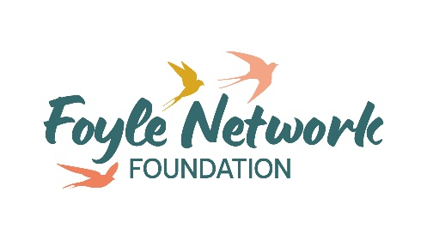
Community Development and Food Co-ordinator
JOB DESCRIPTION & PERSONNEL SPECIFICATION

Job Description

Job Title: Community Development and Food Co-ordinator

Responsible To: Director

Based at: Unit 15 Springtown Industrial Estate

Hours of Duty: 36 hrs Per Week (Including one late evening)

Contract: 1 year with extension depending on funding

Salary: £34,834 NJC SO 2 Point 26 Gross

The role will involve working with individuals experiencing poverty across Foyle.
Role outline and purpose
Lead and develop Foyle Network Foundations food and support services which include Foodbank, Community Supermarket and Affordable food project.
Responsibilities:
- To further develop Foyle Network Foundations longer term support services.

- To develop and deliver an affordable food model and a service in rural areas in partnership with local organisations.

- To oversee and manage Foyle Network Foundations food and household support packages alongside other key staff.

- Work alongside other staff to deliver a full package of wrap around support including identifying relevant partner organisations.

- To manage a team of volunteers, building and distributing leadership across the team to assist in the service delivery.

- To explore and understand the experiences that are bringing people to need food support, working with staff to identify further support services required.

- To build trusted relationships with clients.
- Reporting - To record and monitor all referrals and work carried out on Elemental. To provide a yearly outcome-based action plan of work. To provide reports to Director, Trustees and funders as and when required.

Other
- To observe strictly the policy and principle of confidentiality.

- To create and maintain good working relations with staff, volunteers, referral agents and stakeholders.

- To take part and access relevant ongoing training.

- To carry out any other reasonable duties required by the Director.

Key Stakeholders
- Foyle Network Foundation staff, volunteers, trustees and people we support.
- Trussell Trust, DFC, DCSDC
- Referral agents

What we offer
- 25 days annual leave + 12 bank holidays
- 6% Employers Contribution Pension

This job description will be subject to review in the light of changing circumstances and may include any other duties and responsibilities as may be determined in consultation with the jobholder. It is not intended to be rigid or inflexible but should be regarded as providing guidelines within which the individual works.

PERSONNEL SPECIFICATION

Post: Community Development and Food Co-ordinator

Factors | Essential | Desirable
QUALIFICATIONS  AND/OR  EXPERIENCE | A relevant degree and 2 years’ community development/project management experience in a community or client-based organisation  OR;  4 years’ project management experience including working with people in a community or client-based organisation  Experience managing and working with volunteers.  Experience of community outreach in the local area.  Good project management skills, able to balance a range of priorities. | Management experience working in a foodbank, social supermarket or pantry type project.  Demonstrate a commitment to the values of the Trussell Trust and Foyle Network Foundation.
KNOWLEDGE OF | The ability to establish strong partnerships with outside agencies through a range of possible options including building networks, partnerships and alliances.  Knowledge and experience of working with people experiencing poverty, from disadvantaged, marginalised, or socially excluded backgrounds. | Knowledge of Foyle Network Foundation and Trussell Trust’s aim, vision and mission.  Ability to design programmes and services.
SPECIAL APTITUDES | Excellent communication skills verbal and written  Excellent organisation and time management skills  Excellent interpersonal skills  Passionate about tackling poverty  Ability to work independently and unsupervised
SPECIAL  CIRCUMSTANCES | Current full driving licence and access to a car OR can demonstrate mobility to carry out the functions of the job  Can work flexible hours.

Application Process and Resources
We only accept applications through our application form.

Closing date: Thurs 26th September at 12noon

Applications forms to be returned to Seanan Walker by email seananwalker@foyle.foodbank.org.uk

If you are shortlisted for interview, we will be in touch soon after the closing date.

More information on our work and services can be found at:

https://foyle.foodbank.org.uk/

https://www.trusselltrust.org/

