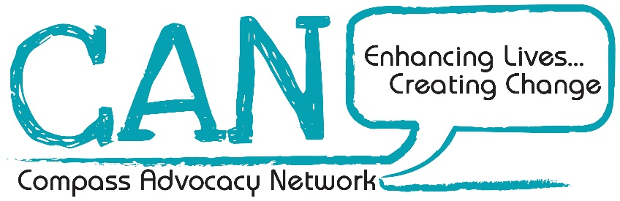

Require an:
Activities Co-ordinator
(Best Buddies)
Hours: 20 per week
Salary: £24616 pro rata
CAN, 32 Lislagan Road, Ballymoney,
BT53 7DD.
For an application pack including job description, contact us:
Email: codie@compasspeople.org
Applications must be returned by no later than 4.30pm on Friday 11th October 2024
This position will be funded by The National Lottery Community Fund.
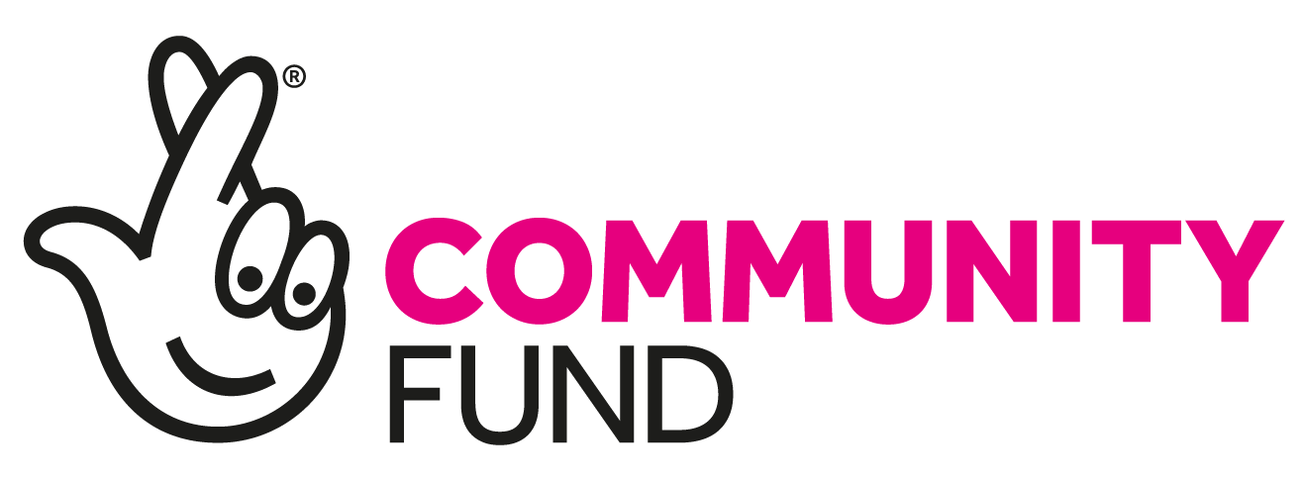

CAN is an Equal Opportunities employer and is committed to appointing the best person for the job irrespective of religion, political opinion, gender, disability or race.

