Job Description, Personnel Specification and Application Form

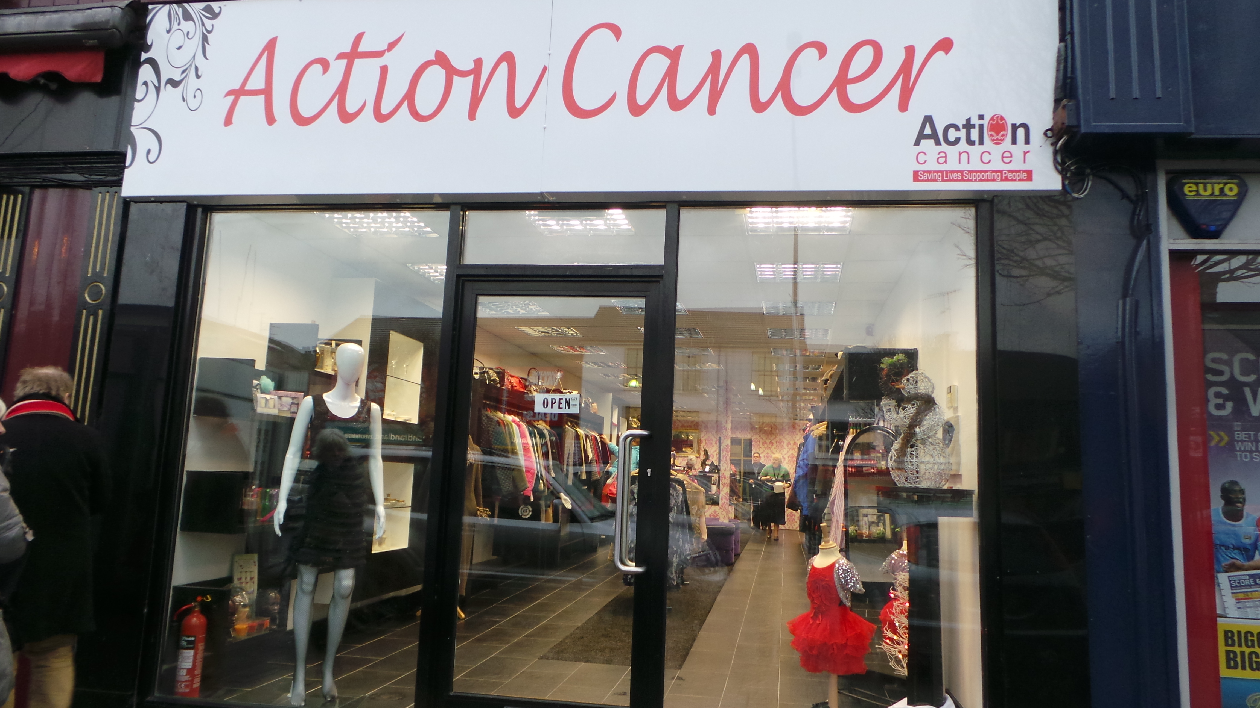

Assistant Shop Manager
Carrickfergus Boutique Shop
9 Market Place
Carrickfergus
BT38 7AW

Permanent role: 21 hours per week

£22,366 - £23,114 (pro rata £13,420 - £13,868)

£12.28 - £12.70ph

Closing date for receipt of applications is Monday 7th October.
Interviews may take place on Thursday 17th October.

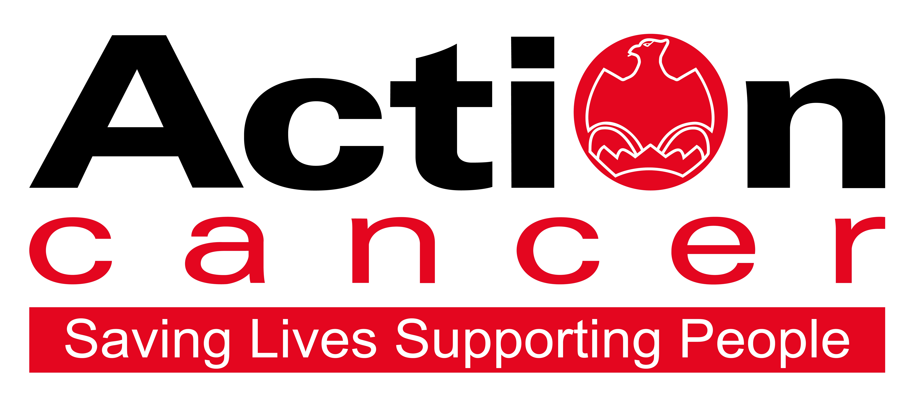

Join our retail team and you’ll be a part of our charity’s mission.

Action Cancer is here for everyone living with a cancer diagnosis, their family and friends.

We deliver our services from Action Cancer House, Belfast, in local communities and workplaces and onboard our mobile unit, the Big Bus, which travels to 200 locations throughout Northern Ireland annually. As well as operating out of Action Cancer House, we provide therapeutic services every week in a number of regional locations and we deliver our health improvement programmes to schools, community groups and workplaces all across Northern Ireland.

So, you are thinking of a career in retail with Action Cancer?

Great! Every day can be different when you are in charge of your own shop. Donations vary, your volunteer team comes from all walks of life and you are meeting different people from your own community every day while helping support a fantastic local charity.

- Enjoy being part of a network of 14 shops
- Selling the best pre-loved clothing
- Being part of the community
- Knowing every sale, you make supports local services

Why work for us?

“I joined because I wanted the flexibility my new job allows, no nights and no Sunday working, makes my work life balance much better” Retail Team Member.

“Being able to spend more time with my family and enjoying my time off especially at Christmas” Retail Shop Manager.

“I’m a breast cancer survivor and I wanted to give something back” Retail Shop Manager.

“Many in our team have a personal connection to the charity and have used our services before. Some have joined from mainstream retail wanting to enjoy a better work life balance. Whatever your reason for wanting to join, I know you will enjoy the experience and will come to feel valued and appreciated for the strengths you will bring.” Action Cancer’s Retail Operations Manager.

In addition to a competitive salary, Action Cancer offer the Total Reward Package – see Page 7 - which focuses on what our staff value, and includes a flexible mix of rewards designed to meet staff needs, their lifestyle, and their stage in life, including a time-off-in-lieu accrual system, training, flexible family-friendly working arrangements, pension contributions, and excellent professional development opportunities.

Action Cancer is a local Northern Ireland charity - all our money is raised to provide services for local communities. Our dedicated team of staff and volunteers work across the whole of Northern Ireland helping to save lives and support people affected by cancer. To operate our services, we must raise circa £4 million every year.

We provide early detection and health improvement services, and counselling and support services for cancer patients and their families, thereby making a real difference to people who are affected by or living with cancer.

Employees of Action Cancer must support its Mission, Values and Behaviours:



Values and Behaviours:

Our strengths are that we are a Values driven charity with people being at the very centre of everything we do. Our services are proven to make a difference, we are a Northern Ireland charity run and controlled by local people, raising money, spending money, and supporting people only here in Northern Ireland.
We have three stated Values which are supported by seven expected behaviours.

Value 1: Putting People First - People are at the centre of everything we do.

Value 2: Making a Difference - Having a positive impact on everything we do.

Value 3: Having Integrity – Operating with full transparency, honesty and fairness in everything we do.

Our Values are supported by seven Behaviours. We Will…

1. Treat everyone with respect, care, dignity and consideration.
2. Listen, hear and respond positively to what people say.
3. Work together, supporting, adding value, learning from and sharing with others.
4. Embrace and develop new ideas, ways of working.
5. Nurture, support, develop and equip our people to reach their full potential.
6. Learn from the past, build upon and celebrate our success.
7. Welcome scrutiny and examination, taking ownership and responsibility for our actions.

Job Description –
Assistant Shop Manager

Job Title: Assistant Boutique Shop Manager
Department: Retail
Reports to: Store Manager

Pictured – Action Cancer, Carrickfergus


Overall Responsibility

The role is accountable for achieving sales within their store in accordance with the annual retail sales budget.

Using best charity retail practice, creative flair and an ability to lead by example while promoting excellent customer service.

Key Areas of Responsibility:

Sales & Stock Generation
- To help meet agreed sales targets.
- To maximise sales by helping to maintain high standards of display and layout in the shop, ensuring stock density is maintained and regular rotation of stock is carried out while following guidelines and operational procedures.
- Be pro-active in the generation of stock
- To ensure stock is priced according to the charity’s guidelines.
- To monitor and check the security of stock on the shop floor and stock room, and to report any irregularities to the Store Manager.

Gift Aid
- Promote donor sign-ups for Gift Aid and input all Gift Aid donors’ personal details to ensure data protection and accuracy.
- Process Gift Aid items with correct individual donor details and price accordingly.

Financial Administration
- To implement and follow all financial procedures as set by the Retail Operations Manager.
- To take full responsibility for the shop’s administration and accounting procedures, including till operations, daily banking and weekly accounts and to address and report any financial irregularities that may arise in the shop in the manager’s absence.

Volunteers
- Support the recruitment of volunteers locally to join the team.
- Help train, manage, and support the volunteer team ensuring effective cover is in place in the shop.
- Help promote the overall harmony of the shop team, ensuring that everyone involved is kept informed of relevant information and developments including those concerning the work of Action Cancer.

Health and Safety
- To ensure that the workplace for which the post-holder is responsible is maintained appropriately and in accordance with Action Cancer’s Health and Safety Policy and relevant Health and Safety Legislation.
- To ensure that all volunteers are trained in all aspects of Health and Safety.
- To complete relevant Health and Safety checklists as instructed by the Retail Operations Manager.

Other Requirements

- To observe equality of opportunity in all areas of the day-to-day work for which the post-holder has responsibility.
- To compulsorily attend monthly shop management meetings and to undertake training as agreed with the Retail Operations Manager.
- To actively participate in the implementation of the Annual Performance Review System and any assessments.
- Where possible provide cover for other Action Cancer shops as requested by the Retail Operations Manager.
- To undertake any other duties which may from time to time be requested by the Retail Operations Manager, which are commensurate with the duties and responsibilities of the post.

This job description will be subject to review in the light of changing circumstances and is not intended to be rigid and definitive, but should be regarded as providing guidelines within which the individual works. Other duties of a similar nature and appropriate to the grade may be assigned from time to time. It is important to note that the responsibilities of the post may change to meet the evolving needs of the services that the charity provides.

General Responsibilities

Members of staff are expected at all times to provide the appropriate service and to treat those with whom they come into contact with in a courteous and respectful manner.

All staff must comply with Action Cancer’s No Smoking Policy on Action Cancer Premises and also while on duty for the charity.

All duties are carried out in compliance with Action Cancer’s Health and Safety Policy and Statutory requirements.

Action Cancer is an Equal Opportunities Employer. You are required to adhere to Action Cancer’s Equal Opportunities Policy throughout the course of employment.

All staff must comply with Action Cancer GDPR Policy and Procedures.

To ensure the ongoing confidence of the public in the staff of Action Cancer, staff must ensure they maintain the high standards of personal accountability.

PERSON SPECIFICATION

Essential Requirements

- Relevant experience in a retail sales environment with experience of cash handing.

- Experience of working within and achieving income and expenditure budgets.

- Good communication and organisational skills

- An ability to work under pressure using own initiative as required while having a positive and flexible approach.

- Be able to undertake manual lifting and handling duties.

Desirable Requirements

- Six month’s relevant management experience in a retail sales environment.

- Relevant management experience in a fashion or clothing retail sales environment.

- Experience of working with volunteers in a retail environment.

- Computer literate with a working knowledge of MS Office (Word, Excel, Outlook, Internet)

- Gift Aid experience

Terms and Conditions of Employment

- All offers of employment are subject to receipt of 2 satisfactory references from referees who can comment on your work ability. One referee should be your current or most recent employer, and one from a previous employer.
- Successful applicants must evidence their right to work in the UK (under the Asylum and Immigration Act). This will be evidenced in the first instance by a passport or other forms of ID that will be outlined if no passport is available.
- 6 months’ probationary period
- Evidence of relevant qualifications
- All potential employees may be asked to attend a pre-employment medical
- Business insurance vehicle cover is required to claim mileage expenses for use of own car.

“I get the chance to manage my own day, gain much more experience in retail – from sourcing stock, sorting donations and pricing goods, to creating displays, supervising people and managing finances. There’s so much diversity and we are given a lot of autonomy in different areas of work.” Retail Team Member

Action Cancer is an Equal Opportunities employer.

Appendix 1: Action Cancer Total Reward Statement
TRAINING AND DEVELOPMENT
- Organisation Wide Training Budget
- Paid tailored training and development support
- Comprehensive In-House Training Courses and External Development Opportunities linked to Role, Strategic Plan, Individual Requests, and Competencies
- Comprehensive Induction Programme
- One to One Coaching & Mentoring
- Personal Job Plans, Development Plans, and Ongoing Supervision
- Continued Professional Development Support
- Structured Interim and Annual Performance Reviews
- Regular Teambuilding and Staff Away Days
- Cross Departmental Working Opportunities
- Overseas Challenge Opportunities

WORK LIFE BALANCE
- Standard 35 hour working week
- Staggered start times
- Up to 25 days annual leave, 11 annual statutory days, and 1 extra day leave at Christmas
- Flexible working (home working, compressed and reduced working hours)
- Fixed Christmas closure
- Time off in Lieu (TOIL) in compensation of additional hours worked
- Discretionary leave
- Family Friendly Policies
- People Friendly Policies
- Christmas Family Party

SOCIAL, PHYSICAL AND MENTAL HEALTH WELLBEING
- Therapeutic Supports - Counselling, Complementary Therapy, Acupuncture
- External Staff Care and Support Services
- External Occupational Health Service
- Health Checks, Screening and Flu Vaccinations
- Regular Staff Health and Wellbeing Surveys
- WPA - NHS Cash Back Plan (permanent staff)
- Death in Service Plan
- Emotional & practical support – bereavement counselling, probate helpline, EAP
- Mediation Services
- Subsidised Christmas Departmental Celebrations
- Staff Pool Car

FINANCIAL REWARD AND RECOGNITION
- Sector Competitive Salaries
- Enhanced Sick Pay (Service Related)
- Enhanced Maternity, Paternity and Adoption leave and pay
- 6% Contributory Pension Scheme
- Death in Service Benefit
- Work Related Professional Membership Fees Paid
- Salary Sacrifice for Pension, Childcare, Bus Travel, and Bike to Work Schemes
- Celebration of Individual and Team Success
- Mileage Allowance at the Prevailing HMRC Rate
- Clear Policies and Procedures
- Enhanced Paid Annual Leave
- Additional Day Paid Leave at 10,15,and 20 Years’ Service
- Free Parking

Manager, Assistant Manager, Deputy Manager, Acting Manager, Department/Concession Manager, Supervisor, Shop Assistant.

