

# Job Description and Personnel Specification

**Health Improvement Support Officer**

# Full Time/PT roles

**Fixed Term initial 12mths post (with possible extension)**

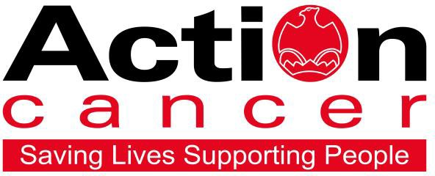

## Title of Post: Health Improvement Support Officer Hours: 35 hours per week (PT hrs considered) Location: Based at Action Cancer House, Belfast

**Salary: NJC Scale Pts: 2-7 (£22,366 - £24,294)**

**We also offer:**

### 20 days leave increasing to 25 days + 11 Public Holidays

* 1 extra leave day at Christmas
* Christmas closure
* Enhanced sickness, maternity, paternity, and adoption leave and pay
* 6% contributory pension scheme
* NHS Top-Up Cash Plan
* Death in Service Plan
* Staff care and support services, including access to Action Cancer services
* Training and development

In addition to a competitive salary, Action Cancer offer a Total Reward Package – see Appendix - which focuses on what our staff value and includes a flexible mix of rewards designed to meet staff needs, their lifestyle, and their stage in life, including a time-off-in-lieu accrual system, training, flexible family- friendly working arrangements, pension contributions, and excellent professional development opportunities.

Action Cancer is a local Northern Ireland charity - all our money is raised to provide services for local communities. Our dedicated team of staff and volunteers work across the whole of Northern Ireland helping to save lives and support people affected by cancer. To operate our services, we must raise circa

£4 million every year. We provide early detection and health promotion services, and counselling and support services for cancer patients and their families, thereby making a real difference to people who are affected by or living with cancer.

Action Cancer staff - a mix of highly skilled professionals - are the most valuable asset to our charity. We offer a wide variety of training and development opportunities, and family friendly initiatives to enhance work-life balance, and to value and support individuals and family life. In recognition of this we were awarded Best Learning and Development Organisation in Ireland - Not for Profit Sector and were winners of The Irish News ‘Best Place to Work’ Award, Employers For Childcare “Childcare Works Award”, Employers For Childcare Family Friendly Employer Award - Social Enterprise/Charity of the Year, and Employer of the Year Award by UTV Business Eye Awards.

We were also very proud to achieve Investors in People Gold Champion status, Investors in People Health & Wellbeing Good Practice accreditation, and Investors in Volunteers accreditation. These awards testament to our continued commitment to “have highly valued, trained, enthusiastic, focused and committed people who work together and engage with others to make a positive impact on our community”.

#### Employees of Action Cancer must support its Mission, Values and Behaviours:

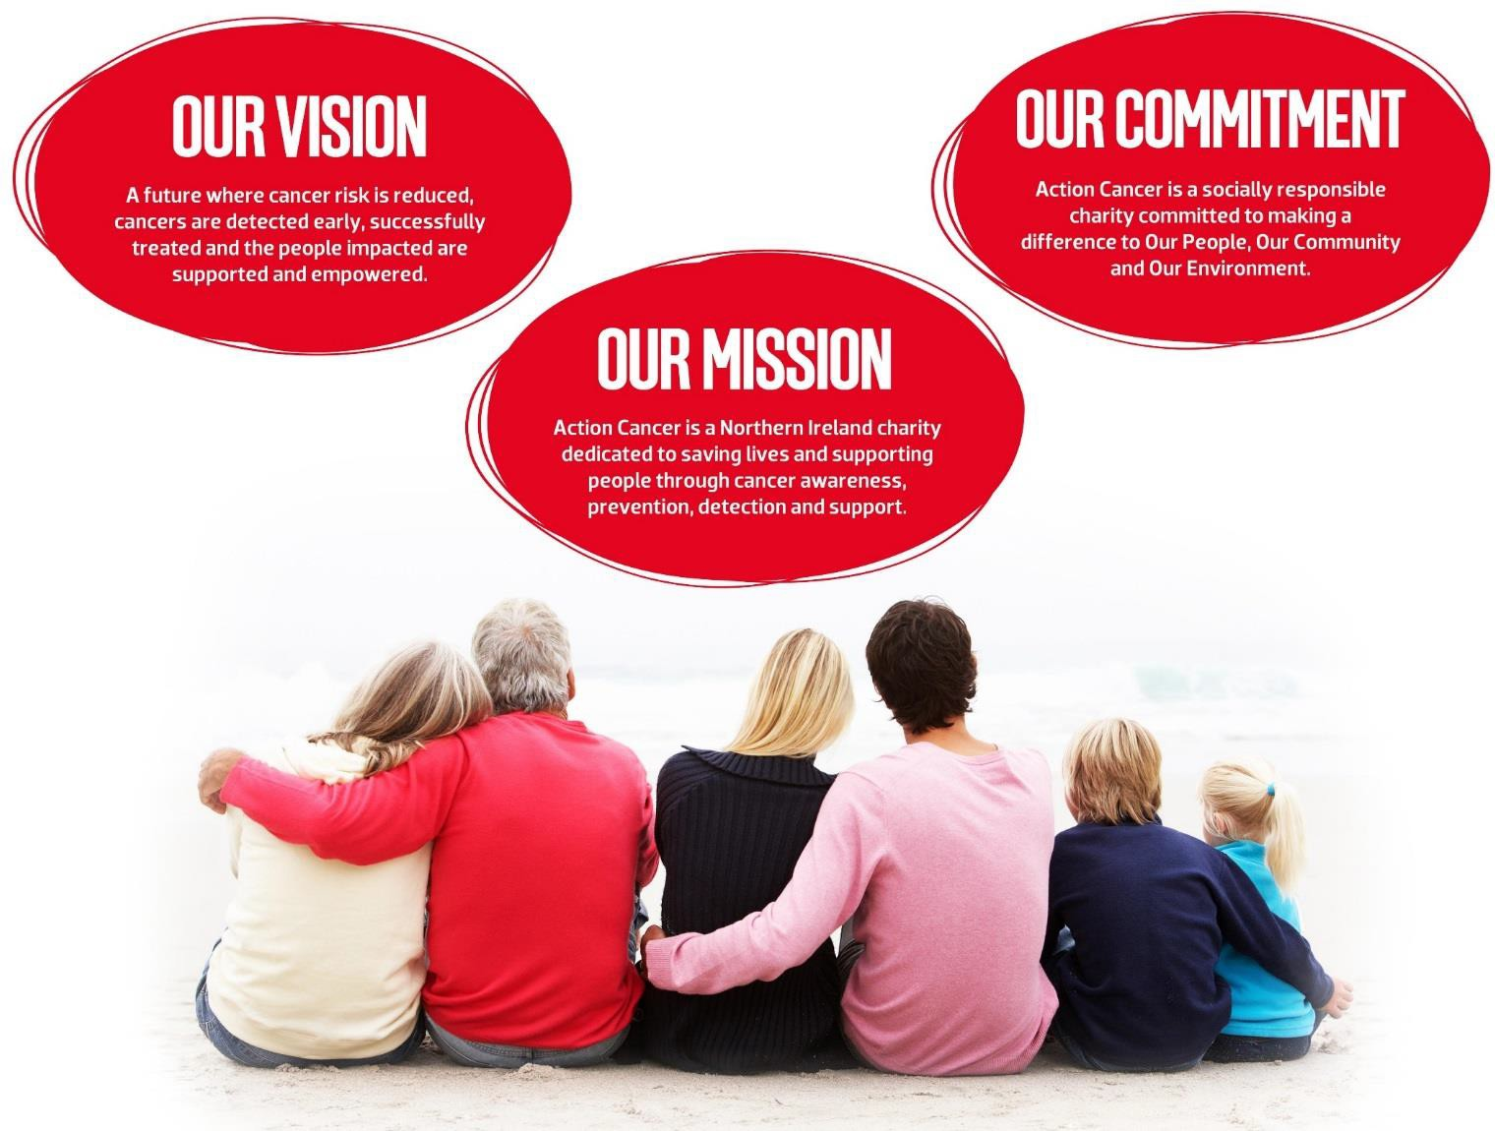

**Values and Behaviours:**

Our strengths are that we are a Values driven charity with people being at the very centre of everything we do. Our services are proven to make a difference, we are a Northern Ireland charity run and controlled by local people, raising money, spending money, and supporting people only here in Northern Ireland.

We have three stated Values which are supported by seven expected behaviours.

**Value 1: Putting People First** - People are at the centre of everything we do.

**Value 2: Making a Difference** - Having a positive impact on everything we do.

**Value 3: Having Integrity** – Operating with full transparency, honesty and fairness in everything we do. Our Values are supported by seven **Behaviours.** We Will…

### Treat people with respect, care, dignity and consideration.

1. Listen, hear and respond positively to what people say.
2. Work together, supporting, adding value, learning from and sharing with others.
3. Embrace and develop new ideas, and ways of working.
4. Nurture, support, develop and equip our people to reach their full potential
5. Learn from the past, build upon and celebrate our success
6. Welcome scrutiny, taking ownership and responsibility for our actions.

**Health Improvement Support Officer – Job Description**

**Overall Purpose**

The overall purpose of this role is to provide high quality, professional and effective health check services, and general health and wellness services/programmes, under the direction of the Health Improvement and Evaluation Manager.

## Main Duties:

* Deliver Health Checks on board the Action Cancer Big Bus, in Action Cancer House and in Community and Workplace settings.
* Deliver a range of health education and improvement programmes and activities to adults in community and workplace settings across Northern Ireland.
* Assist in developing new programmes, services and materials in support of achieving the charity’s health improvement strategic aims.
* Assist with social media content creation and scheduling for health improvement.
* Assist with service evaluation data analysis and reporting.

## Communication

* Support and advise clients requesting information relating to prevention, early detection and cancer support strategies.
* Communicate effectively with clients, recognising the need for alternative communication methods to overcome different levels of understanding, cultural background and preferred ways of communicating.
* Utilise a variety of social media platforms for the effective communication of Health Improvement messages.

## Team Working

* Working together in the Health Improvement team, assist in the design and development of new programmes, services and materials in support of achieving the charity’s health improvement strategic aims.
* Work as an effective and responsible team member, supporting others.
* Accept delegation from others, prioritise own workload and ensure effective time-management strategies are embedded in own practice.
* Participate in team activities that create opportunities to improve service and programme delivery.

## Quality Assurance

* Recognise and work within own competence and professional code of conduct.
* Take an active role in the production of monitoring, evaluation and audit processes, as required and appropriate.
* Assess effectiveness of service and programme delivery through self and peer review, benchmarking and formal evaluation.

## Learning and development

* Act as a mentor to new staff, students and volunteers, assessing competence against set standards as requested and if appropriately qualified.
* Assess own learning needs and undertake learning as appropriate
* Make appropriate use of learning opportunities within and outside the workplace, evaluating their effectiveness and feeding back relevant information.

## Other Duties

* Undertake administration required in support of service and programme delivery, including but not limited to, diary and rota management and the maintenance of accurate, up to date and relevant information required by the organisation for reporting and research purposes.
* Monitor work areas and practices to ensure they are safe and free from hazards and conform to health, safety and security legislation, policies, procedures and guidelines.
* Undertake work and development projects as assigned by the Health Improvement & Evaluation Manager.

#### Key Essential Requirements of the role:

1. The ability and willingness to travel extensively throughout Northern Ireland, alone and as part of a carpool, where necessary – a current full driving licence and access to a car, or some other form of transport, to allow the post holder to carry out the duties of the post in full, is an essential criterion.
2. The ability and willingness to work flexible hours, including evenings and weekends, holidays/sickness as required.
3. To adhere to all the charity’s Values, Behaviours, Policies and Procedures
4. Ensure personal training and development commensurate with the role and job responsibilities.
5. To participate fully in the life of the charity, contributing to its development and sustainability.

This job description will be subject to review in the light of changing circumstances and is not intended to be rigid and definitive but should be regarded as providing guidelines within which the individual works. Other duties of a similar nature and appropriate to the grade may be assigned from time to time. It is important to note that the responsibilities of the post may change to meet the evolving needs of the services that the charity provides.

**Employees of Action Cancer must support its Mission as follows:**

**“Action Cancer is a Northern Ireland charity dedicated to saving lives and supporting people through cancer awareness, prevention, detection, and support.”**

**Action Cancer expects all staff to “live” by three values:**

1. **Putting People First – people are at the centre of everything we do.**
2. **Making A Difference – Having a positive impact on everything we do.**
3. **Having Integrity** – **Operating with full transparency, honesty and fairness in everything we do.**

#### General Responsibilities

Members of staff are always expected to provide the appropriate service and to treat those with whom they come into contact with in a courteous and respectful manner

All staff must comply with Action Cancer’s No Smoking Policy on Action Cancer Premises

All duties are carried out in compliance with Action Cancer’s Health and Safety Policy and Statutory requirements.

Action Cancer is an Equal Opportunities Employer. You are required to adhere to Action Cancer’s Equal Opportunities Policy throughout the course of employment.

All staff must comply with Action Cancer Data Protection Policy and Procedures.

To ensure the ongoing confidence of the public in the staff of Action Cancer, staff must ensure they maintain the high standards of personal accountability.

## PERSONNEL SPECIFICATION

#### Essential Requirements

* 1. Hold a Health Improvement1 related degree.
  2. At least 6mths experience delivering health checks or other health related service.2
  3. A proven team player, but with the ability to work independently.
  4. Proven ability to plan, prioritise and work to deadlines.
  5. Good communication skills (written & verbal).
  6. Experience and working knowledge of data inputting and analysis.
  7. Ability to work flexibly and to work evenings and weekends.
  8. Experience and working knowledge of IT (Microsoft packages).
  9. Be able to undertake manual lifting and handling duties to carry out the duties of the post in full.
  10. Hold a full, current driving license, with business insurance, and access to a car to enable travel throughout N Ireland or some other form of transport to allow the post holder to carry out the duties of the post in full.
  11. The ability and willingness to travel extensively throughout Northern Ireland alone, and as part of a carpool, where necessary - be willing to drive either Action Cancer company vehicle, or own car as scheduled on a car pool rota.

## Desirable

1. Have a minimum of 1yrs experience delivering health checks or other health related service.
2. Experience of social media content creation and planning.

**Terms and Conditions of Employment**

* 2 satisfactory written references are required direct from a current / previous employer covering the preceding two years of employment.[1]
* Successful applicants must evidence their right to work in the UK (under the Asylum and Immigration Act).This will be evidenced in the first instance by a passport or other forms of ID that will be outlined if no passport is available.
* 6 months probationary period
* Evidence of relevant academic and professional qualifications
* Evidence of appropriate vehicle documentation
* All potential employees may be asked to attend a pre-employment medical
* The activities of this role require a Basic AccessNI check.

**Action Cancer is an Equal Opportunities Employer.**

1e.g. Health Promotion, Sports Science, Physical Activity & Health, Human Nutrition, Dietetics, Health & Leisure, Food & Nutrition, Health Physiology, Health Psychology, Occupational Therapy, Environmental Health.

2 This includes experience gained during undergrad placement work.

**Appendix 1: Action Cancer Total Reward Statement**

|  |
| --- |
| **Training and Development**   * Organisation Wide Training Budget * Paid Tailored Training and Development Support * Comprehensive In-House Training Courses and External Development Opportunities linked to Role, Strategic Plan, Individual Requests, and Competencies * Comprehensive Induction Program * Continued Professional Development Support * Structured Interim and Annual Performance Reviews * Regular All Staff and Department Teambuilding Away Days and Events * Cross Departmental Working Opportunities/ Workplace Shadowing * Overseas Challenge Opportunities |

|  |
| --- |
| **Work Life Balance**   * Standard 35 hour working week * Flexible Working - hybrid working, compressed hours, staggered start times * Enhanced paid annual leave - 11 annual statutory days, up to 25 days annual leave (depending on role), Additional Day Paid Leave at Christmas * Fixed Christmas closure throughout the entire organisation * Christmas staff and family events * Time Off In Lieu in compensation of additional hours worked * Additional leave purchase scheme * Sabbatical, Discretionary and Dependant care leave * People and Family Friendly Policies * Enhanced maternity, paternity and adoption leave and pay subject to eligibility. |

|  |
| --- |
| **Social, Physical and Mental Health and Wellbeing**   * WPA - NHS Cash Back Plan and Employee Assistance Program. * Health and Menopause Support Policies and Return to Work programs * Therapeutic supports – counselling, complementary therapies, acupuncture * External care and support services – Staffcare & DAS confidential counselling helpline services * AIG Smart Health - digital GPs, health checks, nutrition consultation, fitness programme, mental health support, myStrength app, 24/7 mental health helpline, legal and financial support. * External Occupational Health Service, health checks, screening, and vaccinations * Regular Staff Health and Wellbeing and Awareness and Opinion Surveys, and Staff Wellness Week * Mediation services * Staff kitchen facilities, free tea and coffee, and shower facilities * Christmas family party and subsidised Christmas departmental celebrations * Staff pool car * Clear Policies and Procedures * CSER Team representing staff opinion and arranging events throughout the year. |

|  |
| --- |
| **Financial Reward and Recognition**   * Sector competitive salaries * Action Cancer 6% pension contribution + 3.2% employee contribution + tax relief = 10% contribution to pension pot * Salary Sacrifice for Annual Leave, Pension, and Bike to Work Schemes * Work related professional membership fees paid * Mileage Allowance at the Prevailing HMRC Rate * Additional Day Paid Leave at 10,15,and 20 Years’ service for staff on NJC payscales * Free staff uniforms * Free car parking * Death-in-service benefit of £50,000 lump sum payable to nominee. |

1. Where such references are unavailable, and in respect of employee(s) joining directly from school or government sponsored youth training schemes, character references will be required.