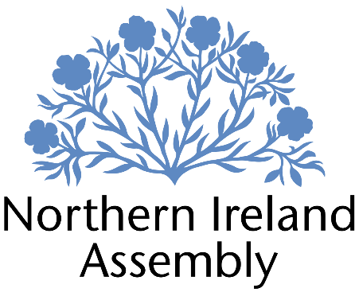

**Michelle Guy MLA**

*Alliance Party Member of the Northern Ireland Assembly for Lagan Valley Constituency*

**RESEARCH, CONSTITUENCY AND COMMUNICATIONS MANAGER**

|  |  |
| --- | --- |
| Report to: | Michelle Guy MLA |
| Office Location: | Spilt between Parliament Buildings, Stormont and Lagan Valley Constituency Office |
| Hours: | 37 hours per week |
| Holidays: | As per determination |
| Salary: | £41,023 Salary Grade 3 (1) |
| Pension: | A central Assembly-approved pension scheme is provided. If enrolled an amount equivalent to 10% of employee’s salary will be paid into the pension scheme. |
| Duration: | Permanent.  Employment contingent upon member remaining an MLA or until legislation is introduced to change Constituency expense provision. Six-month probation period shall apply. |
| Closing Date | Noon, Friday 30th August 2024 |
| Interview dates: | It is anticipated that shortlisted candidates will be interviewed during week beginning 2nd of September 2024 |

# JOB DESCRIPTION

This role is suited to an experienced person who can demonstrate they can support the work of Michelle Guy MLA by managing the delivery of key outputs. The focus of the role is:

* Research and policy
* Constituency office management
* Communications support

The ideal candidate will be enthusiastic and able to deliver in a fast-paced environment and prioritise actions as appropriate.

**Research and policy**

* Policy and research will be the core part of this job in terms of deliverables from the postholder. They will be responsible for providing rapid, accurate and detailed research on a wide range of policy issues in support of Michelle Guy MLA’s work.
* Drafting speeches, questions and briefing papers
* Preparing and developing Assembly motions and Private Members Bills
* Monitoring business of the Assembly and Committees, and providing detailed briefings for the Member
* Responding to correspondence and enquiries from constituents, media, lobbyists, businesses and community groups in line with the Member’s requirements
* Maintaining up to date knowledge of relevant legislation, policy and wider political and industry developments

**Constituency**

* This aspect of the role is focused on providing a management function in relation to the Constituency Office. The postholder will have line management responsibility for Constituency Office Staff and will oversee the efficient delivery of Michelle Guy MLA’s constituency services.
* The Research, Constituency and Communications Manager will ensure that Constituency Office staff log, progress and monitor casework to ensure all identified actions are taken and comply with GDPR and data management. They will also be expected to contribute to casework as appropriate to meet demands.
* They will be responsible for overseeing the management of office equipment, resources and operational expenses as per NI Assembly Determination rules.
* Dealing with complex queries and complaints on Member’s behalf, including drafting letters for the MLA to sign
* Attending work related training and networking meeting to develop skills
* Other duties as required in support of the MLA carrying out their Assembly duties.

**Communications**

* Identifying media and press opportunities and drafting statements in both a pro-active and re-active manner as required
* Manage social media platforms to support and promote the work of Michelle Guy MLA
* Develop and manage a suite of lines to take related to policy and constituency matters
* Other communications related tasks as required

**PERSON SPECIFICATION**

|  |  |  |
| --- | --- | --- |
|  | **Essential Criteria** | **Desirable Criteria** |
| **Professional / Technical Qualifications** | * Five GCSE’s / O’ Levels or equivalent at Grade C or above including both English Language and Mathematics * Third level qualification * Proficiency in the use of Microsoft Outlook, Word and Excel packages | * ICT qualification * Degree in Law or Masters Degree |
| **Experience / Job Knowledge** | * Minimum three years’ experience in a policy and/or research role in a paid or voluntary capacity * Experience of drafting and or responding to public consultations with an understanding of relevant impact assessments. * Experience of handling queries and issues from members of the public * Proficiency using key social media platforms such as Facebook, Instagram and X (Twitter). * Knowledge of Northern Ireland political scene * Experience of financial budgeting and monitoring | * Knowledge of the workings of the Northern Ireland Assembly * Knowledge of policy related to education, children and young people. * Ability to edit video clips for social media and add captions. * Experience of dealing with sensitive and confidential information (both verbal and written) in line with the Data Protection Actand GDPR * Experience of using casework or similar software package. |
| **Personal Qualities /**  **Skills** | * Flexible and professional approach to work. * Excellent written communication skills. * Excellent verbal communication skills in person and on the phone. * Ability to engage with members of the public, sometimes in challenging circumstances * Understanding of Alliance Party objectives | * Good communication skills with capacity to adapt techniques in differing contexts * Ability to work as part of a small team * Good time management * Ability to multi task |
| **Circumstances** | * This position is 37 hours a week. * Able to work unsupervised and as lone worker in office or at home when required | * May be required to travel to meetings |

Applicants must demonstrate clearly on their application form how they meet the criteria.