Job Information Pack

**Belfast Hills Operations Manager**

Expected Date for Interview

30th September 2024

**Guidance Notes on Completing the Application Form**

Thank you for requesting an application pack for a job opportunity with Belfast Hills Partnership. In order to ensure that your application is considered you must complete the application form in this pack and return by hard copy or e-mail not later than 10am **on Monday 16th September 2024.**

Candidates will be selected for interviews only on the basis of the information supplied on this form. It is in your best interest to follow all instructions and complete all necessary sections in a clear and concise manner. Candidates are also expected to keep the above interview date free in their diaries.

All applications must be completed in **BLACK** ink / typescript and **ALL** boxes / questions must be completed. Failure to do so may result in your application not being considered.

You have been supplied with a job description, which sets out the essential and desirable criteria for this job.

When completing this form, you are requested to study the criteria and you should **CLEARLY** indicate when your experience or qualifications are relevant to the job specification. If you find that you cannot include all relevant information in the spaces provided you may continue on additional sheets but please ensure these are referred to and securely attached.

If you do not have the qualifications requested but do have an equivalent you must include details of this, clearly demonstrating their equivalency. The panel may not assume you have the qualifications or experience required.

We would envisage that successful candidates to be in post Dec24/Jan25.

***Please do not include a CV.***

***Belfast Hills Partnership***

***9 Social Economy Village***

***BELFAST, BT17 0XS***

***Tel: 028 90603466***

***Email: woodland@belfasthills.org***

***Web:*** [***www.belfasthills.org***](http://www.belfasthills.org)

We endeavour to respond to all applicants, however if there are a particularly high number of applications you will be contacted only if you have been shortlisted for interview.

**Background**

The Belfast Hills Partnership (BHP) is an independent charity which seeks to improve how the hills are managed. It has an operational area which covers the uplands to the west and north of Belfast, running from Boomer’s Hill and Slievenacloy in the south to Cave Hill and Carnmoney Hill in the north.

Its programmes and projects cover a wide range of activities covering health, biodiversity, planning and development, access, heritage and landscape, with related work such as youth engagement, public engagement, field work and surveys, website development, events and managing volunteers.

A range of other general information on the work of the Belfast Hills Partnership is available from our website [www.belfasthills.org](http://www.belfasthills.org).

The Belfast Hills Partnership (BHP) is seeking to employ an Operations Manager to be responsible for the implementation of the various schemes, including management of staff and budgets

**The Belfast Hills Partnership reserves the right to hold a reserve list, for a period of approximately 12 months, from this recruitment to fill this role or similar roles which may arise**.

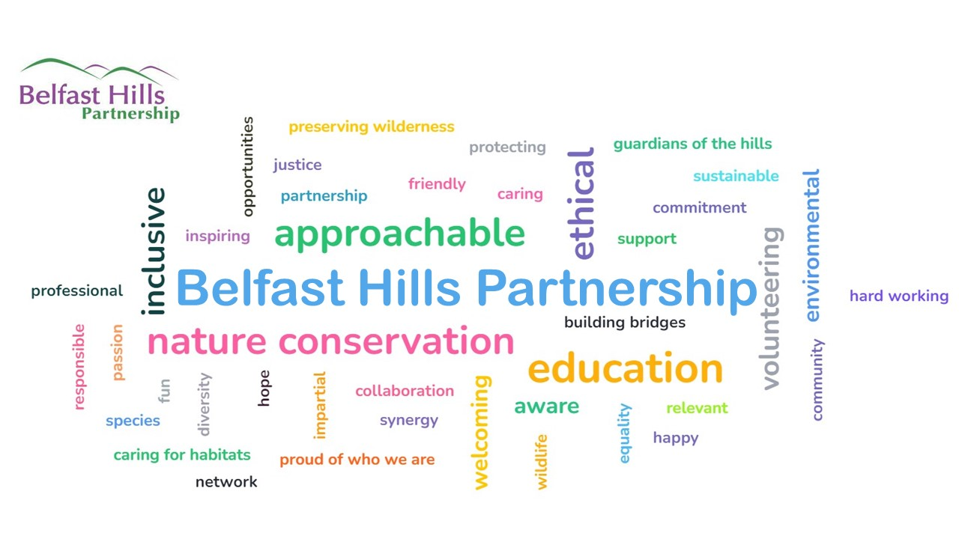

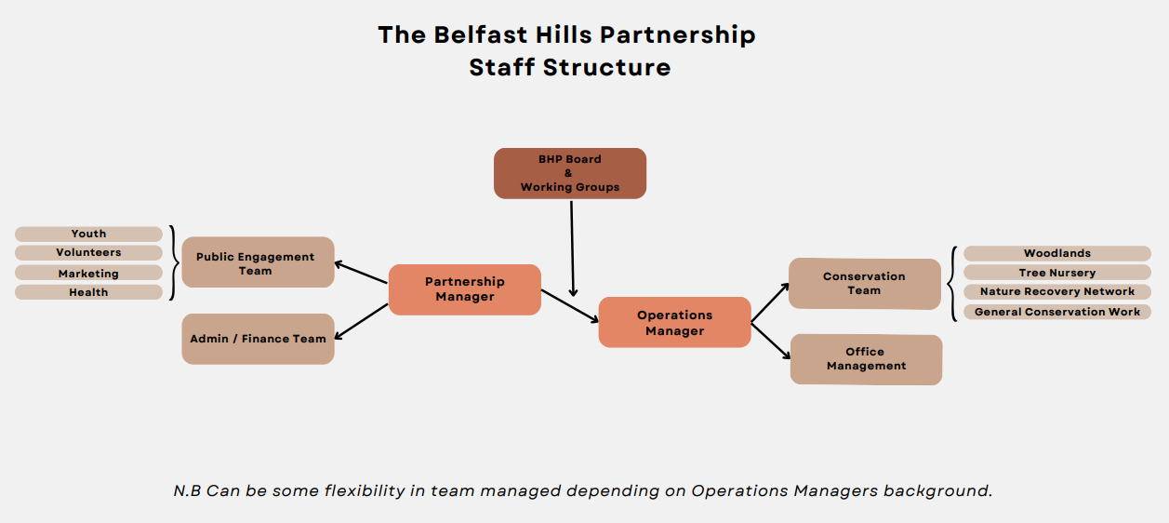

**JOB DESCRIPTION**

**JOB TITLE:** **OPERATIONS MANAGER**

**RESPONSIBLE TO:** PARTNERSHIP MANAGER AND PARTNERSHIP BOARD

**RESPONSIBLE FOR:** ALL SCHEME STAFF

**LOCATION:** SOCIAL ECONOMY VILLAGE, HANNAHSTOWN, BELFAST

**MAIN TASK:**

To work with and report to the Partnership Manager to provide strategic management of the Belfast Hills Partnership (BHP). Ensure the effective development and day to day implementation of the organisation operations, its staff and programmes.

**SPECIFIC TASKS:**

1. To be responsible for the implementation of the various schemes, including management of staff and budgets.
2. To work with the Partnership Manager to develop and implement strategic plans and annual operational plans to structure the partnership’s work.
3. To report to the Partnership Manager and Directors of the Belfast Hills Partnership, and account for all scheme activities and finances.
4. To undertake outreach to foster good relationships between the partners, interested organisations and individuals, local people, visitors, the media and promote the work of the Belfast Hills Partnership and generate wide scale interest.
5. To be responsible for raising (including making successful funding applications), managing, accounting and reporting of scheme funds.
6. To represent the Belfast Hills Partnership and deputise for the Partnership Manager at events and meetings as required.
7. To deliver practical projects, engagement programmes and analytical reports etc. as required.
8. To be responsible for effectively inducting, managing and leading staff and volunteers. To ensure that records of all work undertaken, including financial records are kept.
9. To collate monitoring information and evaluate the progress of the project against agreed objectives and performance indicators, and present this to the Board and funders as required.
10. To comply, promote and produce the Boards policies and procedures.
11. Any other duties as may be allocated from time to time in accordance with the general nature of the post.

**ESSENTIAL CRITERIA:**

1. At least five years relevant experience in carrying out programmes of work in at least one of the following areas: nature conservation, agriculture, environmental information and education, outdoor visitor management, countryside recreation, community regeneration

OR A third level qualification in one or more of the following: countryside management, environmental science or environmental management, agriculture, community regeneration, countryside information plus a minimum of three year’s relevant experience in successfully carrying out practical programmes in at least one of the areas highlighted in Criterion 1 above.

1. At least 3 years’ experience of managing other personnel and working with volunteers
2. High level of organisational ability and able to meet deadlines and adhere to budgetary constraints
3. Project management experience including budgetary control
4. Experience of writing successful funding applications
5. Proficient in using computers e.g. for the preparation of presentations, project management packages, documents, information for uploading to a website and in preparing financial and other monitoring information using spreadsheets.
6. Excellent written and oral communication skills.
7. An understanding of the Belfast Hills or similar upland areas, the importance of their landscape, biodiversity and the problems and issues associated with them.
8. Ability to work outside normal working hours as required for the effective performance of duties of the post.
9. Access to a suitable means of transport to fulfil the requirements of the post.

**DESIRABLE CRITERIA:**

1. Experience of working with a wide range of people including local communities, commercial operators, private landowners, governmental and non governmental organisations
2. Previous experience of working with and supporting farmers and communities within development programmes.
3. Previous experience of access and waste management issues.
4. A flexible approach and outlook and an ability to bring fresh, imaginative ideas to the job.
5. An interest in landscape protection and an expertise in an aspect of the protection and enhancement of built or natural heritage.
6. A full valid driving licence and access to a reliable vehicle.

**TERMS AND CONDITIONS:**

**Length of Contract:** Ongoing subject to funding

**Salary:** £41,000

**Hours:** 35 hours per week

**Holidays:** 25 days + 12 statutory days

**Probationary Period:** 6 months

**Notice:** 3 months

**PRIVATE AND CONFIDENTIAL**

**APPLICATION FORM**

**Job No:** Ref 24/03 **Application Number: ……**

For the post of: **Belfast** **Hills** **Operations Manager**

• *The completed Application Form and additional materials must be returned by hard copy or email not later than* **10am on Monday 16th September 2024.** ***Applications received by the Partnership after this date and time will not be accepted, nor will faxed applications and/or Curriculum Vitae.***

• *Emailed copies must be addressed to* [*woodland@belfasthills.org*](mailto:woodland@belfasthills.org)*. We will try to acknowledge receipt as soon as possible.*

• *Hard Copy applications must be returned in an envelope clearly marked PRIVATE AND CONFIDENTIAL and* addressed to: **The Partnership Manager, Belfast Hills Partnership, 9 Social Economy Village, Hannahstown Hill BELFAST BT17 0XS.**

**Personal Details – N.B. this page will not be available to shortlisting panel**

Title: ….. Surname: ………………………………….……………………….

Forename(s): ………………………………….……………………….

Home address: ………………………………….……………………….

………………………………….……………………….

………………………………….……………………….

Post Code: ……………….... Telephone No:…...………………...

Mobile:………………….…. Email address :………………………………………

**National Insurance Number**: ………………………………..

Do you require a work permit to work in the UK? YES ❏ NO ❏

Do you consider yourself to

have a disability? **Yes ……. No …….** *(please tick as appropriate)*

If **yes**, is there anything we need to know about your disability in order to offer you a fair selection interview, e.g. car parking facilities, access facilities?

**This page has been left black intentionallyQualifications**

|  |  |  |  |  |
| --- | --- | --- | --- | --- |
| **Date** (month & year) | **Examining Body** | **Type & Level** | **Subject** | **Grade** |
|  |  |  |  |  |
|  |  |  |  |  |
|  |  |  |  |  |
|  |  |  |  |  |
|  |  |  |  |  |
|  |  |  |  |  |
|  |  |  |  |  |
|  |  |  |  |  |
|  |  |  |  |  |
|  |  |  |  |  |
|  |  |  |  |  |
|  |  |  |  |  |
|  |  |  |  |  |
|  |  |  |  |  |
|  |  |  |  |  |
|  |  |  |  |  |

*(Please use additional sheets if necessary)*

**Further/Higher Education**

If you have attended university, polytechnic or college, please give*:*

|  |  |  |  |  |
| --- | --- | --- | --- | --- |
| **Name of establishment** | **Qualification**  **(Subject & Level)** | **Dates of study** | | **Date Obtained** |
| **From** | **To** |
|  |  |  |  |  |
|  |  |  |  |  |
|  |  |  |  |  |
|  |  |  |  |  |

Please give details of any other professional qualifications or relevant training

|  |  |  |
| --- | --- | --- |
| **Title of qualification or training** | **Examining Body** | **Date obtained** |
|  |  |  |
|  |  |  |
|  |  |  |
|  |  |  |
|  |  |  |
|  |  |  |
|  |  |  |

**Present Post**

Please give the following details if you are currently employed

|  |  |  |
| --- | --- | --- |
| **Name & Address of**  **Current Employer** | **Job Title** | **Brief List of Main Duties** |
|  |  |  |

Current Salary……………….. Date Appointed………………… Period of Notice…………………..

**Previous Posts & Experience**

*Beginning with the most recent post, please list your previous posts.*

|  |  |  |  |  |
| --- | --- | --- | --- | --- |
| **Name & Address of Employer** | **Job Title** | **Duties (**briefly) **and Reason for Leaving** | **Dates** (Month & Year) | |
| **From** | **To** |
|  |  |  |  |  |
|  |  |  |  |  |
|  |  |  |  |  |
|  |  |  |  |  |

*(Please continue on additional sheets if necessary)*

**Supporting Information**

• *We shortlist based only on the information which you provide in this application form. You have provided information on your qualifications and employment.*

• *You are invited to make a statement in the space below showing specific evidence as to how you meet the other essential criteria outlined in the Job Description.* ***Please state exact duration of any experience and nature*** *e.g. full-time, part-time, volunteer. (Please continue on additional sheets, if necessary).*

1. Experience of carrying out programmes of work in at least one of the following areas: nature conservation, agriculture, environmental information and education, outdoor visitor management, countryside recreation, community regeneration – minimum of three years’ experience with a relevant 3rd level qualification or five year without.

2. At least 3 years’ experience of managing other personnel and working with volunteers.

3. High level of organisational ability and able to meet deadlines and adhere to budgetary constraints

1. Project management experience including budgetary control
2. Experience of writing successful funding applications
3. Proficient in using computers e.g. for the preparation of presentations, project management packages, documents, information for uploading to a website and in preparing financial and other monitoring information using spreadsheets
4. Excellent written and oral communication skills.
5. An understanding of the Belfast Hills or similar upland areas, the importance of their landscape, biodiversity and the problems and issues associated with them
6. Ability to work outside normal working hours as required for the effective performance of duties of the post
7. Access to a suitable means of transport to fulfil the requirements of the post

• *Please make a statement in the space below showing specifically how you meet the desirable criteria outlined in the Job Description. (Please continue on additional sheets, if necessary).*

1. Experience of working with a wide range of people including local communities, commercial operators, private landowners, governmental and non-governmental organisations

2. Previous experience of working with and supporting farmers and communities within development programmes

3. Previous experience of access and waste management issues.

4. A flexible approach and outlook and an ability to bring fresh, imaginative ideas to the job.

5. An interest in landscape protection and an expertise in an aspect of the protection and enhancement of built or natural heritage.

6. A full valid driving licence and access to a reliable vehicle.

**Please Indicate how you became aware of this vacancy:…………..………….**

**Referees**

Applicants are required to supply names of 2 suitable referees from current and/or previous employment. Both referees should be able to comment on the ability to carry out the responsibilities of the role. Referees will only be contacted at a final stage of the process.

|  |  |  |
| --- | --- | --- |
| Name: |  | Name: |
| Address: | Address: |
|  |  |
|  |  |
|  |  |
| Contact Tel No | Contact Tel No |
| Occupation | Occupation |

**• *Please ensure that you have completed the Equal Opportunities Monitoring Form and return it together with this Application Form in an envelope addressed to the Monitoring Officer clearly marked “PRIVATE AND CONFIDENTIAL”.***

**Declaration by applicant**

The foregoing particulars are complete and correct to the best of my knowledge and belief. I understand that any false information given may result in a job offer being withdrawn or to dismissal and that any offer of employment made by Belfast Hills Partnership is subject to receipt of satisfactory references and/or vetting checks.

I consent to the processing of this information for the purposes of my application, subsequent employment and agree to personal vetting or other such searches being made, as may be necessary, now or in the course of my employment.

Usual signature: ……………………………………………………..

If applying by email you will be asked to sign this prior to any interview offered.

Date: …………………………………………………..…

**Belfast Hills Partnership**

**9 Social Economy Village**

**Hannahstown Hill**

**BELFAST BT17 0XS**

**Email: woodland@belfasthills.org**

**This page has been left black intentionally**

**EQUAL OPPORTUNITIES MONITORING FORM**

It is the policy of Belfast Hills Partnership to ensure that no job applicant receives less favourable treatment on the grounds of race, disability, religious belief, political opinion, gender, marital or family status, sexual orientation or age.

Belfast Hills Partnership seeks the information below which will be treated in the strictest confidence and used for monitoring purposes only.

This sheet will be detached from the application form and will not be made available to anyone other than the Monitoring Officer.

Answer the following questions by ticking the appropriate box:

1. GENDER MALE ❏ FEMALE ❏

2. DATE OF BIRTH _________________________________

3. MARITAL STATUS MARRIED ❏ SINGLE ❏ DIVORCED ❏ LEGALLY SEPARATED ❏

4. PLEASE INDICATE THE COMMUNITY TO WHICH YOU BELONG:

I AM A MEMBER OF THE PROTESTANT COMMUNITY ❏

I AM A MEMBER OF THE ROMAN CATHOLIC COMMUNITY ❏

I AM A MEMBER OF NEITHER THE PROTESTANT NOR ROMAN CATHOLIC COMMUNITY ❏

5. DO YOU SUFFER FROM ANY DISABILITY OR HEALTH PROBLEM WHICH IS RELEVANT TO YOUR APPLICATION?

YES ❏ NO ❏  
NATURE OF DISABILITY____________________________________________________

WHAT ADJUSTMENTS, IF ANY, ARE REQUIRED?___________________________________________________

6. ETHNIC ORIGIN

BLACK AFRICAN ❏ BANGLADESHI ❏ BLACK CARIBBEAN ❏ CHINESE ❏ INDIAN ❏ IRISH TRAVELLER ❏ PAKISTANI ❏ WHITE ❏ MIXED ETHNIC GROUP❏ OTHER_____________________________________

OFFICIAL USE ONLY Job No………… Application No…………..