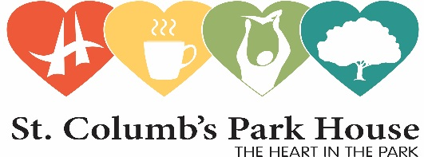

**JOB DESCRIPTION**

**Title:** The Bloom Project Community Engagement Officer

**Reports to:** Managing Director

**Gross Salary:**  £26000 per annum (NJC Scale 15)

**Contract Type:** 35 hours per week over 5 days (flexible working hours)

Fixed term contract completing May 2027

**Purpose and function of post:**

* This position will focus on co-ordinating and delivery of all elements of the activity programme in partnership with the Grounds & Garden Animator.
* Establish and facilitate a Steering Group to assist in the development of programmes, activities and community connection.
* Promote and communicate what The Bloom Project is about within the local Council area to ensure widest possible reach
* Building partnerships with local community groups and organisations to ensure wider community engagement
* Developing the community programme which will include activities that meet the diverse needs of a wide range of participants
* Assist in the recruitment a bank of volunteers to assist in the maintenance and development of the growing space
* To report to the MD and funders on a regular basis.
* Monitor and Evaluate the Project and collate data as required by the funder
* Manage and control all aspects of the project budget, reporting to funder as required
* Develop a range of impact measures to use in the lifetime of the project to show benefits to the community
* Any other reasonable duties as requested by the Director and relevant to the above post

**Duties and tasks:**

Building Relationships.

* In the community, connecting groups, participants and volunteers
* between all stakeholders involved park users, residents, community groups, carers

Communication PR and Social media

* community led approach
* safe space shared and accessible to all
* ensuring community buy in
* good news stories

Events

* Co-ordinate events in the Walled Garden, grounds of the House and Park eg monthly market place, Natures calendar
* Communication with volunteers, residents, steering group
* Promote the programme using a variety of medium including Instagram, facebook, community noticeboard and engagement with local resident associations, schools and care homes

General

* To act as an ambassador for St Columbs Park House
* Work in partnership with the key stakeholders.
* Report to MD and record baselines and impact measures throughout the project.
* To trouble shoot issues with the support of the MD and the wider stakeholder group.