# 

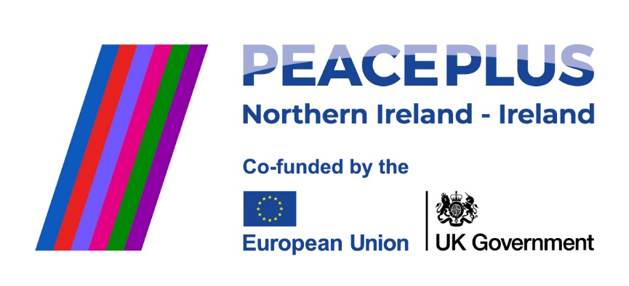

Supported by PEACEPLUS, a programme managed by the Special EU Programmes Body (SEUPB).

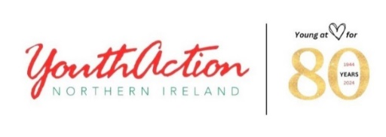

## **Job Description**

## ________________________________________________________________

Title: **Youth Worker**

**Shared Agenda for Peace**

Responsible to: Senior Leader for Membership Development: (Sheila Morris)

Links to: YouthAction NI-(Lead Partner) plus Project Delivery Partners

Contract: October 24 – September 28

Location YouthAction (to be confirmed)

Project: Shared Agenda for Peace

Funder: SEUPB (PEACEPLUS 3.1)

Hours: 37.5 hours per week

Salary £30,096

__________________________________________________________________________________

**About YouthAction NI**

YouthAction NI is an outward and forward-looking learning organisation with a conscious and evolving leadership culture that embraces self-evaluation and continuous improvement to best meet the changing needs of young people through youth work and youth arts. It is a membership-based youth work and arts charity that actively works with young people as partners to tackle inequalities in their lives. Through such intention and purpose our mission is to: improve their life chances; inspire them as activists; grow inclusive and outward looking communities; and build a peaceful and shared society.

The organisation has regional bases in Belfast (College Square North), Newry, Armagh, Kilkeel, Enniskillen and Derry/L’Derry. As part of our strategic goals, we strive for a sustainable and robust financial base that is used for high quality youth work and value for money outcomes. We demonstrate the highest levels of governance and operational excellence within a clear constitutional and legal framework.

_______________________________________________________________________­­­­____

**Company Benefits**

* Inclusive and Friendly Working Environment
* Attractive annual leave with length of service rewards
* Allocated well-being days at Christmas
* Occupational Family Friendly Policies
* Occupational Sick Pay
* Investors in People
* Time Off In Lieu
* Personal Development including in service training opportunities
* Investors in People

**DESCRIPTION OF PROJECT: Shared Agenda for Peace (PEACEPLUS 3.1)**

**Shared Agenda for Peace** is a regional youth work project operating in disadvantaged and polarised communities across 11 Northern Ireland Council areas and the 6 border counties of Ireland.

**Shared Agenda for Peace** is a youth work partnership between 7 organisations from Northern Ireland and Ireland including YouthAction NI (Lead partner), Bytes Project, Corrymeela Community, Fighting Words, Youth Link, Youth Work Ireland and YMCA Ireland. It includes 3 associate partners; Community Dialogue, Integrated Education Fund and Peace Players.

**Shared Agenda for Peace** will support 240 local youth groups, 432 volunteers and workers, and 5,280 young people age 11-25yrs from diverse community backgrounds to cooperate and work together in non-formal shared education programming that supports new and sustainable relationships while building cross-community, cross-border good relations.

Through **Shared Agenda for Peace,** locally based youth work groups/organizations will be supported to form Shared Learning Partnerships and commit to a minimum of a one-year programme of activities that build cultural awareness, enable meaningful contact and learning programmes and promote good relations across all levels of the organisation by:

1. **Developing the People**- *Capacity building with local volunteers and youth work staff through identifying support needs, developing specific plans, planning and delivering a range of shared learning training attributed to the needs of youth workers and volunteers.*
2. **Developing the Practice** -*Supporting quality youth work engagement with and between young people (age 11-24yrs) from different groups, involving purposeful planed exploration workshops, collective social action/activism and creative expression through music, sports, and /or art.*
3. **Developing the Organisation**- *Using a range of interactive methods and resources to support youth committees to develop local action plans to build and improve good relations.*

Through **Shared Agenda for Peace**, each local Shared Learning Partnership will co design and engage in the following:

* 5-6 support meetings and workshops at committee/board level.
* 10-12 meetings and workshops with staff/volunteers.
* 10hrs minimum training/capacity building for volunteers/workers.
* 30hrs minimum contact for young people as part of shared learning programmes.
* Additional 6 hrs pre and post-contact engagement with young people which will incorporate personal actions plans, youth achievement awards learning goals, group discussion, creative expression workshops, directed activism tasks, social action/volunteering, outdoor learning, residential experiences and personal mentoring.

**PLANNED CONTACT**

**Young people:** Will engage in a minimum of 30 hours contact throughout a 1 year period.

PRE CONTACT STAGE (6 hours) will focus on young people's expectations and opportunities for shared learning as well as consideration of empathy, trust, good relations, and creative expression workshops.

CONTACT STAGE (30 hours) will include centre-based visits, residentials, interactive youth-led contact days. Young people will have the opportunity to build trust with one another through team-building and facilitated reflection and sharing.

POST CONTACT (6 hours minimum) Young people will reflect on their experience and learning, and use this experience to educate their community, act as role models and inspire other young leaders.

**Youth Work Staff and Volunteers**: 10 hours of shared contact over a 1-year period. This can include 1-2-1 and shared support workshops, accredited training facilitated dialogue, shared learning self-evaluations, shared education curriculum resources, shared Learning events and digital platforms.

**Organisations:** Will engage in 5-6 support workshops at committee/board level over a 12-month period to develop and build relations between Shared Learning Partnerships to improve organisations policies, procedures, good relations, resources, staff development, Shared Learning celebrations. Organisations may also work towards achieving a Diversity Mark Award.

**OUTPUTS /TARGETS**

* Develop and support 6 Shared Learning Partnership per year (12 local member groups).
* Support the 12 local members to develop and build capacity of staff volunteers and board / committee members.
* Engage 240 young people age 11-24yrs in addressing Good Relations, Citizenship, Personal Development (20 young people per group per year @ 12 local groups). Minimum 80% attendance.

**__________________________________________________________________________________**

**JOB RESPONSIBILITIES**

**PROMOTION AND RECRUITMENT**

* Promote, recruit and retain target number of young people and local youth work organisations within the council area.
* Recruit young people from each of the respective local youth work/member groups and Shared Learning Partnerships.
* Work alongside the **SHARED AGENDA FOR PEACE** consortium to recruit youth work groups each year through its extensive membership network
* Identify and agree local shared learning partners that will connect through a clear MOU (memorandum of understanding).

**DELIVERY AND RETENTION OF PARTICIPANTS (80%)**

* Adopt various methods of engaging and connecting local groups to help develop shared learning partnerships.

The youth worker will:

* Identify and assess the needs of individual youth work organisations to ensure a menu of options - appropriate training, support measures and shared learning opportunities are tailored to meet the needs of young people, youth work staff and volunteers, including committee/board members.
* Ensure young people and organisations are co designers of programme activities and learning outcomes.
* Draw on existing partnerships and develop new networks to enhance recruitment and programme development.
* Work with each shared learning partnership to develop a **shared learning partnership agreement / MOU** and to monitor and record progress toward achievement of goals.
* Plan appropriate programmes that will develop the practice, develop the people and develop the organisation**.**
* Ensure **cross community** elements of programme and participation of young people and youth organisations.
* Deliver a suite of **accredited training** up to and including Level 1-3 CRED qualifications (QCF) as required.
* Undertake the assessment of **portfolios for accreditation** through awarding bodies (OCNNI etc).
* Use the ‘**Agenda for Peace’** as the quality framework to recognise and measure the achievements and outcomes for all participating youth organisations.
* Liaise with the Quality Assurance coordinator within the Training Team at YouthAction to ensure delivery and assessment of programmes is in line with awarding body requirements.
* Organise **one to one and shared** support workshops and activities to enhance shared learning and personal development of youth workers, volunteers, and young people.
* Organise residentials, **cross community and cross border contact** and youth led interactive contact days for young people on a regular basis
* Provide support and workshops to youth work organisations at committee/ board level to **promote inclusive and welcoming youth work organisations** that value difference and diversity.
* Provide **post programme support** to each shared learning partnerships to identify plans for continued collaboration, with check-in reviews and support them to engage in the Youth Bank Model.
* Undertake Child Protection and Vulnerable Adult training when requested and implement in programmes.

**MONITORING AND EVALUATION**

* **Measuring Distance Travelled -** The Shared Agenda for Peace youth worker will use an established monitoring and evaluation measurement framework aligned to the Peace Plus Shared Learning Together programme. Project result and output indicators will be monitored in a systematic way throughout the project.

The youth worker will:

* Utilise the simple evaluation form devised by YANI will be adopted by all partners throughout the programme.
* Develop organisational action/development plans and reviews, including distance travelled by each local youth group partner and Shared Learning Partnership.
* Record impact and the learning outcomes/journey set by the young person.
* Record, monitor and update on a monthly basis (participant details, contact records, one to one contact, shared contact days, session plans, qualifications, etc.) to meet the data requirements of the funders and the organisation.
* Provide monthly progress reports against targets set to line manager and project manager.
* Document and present examples of models of best impact practice including benefits, outcomes and outputs from the project.
* Attend and actively contribute to quarterly self-evaluation project partner meetings as part of our quality improvement process.
* Link with and contribute to other initiatives within the **Shared Agenda for Peace** project as required.

**FINANCE AND ADMINISTRATION**

The youth worker will:

* Report on the financial and programme activities of Shared Agenda for Peace quarterly on the JEMS system.
* Maintain administrative systems required to support the work of the project (raising cheque requisitions, purchase orders, plan ahead with administrative requirements).
* Robustly manage and maintain participant details/expense records for monitoring and auditing purposes, following Youth Action’s procedures.
* Work within agreed budgets, as laid down by Youth Action Northern Ireland Senior Youth Worker.
* Comply with Youth Action Northern Ireland’s financial procedures at all times.

**GENERAL**

The youth worker will

* Complete any other duties as directed by the Senior Leader at Youth Action Northern Ireland.
* Provide support YouthAction NI’s network of members on an ongoing basis.
* Develop an understanding of the ethos, aims and objectives of the volunteering policy, strategy and plan of Youth Action Northern Ireland.
* Complete any necessary reports, evaluations and accreditation documentation as required/providing regular progress reports.
* Reflect the ethos, policies and practice of Youth Action Northern Ireland at all time (adhering to the youth workers charter) and demonstrate integrity, maturity and good judgement at all times.
* Comply with Youth Action Northern Ireland’s “Protecting Children, young people and young adults – policy & procedures, including good practice guidelines” at all times.
* Become familiar with and adhere to Youth Action’s policies and procedures at all times

**ESSENTIAL CRITERIA:**

* Third level qualification in Youth and Community Work or relevant discipline
* Possess a minimum of two years’ professional experience working with young people in a youth work or informal setting.
* Minimum five years’ leadership development in Peacebuilding, including delivering cross-community, cross border or shared education youth programmes related to good relations or peacebuilding.
* Previous experience in delivering training and accredited courses to young people, youth work staff and volunteers.
* Proven track record in working towards targets/outputs.
* Possess good organisation skills, with the ability to prioritise effectively.
* Possess excellent communication skills and the ability to work with multiple stakeholders, partners, and organisations as part of the wider project.
* Possess effective personal management skills and have the ability to work on own initiative.
* Possess a current UK driving licence and access to a car on appointment to be able to travel across various locations. This criterion will be waived in the case of applicants whose disability prohibits driving but who have access to a form of transport which will permit the applicant to meet the requirements of the post.
* Previous experience with Microsoft Office packages, particularly Word and Excel.

**DESIRABLE CRITERIA:**

* Previous experience of working in the Charity/Youth Work Sector.
* Peace Building Qualifications such as OCN Level 2, 3, 4 in CRED.

**__________________________________________________________________________________**

**Application Forms can be requested from Mark McGinley at** [**mark@youthaction.org**](mailto:mark@youthaction.org)

**Closing Date: 4pm on Friday 30th August 2024**

**Interviews will be held on Monday 23rd September 2024**