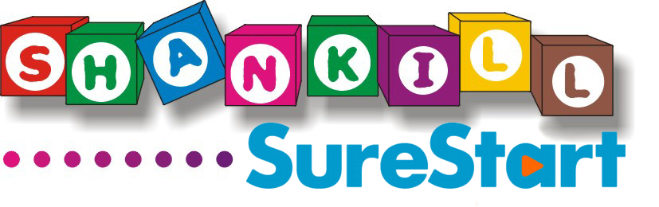
JOB DESCRIPTION

Job Title: Early Learning Coordinator

Salary: £19,285.50

Hours: 30 hours per week/39 week term-time contract
paid for 43 week to include 4 weeks annual leave.
Paid over 52 weeks

Accountable to: Greater Shankill Partnership

Line Manager: Shankill Sure Start Project Coordinator

Holiday Entitlement: 25 days, plus 12 statutory holidays, pro-rata for part-time staff

Location: Alessie Centre

Main Purpose of the Job
The Early Learning Coordinator (ELC) will be responsible for planning, organising, implementing and monitoring a stimulating and varied programme of play-based activities and learning experiences for children attending the Sure Start Developmental Programme for 2 – 3 Year Olds (Pf2Y). The Early Learning Coordinator will also be responsible for helping plan, in collaboration with childcare staff, a programme of activities for children attending other Sure Start programmes.

Key Responsibilities

- To support the development of the Sure Start Developmental Programme for 2 – 3 Year Olds through observing and monitoring practice within each Pf2Y setting, including supporting staff embed training into practice.

- To ensure stimulating, play-based activities are provided for children aged 0 – 3 years
attending Shankill Sure Start centres which will promote their speech and communication, social, physical, intellectual, creative and emotional development and which are appropriate to the child’s age and stage of development.

- To be responsible, in collaboration with Programme Supervisors, for the coordination of Stay and Play sessions and helping to maximise parental involvement in the Pf2Y.

- To be responsible for ensuring consistency across all Pf2Y’s in terms of ethos, practice etc.

- To be responsible for the provision of support and regular supervision to Programme Supervisors within the Pf2Y and maintaining relevant records relating to this.

- To act as Designated Officer, liaise with Social Services, attend Case Conferences as appropriate and respond to any concerns and/or disclosures raised by Pf2Y staff.

- To be responsible for making arrangements to ensure appropriate staff ratios are maintained at all times, organising cover for staff on leave (eg during holidays, sick, maternity etc.) and on training.

- To work collaboratively with Programme Supervisors and the wider Sure Start staff team to maximise outcomes for children and ensure that the needs of individual children and families are met. This will include goal setting, Individual Learning Plans (ILP’s) and identification of children who may require onward referral.

- To promote an understanding among childcare staff of the importance of providing quality play-based learning experiences for children’s development and ensuring the needs of children attending the Sure Start Centres are met, including those with special/additional needs.

- To coordinate and manage childcare staff to facilitate crèches for Sure Start programmes eg Cook it! and other parenting programmes delivered by Sure Start staff.

- To ensure settings have and maintain a good standard of hygiene, health and safety and ensure adherence to health and safety legislation and guidelines in accordance with Minimum Standards (DHSSPS, 2012) and other relevant legislation.

- To prepare for Social Services and ETI inspections and ensure any recommendations made are implemented, were appropriate.

- To liaise with Programme Support Specialists to ensure that the support provided meets the needs of the staff team and programme provision and ensuring Pf2Y staff attend Cluster Group meetings.

- To be responsible for managing a budget for programme/activity costs for Pf2Y.

- To be responsible for completing administrative duties associated with pay roll/leave etc. and ensuring these are presented to payroll on a timely basis

- To keep informed of changes in relevant policies and legislation that impact on early years and ensure childcare staff remain informed, as well as other project staff, as appropriate.

- To contribute to the development of policies relating to childcare and ensure compliance with relevant legislation at all times.

- To assist the Project Coordinator and other relevant staff in allocating places on the Pf2Y. This includes carrying out pre-allocation visits to all families completing an Expression of Interest form.

- To assist in the identification and organisation of appropriate training for all childcare staff.

- To be responsible for own personal development by updating knowledge and attending training relevant to the position. This includes attending ELC Cluster Group meetings.

- To liaise with training providers in relation to students seeking childcare placements and throughout the placement period

- To be responsible for ensuring monitoring returns for Sure Start Play database are received from Pf2Y settings on a timely basis, in line with the requirements of the Dept of Education and/or the Eastern Childcare Partnership.

- To report to the Project Coordinator on a regular basis on all issues relating to childcare practice within the project and submit reports to Project Coordinator and Early Years Sub Committee as required.

- To make yourself available for supervision meetings and team meetings as required. To be responsible for chairing and minuting regular meetings of the Pf2Y team.

- To develop supportive relationships with early years’ settings within the Greater Shankill area. This includes liaison with local Nursery schools and early year’s providers to ensure smooth transitioning of children in and out of Pf2Y, as well as promotion of Message of the Month initiative within the Greater Shankill community.

- To promote and advocate Shankill Sure Start’s vision and underlying principles and ensure that good practice guidelines are adhered to at all times.

- To work as a member of the Shankill Sure Start multi-disciplinary team, ensuring relevant information is shared with for example health professionals within the team eg SLT, HV etc.

- To work in a confidential and professional manner at all times and ensure that client welfare and safety is of paramount importance.

- To be responsible for the cover of sickness or annual leave arrangements across the P2Y0 settings.

- To undertake any other relevant duties considered appropriate by the Project Coordinator or Early Years Sub Committee.

The duties and responsibilities outlined in this job description are not meant to be definitive nor restrictive and may be modified to meet changing needs. It should be noted therefore that duties, designation and location of the post might be subject to change in the future to meet the changing requirements of the service.

Early Learning Coordinator - Personnel Specification

PERSON SPECIFICATION

Job Title: EARLY LEARNING COORDINATOR
Salary Scale: £19,285.50
Hours:
30 hours per week/39 week term-time contract
paid for 43 week to include 4 weeks annual leave.
Paid over 52 weeks

Reports to: Early Years Project/Shankill Sure Start Manager

Essential Criteria

Qualifications and Experience:
- QCF Level 5 Diploma in Leadership for CCLD Management Pathway or equivalent
- A minimum of two years’ paid experience in employment working with children aged 0 – 3 years, gained within the last four years
- A minimum of 2 years’ experience of managing staff in an early year setting

Knowledge:
  - Knowledge and understanding of current issues and legislation in childcare
- Knowledge and understanding of the importance of the role of parents and carers in children’s development
- Knowledge and understanding of the importance of quality play for children’s development
- Knowledge of Minimum Standards for Childminding and Daycare for Children Under 12

Abilities:
- An ability to work as part of a multi-disciplinary team and on own initiative
- Good interpersonal skills
- A good standard of written and verbal communication skills
- A full, current driving license enabling the holder to drive in NI and the use of a
vehicle for business purposes.

Desirable Criteria:
- BA Hons Degree in Early Childhood Studies
- Certificate in Supervisory Management
- Completed Pf2Y training

