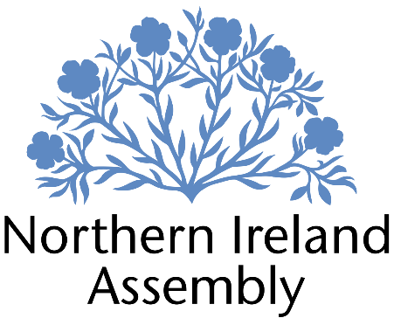

**Michelle Guy MLA**

*Alliance Party Member of the Northern Ireland Assembly for Lagan Valley Constituency*

**CONSTITUENCY, CASEWORK AND COMMUNICATIONS OFFICER**

|  |  |
| --- | --- |
| Report to: | Michelle Guy MLA |
| Office Location: | Primarily Lagan Valley Constituency Office but also, as required, Parliament Buildings, Stormont |
| Hours: | 37 hours per week |
| Holidays: | As per determination |
| Salary: | £34,569 Grade 2 (2) |
| Pension: | A central Assembly-approved pension scheme is provided. If enrolled an amount equivalent to 10% of employees salary will be paid into the pension scheme. |
| Duration: | Permanent.  Employment contingent upon member remaining an MLA or until legislation is introduced to change Constituency expense provision. Six-month probation period shall apply. |
| Closing Date | Noon, Friday 30th August 2024 |
| Interview dates: | It is anticipated that shortlisted candidates will be interviewed during week beginning 2nd of September 2024 |

# JOB DESCRIPTION

The Constituency, Casework and Communications Officer will be the key point of contact responsible for managing casework and constituency queries to support the work of Michelle Guy MLA. This is a vital role that requires someone who is dedicated, proactive, organised and resourceful. The postholder will also be responsible for the day-to-day management of the constituency office.

* To assist in the work of the Constituency Office by delivering effective casework as part of Michelle Guy MLA’s constituency services, and any other duties required to run the Constituency service
* Log casework, monitor progress and take appropriate action
* Deal with enquiries sensitively and confidentially
* Review key themes emerging from casework to identify issues to be progressed either with statutory agencies or by legislative action.
* Responsibility for efficient data and file management to comply with GDPR and data management
* Planning and organising meetings and provision of secretarial support as required
* Liaising with groups within the constituency and the general public on behalf of Michelle Guy MLA
* Responding to correspondence and enquiries from constituents, media, lobbyists, businesses and community groups in conjunction with Michelle Guy MLA's requirements
* Dealing with complex queries and complaints on the Member’s behalf, including drafting letters for the Member to sign
* Attending surgeries and as appropriate
* Responsible for overseeing the day-to-day management of office equipment, resources and operational expenses as required
* Attending work related training and networking meetings to develop skills
* Other duties as required in support of the MLA carrying out their Assembly duties

**Communications**

* Publish updates to social media platforms to support and promote the work of Michelle Guy MLA
* Other communications related tasks as required such a press releases, linking in with local journalists and producing video content **PERSON SPECIFICATION**

|  |  |  |
| --- | --- | --- |
|  | **Essential Criteria** | **Desirable Criteria** |
| **Professional / Technical Qualifications** | * Five GCSE’s / O’ Levels or Equivalent at Grade C or above including both English Language and Mathematics * Excellent written skills (Grammar, punctuation and spelling) * Proficiency in the use of * Microsoft Outlook, Word and Excel packages | * 7 GCSEs at Grade C or above including Maths and English Language * ICT qualification * Customer Care qualification |
| **Experience / Job Knowledge** | * Experience of working with a range of stakeholders to achieve outcomes * Previous experience of working with the public * Ability to update and maintain a database * Proficiency using key social media platforms such as Facebook, Instagram and X (Twitter). * Experience of working in an office environment * Experience of working on complex projects * Working knowledge of the Benefits and Housing processes in Northern Ireland | * Campaigning experience, political or otherwise * Experience of working with volunteers * Knowledge of the workings of the Northern Ireland Assembly * Experience of working in a small team * Experience of the advice sector * Experience of using casework or similar software package. * High proficiency using social media including producing video content and adding captions. |
| **Personal Qualities /**  **Skills** | * Good punctuality * Excellent verbal communication skills in person and on the phone * Flexible, innovative and enthusiastic approach to work duties * Understanding of Alliance Party objectives | * Patience and compassion * Time management * Ability to multi-task |
| **Circumstances** | * Able to work unsupervised and as lone worker in office when required | * May be required to travel to meetings/appeals |

Applicants must demonstrate clearly on their application form how they meet the criteria.