

Board Member

Information for Applicants



Contents

Background Information …………………………………. Page 3

Our Visions and Values …………………………………. Page 4

How to Apply ……………………………………………. Page 5-6

The Role …………………………………………………. Page 7 -9

Background Information

Victim Support has focused on addressing the harm caused to victims and witnesses of crime since 1981. On a daily basis we witness the impact of crime and the Criminal Justice System can have on an individual, their family, friends, and the local community.

Our Redress, Restore, Recover strategy for 2020-24 builds on our past successes, sets out what changes we wish to see and what we as an organisation will focus on to help achieve this.

It aims to address the recovery and wellbeing needs of victims and witnesses by addressing the harm and vulnerability caused by crime. It broadens our focus on the justice journey to include the wider recovery journey and needs of victims of crime.

Please find below the links to our Strategy on the website and on YouTube showing an animation explaining the Strategy.

**Website:** <https://www.victimsupportni.com/site/wp-content/uploads/2020/11/Strategy-document-2020-24.pdf>

**YouTube:** <https://youtu.be/pDRNwBT4hsc>

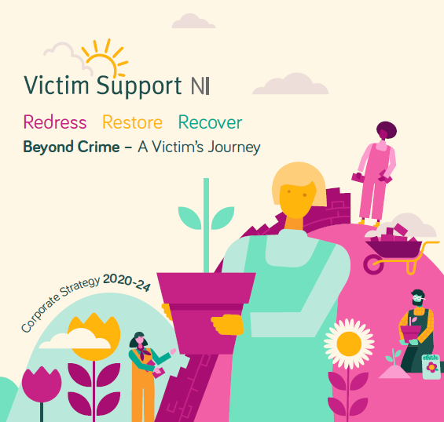

Our Vision & Values

A society that ensures tailored support and information is available for people affected by crime

The long-term vision of our organisation is of..



Our mission is to..

Reduce the harm caused by crime and advance the rights of victims and witnesses of crime in Northern Ireland

Our core values of Integrity, Respect & Compassion allow us to respond to the needs of victims and witnesses, providing tailored support, enabling them to recover and move on from the impact of crime. We will help victims to seek redress when their needs are not met. We will uphold and promote the rights of victims and witnesses, and will campaign for a cross governmental approach to address the harm and vulnerability caused by crime.

HOW TO APPLY

PLEASE READ THE FOLLOWING INFORMATION CAREFULLY BEFORE COMPLETING THE APPLICATION FORM

**Applications and attached sheets CV’s :**

* Applications will only be accepted on Victim Support NI application forms. Cv’s will not be considered
* It is the responsibility of all applicants to clearly demonstrate – in their application form – exactly how they meet the essential (and desirable if applicable) criteria for the post as stated. Failure to do so may result in not being short-listed.
* Attached sheets – within the word limit – will only be considered where they are continuation sheets of a section of the Application Form where insufficient room was available to include all the necessary details.
* All information provided by an applicant on an application form must be true and accurate. Any application forms containing information that is discovered to be untrue or inaccurate will not be accepted. If an appointment has already been made, it may result in disqualification from appointment or dismissal.
* Applications submitted by email will require a handwritten signature at interview.
* Applications must be received by the designated deadline (time and date). Those applications received after the designated deadline will not be accepted.
* Completed applications should be emailed to [recruitment@victimsupportni.org.uk](mailto:recruitment@victimsupportni.org.uk) OR by post to the HR Department, Victim Support, Albany House, 73-75 Great Victoria Street, Belfast, BT2 7AF.
* **Please note that it is our policy to communicate with applicants primarily by email, so we ask that you check your email account regularly to avoid missing any emails**.

It is recommended that you use the following model to describe experience:

**Situation:**

Describe a specific example that relates to the criteria

**Task:**

Explain the context or background to the example. Who else was involved? What were the particular circumstances etc?

**Action:**

Outline the specific actions you took to meet the challenge

**Result:**

Describe the result or outcome of your actions. Consider if, with hindsight, your actions were correct; what, if, anything would you do differently now; and what have you learnt from this experience.

For further information on the STAR method please see the link below:

[The STAR method (nationalcareers.service.gov.uk)](https://nationalcareers.service.gov.uk/careers-advice/interview-advice/the-star-method)

**Selection and Interviews**

* Where a high volume of applications is received, desirable criteria may be relied upon during shortlisting.
* The interview process may include the use of selection tests in addition to a panel interview.
* Candidates shortlisted for interview will be advised of the interview process via email.
* At interview candidates will be questioned about their experience regarding the main functions of this post.
* The interview panel will assess all candidates based on performance during selection tests and at interview.
* Should you require reasonable adjustments when attending interview, please let us know to ensure we can accommodate your needs wherever possible.

**Waiting Lists**

* A waiting list **may** be retained for a period of 12 months for future vacancies for similar positions.

##### **ROLE DESCRIPTION**

**OVERALL PURPOSE**

The role of the Board Members is to contribute to the effective governance of Victim Support NI in promoting the aims/objectives of VSNI.

**PURPOSE OF THE BOARD**

The purpose of the Board is to provide the overall governance and leadership for Victim Support NI around an agreed vision, mission and values and ensure the organisation fulfils its financial and legal responsibilities and promotes best practice.

**MAIN RESPONSIBILITIES OF THE BOARD**

**GOVERNANCE**

The Board will ensure that Victim Support NI is effectively and accountably governed.

**PLANNING**

The Board will ensure Victim Support NI has a clear sense of direction which is effectively articulated in agreed strategic and operational plans which are effectively implemented and regularly reviewed.

**SERVICES**

The Board will ensure Victim Support NI provides high quality services that meet the needs and expectations of service-users.

**FINANCIAL**

The Board will ensure that Victim Support NI’s resources are managed prudently and accountably in achieving the aims and objectives of the organisation.

**INCOME GENERATION**

The Board will ensure Victim Support NI generates sufficient income to achieve its aims and objectives.

**HUMAN RESOURCES**

The Board will ensure Victim Support NI fulfils its responsibilities as a good employer of staff and volunteers.

**HEALTH & SAFETY**

The Board will ensure that Victim Support NI fulfils its responsibilities for the safety, health and welfare of service-users, volunteers, staff and visitors.

**INTERNAL & EXTERNAL COMMUNICATIONS**

The Board will ensure there are good relationships between the Board and staff and volunteers and between VSNI and other relevant agencies.

**SPECIFIC RESPONSIBILITIES OF BOARD MEMBERS**

* Board Members are required to read all papers circulated in advance of the relevant meetings.
* Put forward items of the agenda in advance of meetings.
* Regularly attend and positively participate in all meetings of the Board.
* Board Members should keep to the agenda during meetings.
* Contribute to Board meetings through the Chair.
* Contribute to fully informed decisions by being aware of the work of VSNI, and seek clarification as necessary.
* Bring to the Board, a broad perspective on the organisation as a whole and avoid promoting sectional interests.
* Declare any potential conflicts of interests and do not be present for any discussion where you may have such a conflict of interest.
* Follow and accept the direction and authority of the Chair, concerning the process of the meeting.
* Apologise in advance if absence is unavoidable
* Accept collective responsibility for the decisions of the Board.
* Within the constraints of openness & accountability, maintain the confidentiality of items designated as confidential by the Chair and the contribution of individuals to Board meetings.

**COLLECTIVE REPONSIBILITIES OF BOARD MEMBERS**

Please note that individual Board members do not have any authority in relation to VSNI outside the collective authority of the Board, unless specific authority is delegated by the Board.

OFFICE-BEARERS

* The Board Members will consider who would best fills office-bearer roles and will contribute positively to the election of office-bearers.

COMMITTEES, SUB-COMMITTEES & WORKING GROUPS

* Board members are expected to actively participate in appropriate committees, sub-committees and working groups.

STRATEGY

* Promote the mission, vision & values of Victim Support NI.
* Contribute to the drawing up and monitoring of strategic and operational plans.

INFORMATION & TRAINING NEEDS

* Identify own training and information needs as a member of the Board and participate in appropriate training and/or development activities.

RELATIONS WITH STAFF, VOLUNTEERS AND SERVICE-USERS

* Board members are encouraged to maintain appropriate relations with staff and volunteers, in accordance with the code of practice and organisational policy and procedures.

HEALTH & SAFETY

* Take reasonable care for the health & safety of yourself and others.
* Co-operate with Victim Support NI in complying with relevant health & safety requirements. He/she should not interfere with or misuse anything provided in the interests of health & safety.
* Identify and report potential hazards.

GENERAL

* Exercise individual skills to the benefit of the Board’s work.
* Board Members should reflect the ethos/core principles of the organisation in your dealings at Board level.
* Board Members will act in accordance with the Code of Practice.

TIME COMMITMENT:

* Board Members are expected to attend all board meetings and one sub-committee group.
* All Board Meetings – these take place on a quarterly basis, on a Thursday evening from 5pm – 7pm – Victim Support NI, 1st Floor Albany House, 73-75 Great Victoria Street, Belfast, BT2 7AF
* One Sub-Committee Group - Board members are expected to participate in either our FARR Committee (Finance , Audit, Risk and Remuneration) or GPC (General purposes Committee). These take place on a quarterly basis also, on a Tuesday evening from 5pm – 7pm