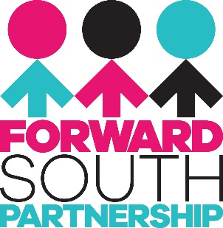

JOB DESCRIPTION

Job Title: South Belfast Community Health Capacity Worker

Based at: Forward South Partnership, 23 University Street, BT7 1FY

Responsible to: Strategic Health & Wellbeing Officer

Purpose:
To build the capacity of local residents and communities to identify and address health inequalities in South Belfast Communities that have areas of weak infrastructure and community support. A key focus will be on developing the use of existing community assets such as community hubs / centres, churches, volunteers, and local community groups to build capacity and increase delivery of health-related programmes and events. The post holder will engage and support local people to identify health needs and develop programmes and initiatives to address these. Where funding is required for delivery of these activities the post holder will seek to secure funding. The worker will also build relationships which enable residents, tenants, groups, associations, and businesses to develop their capacity to engage with the Belfast Agenda, Local Development Plan, and the Making Life Better strategy. The successful applicant will be based between the offices of Forward South Partnership and community outreach is a key facet of the post.

Main Duties:

- To coordinate and deliver community capacity building and health promotion programmes to support local people to identify and address health needs.
- To develop relationships and work in partnership with community and statutory stakeholders.
- To apply for, manage and report on funding for activities related to health and community development.

Range of duties:
- To build relationships with new and existing groups in South Belfast communities that have been identified as areas of weak infrastructure and community support.
- To engage and motivate people of all ages and backgrounds in meaningful conversations related to health needs.
- To encourage and support local people to develop their skills and knowledge in order to deliver health outcomes.
- To access and link into existing programmes and resources related to health.
- To work collaboratively and link with existing groups, businesses, and statutory agencies.
- To provide support to the work of the Strategic Health Officer at Forward South Partnership, in particular the South Belfast Health Strategy.
- Source funding opportunities and complete funding applications.
- To manage and monitor budgets and provide monthly reports.

Terms & Conditions:

Salary: £25,641.72 per annum

Pension: 6% employer’s contribution

Hours: 28 hours / 4 days per week

Holidays: 28 per year plus public and bank holidays (pro rata based on FTE)

This post is funded through the Public Health Agency until 31/03/2025, extended further depending on confirmation of funding.

