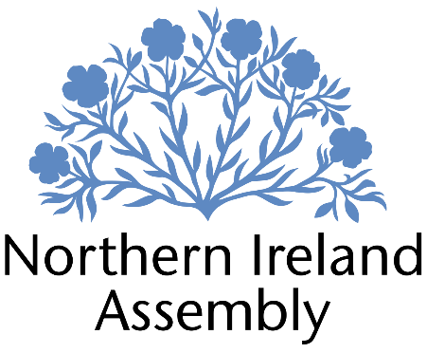

**Nick Mathison MLA**

*Alliance Party Member of the Northern Ireland Assembly for Strangford*

**Policy & Communications Officer (Fixed Term Appointment)**

|  |  |
| --- | --- |
| Report to: | Nick Mathison MLA |
| Office Location: | Parliament Buildings, Stormont & 19 High Street, Comber |
| Hours: | 30 hours per week, Monday to Friday |
| Holidays: | 28 days plus public holidays |
| Salary: | Grade 2, £33,409 per annum (pro rata) |
| Duration: | Fixed term until 31st March 2025 |

|  |  |
| --- | --- |
| Closing Date | Thursday 15th August 2024  Interviews for shortlisted applicants are expected to take place on Thursday 22nd August 2024 |

# JOB DESCRIPTION

Providing policy and comms support for Nick Mathison MLA

**Duties**

* Carrying out policy research on all areas of NI Executive responsibility
* Briefing MLA to assist with preparation for Assembly debates and Committee sessions
* Writing speeches for the MLA for debates in the Assembly and other events
* Preparing written and oral questions for the MLA
* Keeping MLA briefed on educational policy developments
* Facilitating ongoing engagement with educational stakeholders to inform policy development
* Drafting letters for MLA to NI Executive Ministers and senior officials
* Supporting the MLA with diary management
* Supporting MLA with management of social media profiles and writing of press releases
* Any other duties required to enable MLA to carry out his role at the NI Assembly effectively

**PERSON SPECIFICATION**

|  |  |  |
| --- | --- | --- |
|  | **Essential Criteria** | **Desirable Criteria** |
| **Professional / Technical Qualifications** | * Educated to degree level or able to demonstrate 1 years paid experience in a policy-based role * Excellent working knowledge of all Microsoft Office packages | * Degree in relevant subject |
| **Experience / Job Knowledge** | * Working knowledge of Northern Irish political system * Experience of writing policy or research briefings * Experience of stakeholder engagement | * Knowledge of legislation and policy related to NI education system * Understanding of NI Assembly processes and procedures * Experience of producing social media content and / or drafting press releases * Experience of using video editing software |
| **Personal Qualities /**  **Skills** | * Excellent verbal communication skills * Excellent written communication skills with ability to adapt style to various contexts * Ability to manage workload based on changing priorities * Excellent organisational skills * Ability to work proactively on own initiative * Committed team player * Understanding of Alliance Party aims and objectives | * Experience of diary management for an individual or team |
| **Circumstances** |  | * Available for a start in 1st or second week of September |