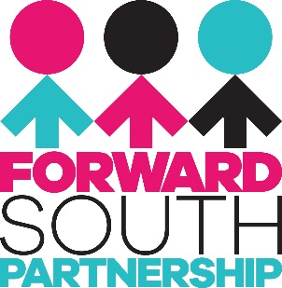

South Belfast Community Health Capacity Worker

PERSON SPECIFICATION

Core Competencies:
Applicants should be highly motivated, have an outgoing personality and be a good organiser with excellent communication skills. The successful candidate will have the skills to work within a small team contributing to the work of the South Belfast Health Strategy. As well as being self-organised and flexible, the post holder will be able to manage own time effectively and work anti-social hours (evenings, weekends) as necessary and must have access to transport.

Experience and Qualifications:

Essential Criteria

- At least one year experience of delivering health and capacity building programmes within a community development setting
- or a third level qualification in a relevant subject (e.g.: community development, sport development or health science)

Skills and knowledge:

Essential criteria

- Understanding of how to use community development approaches to identify and address health needs.
- Excellent communication skills including presentation, facilitation and report writing skills.
- Computer literate, able and willing to keep written and electronic records.
- Demonstrable ability to mobilise community interest to community engagement.
- Experience of engaging and working with a diverse range of stakeholders.
- Evidence of Confident, sensitive and effective interpersonal and communication skills
- An understanding of statutory and community provision that would assist the community development process.
- Knowledge of Community based programmes and interventions to improve health and wellbeing in communities.
- Proven track record in making and managing successful funding applications.
- Proven ability to project plan, management of budgets and evaluation of projects.
- Experience of organising events, for example health fairs, family events, seminars and workshops.

Desirable Criteria
- Strategic knowledge, awareness and understanding of the Making Life Better public health strategic framework.
- Strategic knowledge, awareness and understanding of the Belfast City wide and locality community planning agenda.
- Experience of procurement and tendering processes.

