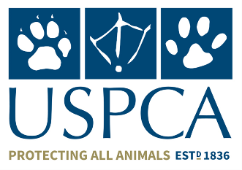
Thank you for your interest in working for the USPCA. Please complete this Application Form and return it by email to: recruitment@uspca.co.uk
The information you provide is strictly confidential and will be used only to administer your application.
About You
Full Name

Address

Postcode

Email

Telephone

Mobile

Full Clean UK Driving Licence: YES/NO

Years held for:

Role Applying for: _________________________________________________________________

My current Employment Status: _____________________________________________________

Employment History: (Please start with your current/most recent employer and work back in chronological order.

Employer and Address –  Most Recent | Job Title | From and To | Tasks/Responsibilities involved

EDUCATION/QUALIFICATIONS

School/College | Dates From/To: | Qualifications

RELEVANT EMPLOYMENT EXPERIENCE INCLUDING DATES

Statement in Support of Application
Please outline below how your experience to date meets the essential and desirable criteria for this role, giving clear examples, dates, etc.

Statement in Support of Application
Referees
Please provide the names and contact details of two referees. One of these should be your current or most recent employer.

Full Name: | Full Name:
Address: | Address:
Telephone: | Telephone:
Email: | Email:
Relationship: | Relationship:
NB: FAILURE TO COMPLETE AND SIGN THIS FORM MAY RESULT IN YOUR APPLICATION NOT BEING SHORTLISTED

DATA PROTECTION STATEMENT
The information that you provide on this form and obtained from any other relevant sources will be used to process your application. The personal information that you give us will also be used in a confidential manner to help us monitor our recruitment process. If you succeed in your application, the information will be used in the administration of your employment with us and to provide you with information about us. We may also use the information if there is a complaint. We may check the information collected, with third parties or with information held by us. We may also use or pass certain third parties information to prevent or detect crime, to protect public funds, or in other ways permitted by law. By signing the application form we will be assuming that you agree to the processing of the sensitive personal data, (as described above), in accordance with the Data Protection Act.
I declare that to the best of my knowledge, the information given is honest and accurate.
I confirm that I have the right to work in the UK.
I understand that any false/misleading statements and/or omissions may result in my application being rejected or if I have already taken up my role, being asked to leave.

Signed: ________________________________________________ Date_____________________

