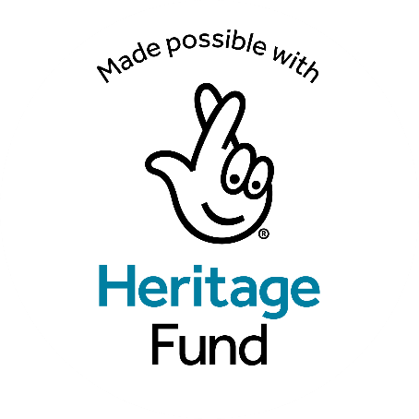

The Crafting Legacies Programme

Project Overview:
Enterprise Causeway, a not-for-profit social enterprise, is pleased to launch the Crafting Legacies Programme, made possible with the support of The National Lottery Heritage Fund.

Thanks to National Lottery players, this heritage outreach initiative will be based at the Courthouse Shared Space Creative Hub in Bushmills. The programme aims to connect local people and the community to their rich heritage through a variety of engaging activities and events.

Programme Objectives:
The Crafting Legacies Programme seeks to deliver the following:
- Engage Diverse Audiences: Target rural groups, older individuals, women, community groups, isolated families, and disadvantaged populations to participate in heritage activities, ensuring inclusivity and broad community involvement.
- Educational Workshops: Offer traditional skills workshops in woodworking, weaving, ceramics, and more. These workshops will be delivered from August 2024 to December 2024, providing hands-on learning opportunities that celebrate and preserve local crafts.
- Youth Engagement: Conduct tailored workshops and camps for young people, including a summer camp and school group sessions. These activities will offer immersive experiences linked to the historical periods associated with the Courthouse.
- Masterclasses and Volunteer Training: Host specialised heritage crafts masterclasses and provide training for local volunteers in research, archiving, oral history, and guiding tours, fostering community-led heritage preservation.
- Digital Content and Interpretation: Develop digital interpretation materials to enhance visitor experiences and attract over 1,000 annual visitors. This includes creating multimedia content that makes heritage learning more accessible and engaging.
- Community Events: Organise a Heritage Celebration Event at the Bushmills Salmon & Whiskey Festival, promoting a sense of shared heritage and community spirit through various activities and demonstrations.

Anticipated Outcomes:
- Heritage Preservation: By delivering a diverse range of heritage workshops, the programme will actively contribute to the preservation and promotion of traditional skills. Masterclasses and outreach programs will ensure that valuable craftsmanship is not only remembered but practiced and passed on to future generations.
- Community Engagement: Engage and upskill community members, particularly targeting those traditionally not involved in heritage activities.
- Social Inclusion: Promote inclusion and social cohesion by involving participants from various backgrounds, strengthening community bonds and pride.
- Environmental Sustainability: Implement eco-friendly practices in workshops and encourage sustainable transportation, contributing to environmental conservation.
- Educational Impact: Provide valuable learning opportunities for local schools and educational institutions, instilling an appreciation for heritage from an early age.
- Digital Integration: Utilise digital resources to create immersive and accessible heritage learning experiences.
- Economic Development: Support local artisans and small businesses, stimulate the local economy, and create job opportunities.
- Long-term Legacy: Ensure the project's benefits continue through trained volunteers, digital resources, and ongoing heritage activities.

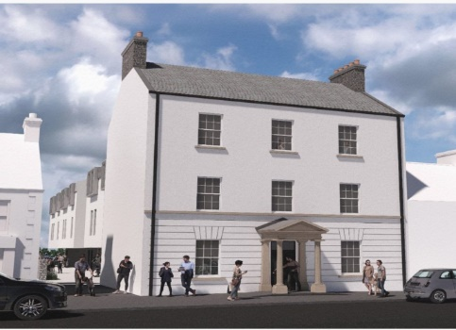
The Courthouse Shared Space Creative Hub, Bushmills. https://www.facebook.com/thecourthousepeaceiv/
The project aims to revitalize the Courthouse, converting it into a versatile space that will include retail areas, a café, dedicated spaces for business workshops, exhibition and event zones, and community spaces.
This initiative represents a significant step towards addressing economic and social challenges prevalent in the Bushmills region.

Facilities and Spaces:
- Anchor Tenant: The Designerie and Makers House (https://thedesignerie.co.uk/ ) showcasing artisan crafts.
- Café: A ground-floor café serving local artisanal food, creating a welcoming space for community members and visitors.
- Studio Spaces: Rentable studios for artists and experience providers on the first floor.
- Shared Space: Top-floor area for community events and workshops, such as creative arts sessions, summer schools, and skill training programs. These spaces will include seating areas, exhibition spaces, and flexible layouts to support diverse community uses.
  - Educational Workshops and Masterclasses: Spaces designed for hands-on learning and craft activities.
  - Heritage Celebration Events: Including the Heritage Celebration Event at the Bushmills Salmon & Whiskey Festival.
  - Volunteer Training: Spaces with modern equipment for comprehensive training sessions.
  - Demonstration Kitchen: For cookery demonstrations and supper clubs, promoting local culinary heritage.

The Meeting House (due to be restored in Autumn 2024)
- Purpose: Complement the Courthouse project by revitalising the neighbouring Covenantor Meeting House, creating a cohesive heritage and cultural hub.
- Facilities: Restored to serve as an additional space for heritage activities, exhibitions, and community gatherings.

The Courthouse Shared Space Creative Hub project has been funded by the European Union's PEACE IV Programme, managed by the Special EU Programmes Body (SEUPB). Match-funding for this project has been provided by the Department for Communities, Northern Ireland and the Department of Rural and Community Development, Ireland.

