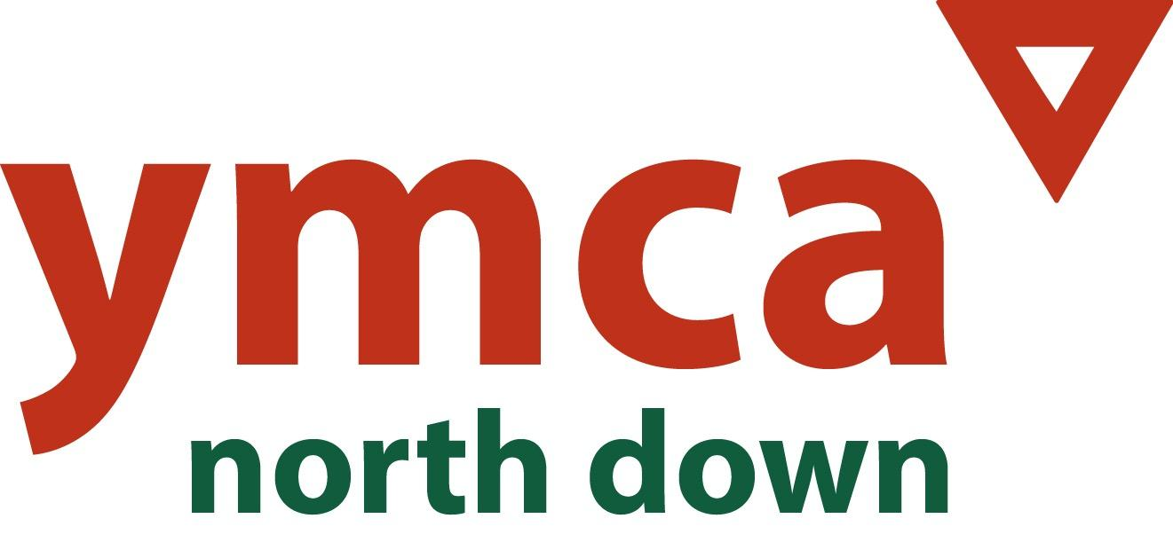
Contact: Pauline McMullan  YMCA North Down  Mobile: 07591852724  Email:Pauline.mcmullan@ymca-ireland.net | 10-12 High Street,  Bangor,  BT20 5AY

Press Release
YMCA Recruiting New Members for Board of Directors

The YMCA is currently recruiting Board Members to oversee the Association’s work with individuals, families and communities across the North Down and Ards area.

YMCA North Down is a faith-based charity, affiliated to YMCA Ireland and a part of the worldwide YMCA movement. The Association delivers a range of youth work, health, community, housing and ethnic minority support programmes as well as providing school-aged childcare. Employing 36 staff, working alongside over twenty volunteers, YMCA North Down is locally governed by its Board of Directors who are responsible for shaping its future direction.

Angela Stallard, the current Chairperson of the Association said, “During my 7+ years on the Board I have been amazed at the breadth and depth of the work of YMCA North Down. It is a great privilege to work with a dedicated and skilled team of staff, volunteers and Board members who work tirelessly to provide the excellent services that are offered across the North Down area. As we embark on embedding a new Strategic Plan I am looking forward to having new Trustees join and strengthen our Board .”

Neil Robinson, Professional accountant and current Treasurer shares his experience; “I joined the Board of YMCA North Down several years ago because I had witnessed the organisation’s positive impact across our community. In my role as Treasurer I have been struck by the commitment of staff and volunteers to improve the lives of people who need support the most. I would encourage those who want to contribute to the YMCA’s brilliant local work to consider joining the Board.”

Pauline McMullan, General Secretary of YMCA North Down YMCA, added, “We are keen to recruit new faces to our Board who have an understanding of Christian social action and a passion for social justice. Whilst we are always looking to add fresh skills, we would especially welcome interest from individuals with expertise in finance and accounting, business development and PR/communications. We are also particularly keen to recruit more women and those from ethnic minority backgrounds onto our Board.”

For more information on becoming a Board Member of YMCA North Down, please contact Pauline McMullan by telephone (07591852724) or email (Pauline.mcmullan@ymca-ireland.net).

END

