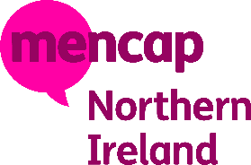
Inclusion Consultant (Research)
Mencap is a learning disability charity. Our vision is for Northern Ireland to be the best place in the world for people with a learning disability to live happy and healthy lives.
People who work for Mencap must be able to show that they understand learning disability and meet Mencap values.
You can find out more about Mencap by going to our website: www.mencap.org.uk

What makes a good Inclusion Consultant (Research)?
- be a person who is over 18 with a learning disability.
- use their experience and knowledge of learning disability to research the impact of Mencap’s work.
- will be an important member of the team.
- Want to help others and be ready to take on a new challenge

Where will the Inclusion Consultant (Research) work?
This role can be carried out in person or a mix of online work and in person.
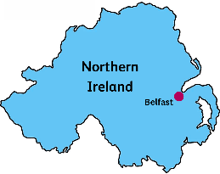
Inclusion Consultants (Research) will have to attend team meetings at the Mencap office in Belfast
Inclusion Consultants (Research) may sometimes have the opportunity to travel to other Mencap offices around Northern Ireland.
Mencap will pay for travel when you need to do this.

More information about the job.
Inclusion Consultants (Research) are paid only for the hours they work each month. The hourly rate is £11.44.
They will work as and when they are required. In Mencap this is called a relief worker
Inclusion Consultant (Research) will be paid for the hours you work after you complete them. You will be paid every month but will not receive the same amount each time.
The role will start in August or September 2024 and work on this project will be available until March 2025
Interviews for the job will take place in August 2024

What is the job?
Inclusion Consultants (Research) will:
Research the impact of Mencap’s work, to check if Mencap is doing what we say we are doing
Work with colleagues to plan, create and carry out research surveys and focus groups
Talk to people with learning disabilities, their families, Mencap staff and other community members about how we collect information
Attend team meetings to review what people said
Support colleagues to create easier ways to collect and share information about Mencap’s work

Your Experience
We need you to be
    - Good at working as part of a team
    - Willing to learn new skills
    - Have a good knowledge of issues faced by people with learning disability
    - Good at communicating and listening to others
    - Good IT skills or willing to learn how to use computer systems
    - Able to plan work with others and to decide the most important tasks
    - Willing to take part in training
    - Have an interest in research
    - Good at listening and recording information
    - Stays calm under pressure
We would like you to:
- Be good at organising your time and using a calendar
- Have experience of speaking in front of other people
What can I expect from Mencap?
- Introduction to Mencap and the role
- Training for the job
- A settling in period to make sure this is right role for you
- To feel fully supported in your role
- The opportunity to meet new people and be part of diverse team
- The opportunity to learn new skills
- To feel that you are valued

This post is funded by ‘Dormant Assets NI’, delivered by the National Lottery Community Fund. The post is aligned with the charitable purposes of Royal Mencap Society in accordance with Section 18C of the Disability Discrimination Act 1995.

