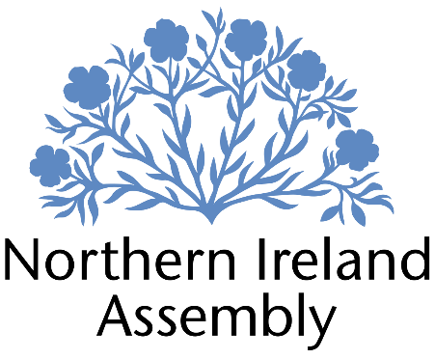
Nick Mathison MLA

Alliance Party Member of the Northern Ireland Assembly for Strangford

Assembly Research Officer

Report to: | Nick Mathison MLA
Office Location: | Parliament Buildings, Stormont & 19 High Street, Comber
Hours: | 37 hours per week, Monday to Friday
Holidays: | 28 days plus public holidays
Salary: | Grade 3, £41,023 per annum
Duration: | Permanent

Closing Date | Sunday 14th July 2024 at 12pm  Interviews for successful applicants are expected to take place on Friday 19th July

JOB DESCRIPTION

Providing a full research and Assembly support service for Nick Mathison MLA

Duties
- Carrying out detailed policy research on all areas of NI Executive responsibility
- Carrying out detailed scrutiny and analysis of legislation to prepare MLA for Assembly debates and Committee sessions
- Providing detailed and ongoing review of policy developments in NI with particular focus on education policy
- Writing speeches for the MLA for debates in the Assembly and other events
- Preparing detailed briefings for the MLA to assist with chairing the Education Committee, including providing summaries of written briefings, highlighting key questions for witnesses, and identifying key areas of scrutiny for legislation at Committee Stage
- Ensuring MLA is briefed on all matters of Assembly procedure and standing orders to facilitate participation in the Assembly Chamber and committees
- Preparing written and oral questions for the MLA on all areas of NI Executive function
- Drafting amendments to motions and legislation
- Facilitating ongoing engagement with educational stakeholders to inform continual policy development
- Drafting letters for MLA to NI Executive Ministers and senior officials
- Providing concise summaries of academic research papers, departmental strategies and reports, and stakeholder reports and research, to inform policy development and understanding
- Analysing departmental budgets to support effective financial scrutiny
- Assisting MLA with drafting of private members legislation as required
- Liaising with MLA’s constituency team to update on all areas of relevant policy development and legislative change
- Any other duties required to enable MLA to carry out his role at the NI Assembly effectively

PERSON SPECIFICATION

 | Essential Criteria | Desirable Criteria
Professional / Technical Qualifications | - Educated to degree level  - Excellent working knowledge of all Microsoft Office packages | - Degree in relevant subject
Experience / Job Knowledge | - Working knowledge of both Northern Irish political system and NI Assembly  - Working knowledge of legislation and policy related to NI education system  - Experience of writing detailed policy briefings  - Experience of speech writing | - Experience of analysing budgets  - Experience of scrutinising and analysing legislation  - Experience of drafting detailed policy-related correspondence to senior officials
Personal Qualities /  Skills | - Excellent verbal communication skills  - Excellent written communication skills with ability to adapt style to various contexts  - Highly flexible, well organised and able to work in a time sensitive environment  - Excellent attention to detail and ability to analyse complex information accurately and concisely  - Ability to manage workload based on changing priorities  - Understanding of Alliance Party aims and objectives | - Evidence of building and maintaining relationships with key stakeholders  - Ability to work on own initiative proactively
Circumstances |  | - Available for immediate start

