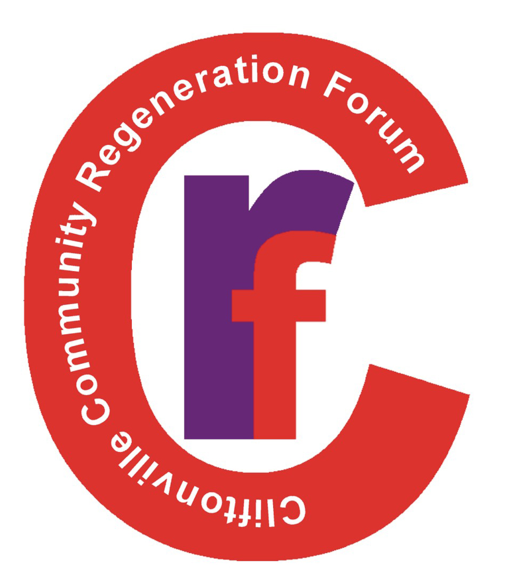 | Cliftonville Community Regeneration Forum  Application Form

Position: Community Development Organiser
Closing Date: Thursday 4th July 2024 at 12.00 noon | App Reference No.

PERSONAL DETAILS
Name
Address
Town/City
Post Code
Tel:
Email:

Referees*
Please provide the name and address of two referees (one must be your present or most recent employer). Permission to use referees names must be obtained before submitting your application.
Name: | Name:
Address | Address:
Tel: | Tel:
Position | Position:
Email: | Email:
* Referees will not be contacted unless you have been offered the post
Declaration
I certify that all the information I have given is correct. I understand that any false information given may result in any job offer being withdrawn.

Name: (Block Capitals)
Signature:
Date:

App Reference No.

PRESENT OR LAST EMPLOYER
Name and Address of present employer or last employer

Post Held:

Duties of the post:

Date appointed: |  | Present Salary: |  | Period of Notice:

VOLUNTARY SERVICE OR COMMUNITY WORK
Please give details of any voluntary or community work that you have undertaken. By this we mean any work undertaken in an unpaid voluntary capacity for a social cause or purpose.

WORK EXPERIENCE
Please list, starting with the latest, any relevant positions you have held, with a brief description of duties and dates.
Dates | Positions | Duties

ESSENTIAL CRITERIA
Please detail how you meet the essential and desirable criteria for this post. Please use additional pages if necessary.
Essential Criteria | How do you meet the Essential criteria?  (Please expand page/boxes or use additional pages as necessary)
You (are):
- Good at connecting with people and have an outgoing personality
- Willing to apply yourself to learn new skills and improve your knowledge
- Able to reflect positively on your work and improve your performance
- Positive, self-driven, and a problem solver
- Able to work independently and able to work as part of the wider CCRF team
- Passionate and dedicated to empowering marginalised residents.
- (Have) a history of voluntary work

Qualifications
- A third level qualification in community development.

Experience
- Experience of working with residents in a disadvantaged community.
- Experience of developing positive working relationships and partnerships with statutory, community/ voluntary sectors
- Experience of managing the challenges and pressures of working in a deprived community

Skills
- Skilled in developing campaign strategy, organising events and have good organisational skills
- Good written and verbal communication skills.
- IT skills including Microsoft Office.
- Excellent time management skills and good at meeting targets and deadlines.
- Good group work skills and ability to set up and maintain new/existing groups.

Knowledge
- Knowledge of the All-Ireland Standards for Community Work
- Knowledge of the issues faced by residents and their families in disadvantaged communities.
- Knowledge of the barriers to local people participating in community groups

Circumstance
- Be able to work unsocial hours (Evenings and weekends).

DESIRABLE CRITERIA
Please detail how you meet the essential and desirable criteria for this post. Please use additional pages if necessary.
Desirable Criteria | How do you meet the Desirable criteria?
You (are):
- Have a good sense of humour.

Experience
- Experience of delivering training and development programmes.
- Experience of using Outcomes Based Accountability (OBA) to measure how we are making a difference
- Experience of applying for and securing funding; and managing budgets
- Experience of producing a community newsletter

Skills
- Desk Top Publishing (DTP) skills
- Social media skills
- Research skills
- Marketing, promotion, media design
Knowledge
- Knowledge of community organising theory and practice

QUALIFICATIONS*
Dates | School/College/  University | Subject | Grade
* Please note: You only need to list the qualifications you consider relevant to this post

Please Return to:
Please return the completed application to:

Anne Mulvenna,
Cliftonville Community Regeneration Forum,
185 Cliftonpark Avenue,
Belfast BT14 6DT.

or

anne@ccrf.org.uk

