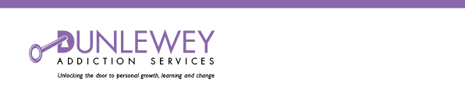

JOB DESCRIPTION

Job Title: Counsellor.

Reporting To: Project Co-ordinator

Location: South Eastern H&SCT Area

Grade / Salary: Under review

Hours: Full time and part time hours available

Role Purpose:

To provide a high-quality Step 2 early intervention adult counselling service, for Harmful Substance Misusers and Hazardous Drinkers.

To provide a service to offenders through the pathways of court mandated orders and prison licence conditions directed through PBNI

MAIN DUTIES:

- Market and promote the early intervention adult service across the SEHSCT area targeting Harmful Substance Misusers and Hazardous Drinkers and concerned families

- Provide comprehensive assessment, care plans, cognitive therapy, structured counselling, coaching, enhanced brief interventions, structured family work and self help programmes across the SEHSCT area for Harmful Substance Misusers and Hazardous Drinkers and concerned families.

- Create and provide literature and support materials to promote the service across the SEHSCT

- Work with SEHSCT CAT, primary care, PBNI and other agencies working with identified groups/individuals to promote joint working, including a common assessment form, risk assessment and referral protocols.
- Establish appropriate liaison and engagement group work with families of service users and also those to families without client engagement.
- Maintain full accurate records of all service activity in line with service specification.
- Ensure service users are involved in the design and delivery of materials and services.
- Establish strong links with local communities and related services to maximise benefit to individual and their family.
- Ensure services are delivered in premises that are safe, respectful and accessible, physically and with regard to appointment times for individuals and families.
- Attend all agreed monthly meetings, supervision, forums, and training as prescribed for project staff.

PERSONNEL SPECIFICATION

Essential
- A Counselling Diploma from a recognised awarding body*
- Accreditation with a professional body or a time framed action plan*
- Minimum of two years experience in the field of substance misuse
- Practical experience of working as a counsellor within the field of addiction.
- Available to work weekends and outside normal working hours

Desirable
- Experience of working as part of a multi-disciplinary team
- Experiencing of working with groups
- Practical experience in delivery of health/wellbeing programmes

Knowledge and Experience required
- Possess excellent verbal, written communication skills.
- Possess excellent interpersonal and organisational skills.
- Knowledge of psychosocial issues facing LGB/T communities, black and ethnic minorities, homeless people with individuals with disabilities dealing with substance misuse problems
- Ability to engage and motivate individuals in therapeutic programmes
- Proficient in the use of a variety of IT packages
- Experience of report writing, maintaining records and providing accurate timely written reports on caseload.
- Possession of clean valid driving licence and access to a form of transport to enable you to meet the requirements of the post
- To perform any other duties commensurate with the post.

* Original copies of qualifications supporting this application and of Accreditation professional development time line will be required at interview, prior to the selection process. Only photocopies will be retained with the application.

