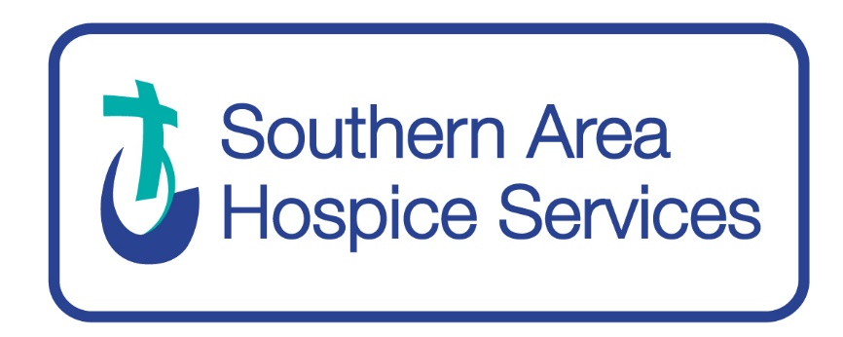

INFORMATION AND GUIDANCE NOTES
FOR APPLICANTS

Completed Application Forms must be received
prior to the relevant closing date and time

FOREWORD
Thank you for your interest in applying for a position with Southern Area Hospice Services.
Should you require any additional information please contact the HR department at hr@southernareahospiceservices.org
Prior to completing and submitting the required application form we recommend that all applicants familiarise themselves with the information contained in this document.
IMPORTANT NOTE
All communication relating to your application will be sent to you via email. You should continually check your email account for correspondence including your junk mail.
DATA PROTECTION STATEMENT
Under the General Data Protection Regulations (GDPR), it is important you are aware that when you apply for employment with Southern Area Hospice Services, we will keep your information safe & secure.
The information that you provide us with, and that obtained from other relevant sources will be used to process your application for employment. The personal information provided will be used confidentially. If you are successful in this recruitment process and take up employment with us, then the information will be used in the administration of your employment e.g., Pension Providers and Occupational Health. We may also use this information if there is a complaint or legal challenge. We may also use or pass to third parties’ information to prevent or detect crime.
By signing the application form, you are consenting to the processing of personal data in accordance with the Data Protection Act.
Please refer to our privacy statement at https://www.southernareahospiceservices.org/privacy-policy.
Please note all information is held safely and securely with access restricted to designated personnel. Personal information will be confidentially destroyed in line with Southern Area Hospice’s Data Protection Policy.

ABOUT SOUTHERN AREA HOSPICE’S SERVICES
SAHS exists to provide the best quality of life for patients and their families through the equitable delivery of specialist palliative care to patients and carers residing in the Southern Health and Social Care Trust area.
Services can be broadly described as specialist in-patient and community (delivered in the Hospice’s hubs as well as in patients’ homes).
Further information on our values and services can be viewed on our website www.southernareahospiceservices.org

RECRUITMENT & SELECTION
Information for Internal Candidates
SAHS supports and encourages staff to develop and reach their full potential. All advertised vacancies are open to current employees, bank staff and agency workers.
SELECTION CRITERIA
It is essential that you read the Job Description and Personnel Specification carefully to allow you to demonstrate in your application form how you meet the essential criteria.
Essential Criteria
It is vital that you provide sufficient details, clearly demonstrating by way of example, how and to what extent you meet these requirements. It is up to you to show how a qualification is the equivalent to what has been requested. You must ensure that relevant qualifications, experience, and key skills, both essential and desirable, are clearly detailed by way of example within the application submitted. The selection panel will not make assumptions from the title of the applicant’s post or the nature of the organisation as to the skills and experience gained. Consequently, it is not sufficient to simply list your duties and responsibilities.
Desirable Criteria
Should it be necessary to further shortlist candidates to progress to the next stage of the selection process, desirable shortlisting criteria will be used as specified within the person specification.
It is therefore essential that you provide sufficient details, clearly demonstrating by way of example, how and to what extent you meet these requirements.

SALARY AND BENEFITS
Salary
Depending on the role, salary is either benchmarked using the Department of Health’s Agenda for Change (AfC) pay scales or using appropriate market rates. We regularly benchmark employment benefits against those of other relevant organisations in order to ensure that we remain competitive.
Annual Leave Entitlement
The holiday year runs from 1 April to 31 March each year and all full-time employees are entitled to five weeks annual leave and in addition 10 public/bank holidays. Part time staff are entitled to the pro rata equivalent of this.
Pension Scheme
If you meet the eligibility criteria, you may continue your membership of or re-join the HSC Pension Scheme. In all other cases, you will be automatically enrolled, in a pension scheme provided by Southern Area Hospice Services.
Training & Development
SAHS has a culture of continuous improvement. As well as regular mandatory training, you will receive regular updates necessary for your particular role in the organisation, including Clinical Supervision for professional care roles.
Work Life Balance
SAHS has a number of policies and benefits in place to assist employees in maintaining and improving their work life balance and general wellbeing.

RECRUITMENT AND SELECTION PROCESS
Applications
Where possible please download an application form from www.southernareahospiceservices.org
Once completed this can be e mailed to hr@southernareahospiceservices.org or posted to HR Department, Southern Area Hospice Services, St Johns House, Courtenay Hill, Newry, BT34 2EB
We do not accept CVs, letters, or any other supplementary material in place of fully completed application forms. We reserve the right to reject an incomplete application form.
Applications submitted after the deadline on the closing date will not be considered. Please note that the onus is placed upon the applicant to ensure that the completed application is submitted successfully on or before the closing date. SAHS will not take into consideration the failure of external IT services to deliver completed forms by the closing date.

Applicants with a disability who require assistance will be facilitated upon request.
Applicants who wish to receive an information pack in accessible formats are requested to advise the HR Team of their requirements as promptly as possible allowing for the fact that the closing date for receipt remains the same for all applicants.

Shortlisting
After the closing date, the first stage in the selection process will be to conduct a shortlist of completed application forms against the essential and, where applicable, desirable criteria. Applicants who have not fully demonstrated on their application form how they meet each of the criteria will not be progressed to the next stage of the process.

Psychometric Assessments
Our assessment tools vary according to the competencies required for the job and sometimes involves psychometric assessments. Psychometric assessment tools provide additional information regarding particular areas of ability which cannot be objectively assessed from an interview alone. These assessments can range from ability/aptitude tests, management in-tray exercises and/or personality profile questionnaires.
Test results will have an impact on the recruitment decision, but they are not used in isolation. Instead, they are considered alongside the other information gathered during the selection process so that an overall view of role suitability can be formed.
Selection tests will only be used were deemed absolutely necessary and set and read by trained assessors.

Interviews
After the shortlisting exercise, it is intended that the selection process will involve a competency-based interview in accordance with the criteria set in the job description and person specification for the relevant post.
When reading through the criteria for the role consider your personal experience in each of the areas. In your interview you should provide recent and relevant examples, which will give the interview panel an insight into your experience, skills, and abilities in each competency area.
Interview Schedules
It can be difficult to re-schedule interview for those who cannot attend at their allocated day or time but in the event that you are unavailable please contact the HR team and we will do our best to accommodate you at an alternative time. This may not always be possible given the commitments of members of the panel.
If an applicant fails to present him or herself for interview, it will be deemed that they have withdrawn from the selection process.
As a charity with limited financial resources, we cannot contribute to travel expenses incurred by applicants invited for interview.
Selection Decisions
All applications for employment are considered strictly on the basis of merit. The selection panel will assess candidates against the relevant criteria. Those candidates who meet the required standards will be deemed suitable for appointment in order of merit, with the highest scoring applicant ranked first. We will then allocate a candidate to a vacancy in the order listed and where a Reserve Register of suitable applicants is drawn up it will remain valid for 6 months from the date of selection.
Feedback
Due to the volume of applications continuously received we are unable to provide external candidates with individual feedback following interview. Each candidate will however be advised of the overall outcome of each stage of the selection process.
APPOINTMENT VERIFICATION
Applicants should note that being informed of the outcome of the selection panel is not in itself an offer of employment and it should not be treated as such. An applicant is deemed to have been offered a post only upon receipt of a formal written offer. A formal written offer of employment from Southern Area Hospice Services is conditional upon the following:
- Satisfactory Access NI checks where applicable
- Receipt of two satisfactory references from two recent employers
- Validation of qualifications where required (original certificates)
- Validation of eligibility to work in the UK
- Satisfactory pre-employment medical (where applicable)
In the event of failure to meet the criteria above, SAHS reserves the right to withdraw the offer.
EQUALITY AND DIVERSITY
Southern Area Hospice Services is committed to embracing diversity and the promotion of equality of opportunity and as such it is our policy and practice to provide equality to all irrespective of:
- Gender, including gender reassignment
- Marital or civil partnership status
- Having or not having dependents
- Religious belief or political opinion
- Race, nationality, ethnic or national origin
- Disability
- Sexual orientation
- Age
We are opposed to all forms of unlawful and unfair discrimination. All job applicants, employees and others who work for us will be treated fairly and will not be discriminated against on any of the above grounds. Any decisions regarding recruitment and selection, promotion, the provision of training or any other benefit will be based on merit alone.
SAHS monitors applications for employment. This demonstrates our commitment to promoting equality of opportunity and enables us to measure the effectiveness of our equal opportunity policies.
Any monitoring information you provide will be treated in the strictest confidence, will not be provided to the shortlisting or interview panels, and will not be used to make any unlawful decisions affecting this recruitment exercise or during the course of your employment with us. The information you provide will only be used for monitoring, investigations or proceedings under the requirements of the Fair Employment and Treatment (NI) Order 1998.

