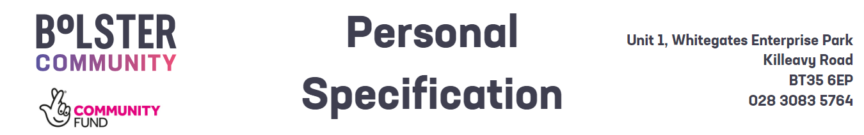
  - Autism Connect Project Support Officer

 | - Essential Criteria | - Desirable Criteria
- 1. Circumstances | - Means to travel to sites in both Northern and Southern Ireland and flexibility to attend evenings and weekends as required.
- 2.Experience & Qualifications | - A minimum of GCSE Grade C Numeracy and Literacy supported by ASD awareness or practice qualifications.  or  - A minimum of two years previous experience supporting adults of mixed abilities to reach their potential. | Experience of supporting autistic adults or those with a learning disability.
- 3. Skills and Expertise | - Ability to work on own initiative.  - Ability to manage groups whilst understanding the needs of the individual.  - Ability to assess and develop support responses in partnership with autistic people, their families, and carers.  - Excellent written and oral communication skills, with the ability to build rapport, express yourself concisely and appropriately with individuals of varied levels of seniority. E.g. experience communicating with families, service-users & management.  - Proficient in the use of Microsoft Office (e.g. e-mails & word documents) in a personal or professional setting. (Training on a dedicated CRM system will be provided). | Understanding of boundaries within mentoring and volunteer led support.
  - Shortlisting will be based on the evidence that you supply on your application form to satisfactorily demonstrate how, and to what extent, you meet the above criteria. The Shortlisting Panel will not make assumptions as to your circumstances, qualifications, and experience.
  - Competencies – Candidates who are shortlisted for interview will be required to demonstrate how, and to what extent, they meet some or all of the competencies listed below during their interview.
- Outstanding communication and interpersonal skills.

A skilled communicator who keeps colleagues and clients well informed and communicates proposals, projects and messaging clearly and concisely across a diverse range of mediums, platforms and capacities. Demonstrates communication success in project management across a range of in person and digital platforms.

- Strong problem-solving ability and creativity.

Demonstrates solution focused leadership within their role towards their colleagues, volunteers, clients.
and customers. Acts as a positive role model and demonstrates examples of nurturing continuous.
improvement for colleagues and customers alike

Demonstrates commitment to achieving corporate strategic and operational objectives through.
Creative and innovative communications, actions and values led engagement.

- The capacity to work under pressure.

The successful candidate will need to show they can deliver exceptional results on time within
constraints and in line with organisational strategy, policy and procedure.
The successful candidate will need to demonstrate previous experience in exceeding the expectations and
requirements of clients, and internal and external customers.

- Project management skills.

Demonstrates experience, skills and outcome of previously managed projects. Demonstrates understanding of time management, and organisational planning to successfully and competently fulfil or exceed the requirements of their post.

- Horizon scanning and pitching skills.

The ability to forensically analyse opportunities, trends and development opportunities. Good report writing skills presentation and impact measurement skills. Demonstrable evidence of collaboration within and across teams. Develops and encourages effective partnerships and a positive team atmosphere, both internally and externally, to improve the efficiency and effectiveness of service delivery based on shared outcomes.

