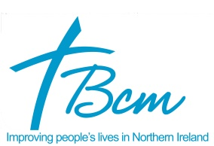

JOB DESCRIPTION

CAREER: Cook

YOUR NEW PLACE OF WORK: KIRK HOUSE
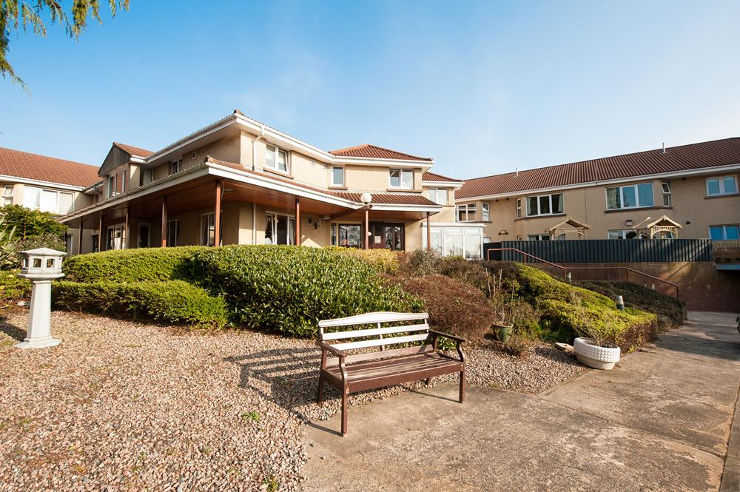

What is Kirk House?

You have applied to work as Cook at Kirk House. Kirk House is a "housing with care" facility in which independence, freedom of choice, self-esteem and dignity are respected and promoted. Residents are supported to maintain links with their family and local community and the level of care each receives is tailored to meet their individual needs.

Kirk House is situated approximately six miles from the centre of Belfast is a well-established residential area. It is within walking distance of shops, health centre, post office and is on a main bus route. The recently landscaped grounds are laid out in lawns and flower beds, with patio and seating areas which are easily accessible.

Accommodation

Forty-two individual flatlets, four of which have been designed for couples, and two of which are suitable for disabled residents. There are also communal dining and social areas. Each flatlet has its own front door with, doorbell and letter box.

It also comprises...

- Small kitchenette with fridge
- En-suite shower room with fold-down shower seat, WC and wash hand basin
- Open plan bed-sitting room which residents can furnish if they wish

Memory Lane for dementia
In 2014, Kirk House adapted one wing into ‘Memory Lane’, providing safe and supportive accommodation for nine residents with dementia.

In Memory Lane major changes were made to residents’ flats and communal areas, combining a cutting-edge approach to dementia design with a homely feel to make residents more comfortable and independent and reduce confusion. Features such as contrasting colours and bright lighting, work alongside personal touches like encouraging residents to choose the colour and number of their own front door to help them find their way. These features also help with retaining memory.

All staff throughout Kirk House, including catering and housekeeping, have completed Dementia Friends training, with Care Staff also completing Best Practice in Dementia Care.

Activities & Services in Kirk House

- Home cooking
- Hairdresser
- Beautician
- Podiatry
- Laundry service
- Weekly church service
- Reminiscence
- Chair aerobics
- Entertainment nights

THE IMPORTANCE OF FOOD / DIET TO OUR RESIDENTS

Our food offering must reflect the highest quality, choice, nutrition and creativity. Our Food and Food service at Kirk House is not only critical to the success of the project, it is key to the comfort, happiness of our residents. As Cook you will be responsible for delivering a quality food service.

SO, WHAT WILL YOU BE DOING?

Reporting to the Manager/Management team;

- You will provide a menu offering choice, seasonality, creativity, presentation and, above all, a food offering that is nutritious and high on quality.
- You will provide a food service which meets the expectations and requirements of our residents taking care to continually liaise with our residents to ensure you are providing what they need – their feedback should inform your thinking.
- You will deliver home baking for our residents.
- You will manage service times, providing a range of choice for breakfast, lunch and dinner to suit all palates, dietary requirements, digestion.
- You will manage the kitchen to a high standard ensuring compliance in terms of hygiene and quality with specific responsibility in maintaining external standards/regulations (eg) environmental health; NI Code of Practice (Food Law); HACCP; Belfast Central Mission’s policy & procedure on Health & Safety.
- You will manage the kitchen to budget, taking into account stock control; portion control; minimisation of wastage;
- You will ensure that all appliances are fully functional and safe and report any faults to BCM Estates.
- You will manage a staff team ensuring that they are fully aware of kitchen procedure in terms of hygiene; quality; stock storage & rotation; cross contamination.
- You will ensure that a robust records management system is in place (eg) temperature; cleaning rota; stock; use by dates etc.
- On occasion, you may be required serve food to residents.

OUR VALUES

We expect that as the basis for performance for all staff, our values of Respect, Integrity, Excellence and a Person Centred Approach are evident in our interactions with each other as members of a wider staff team and with our Residents at all time.

WHAT WE NEED

We want a Cook who places our Residents at the very heart of what they do in terms of the provision of a high-quality food. A high level of Resident satisfaction in terms of food is our overriding objective, so we need a Cook who is creative and who can present on a plate, good quality food.

PERSON SPECIFICATION – HEAD COOK

Criteria | Essential | Desirable
EXPERIENCE | 3-years’ experience of working in a busy kitchen (delivering 50 + covers) with responsibility for setting menus; purchasing; stock control.
QUALIFICATIONS | CIEH Level 3 in Food Safety or equivalent; | HND/Third level qualification in Catering / Professional Cookery /food related discipline
SKILLS | Demonstrable experience in: Managing a budget  Managing a staff team  Managing compliance | Working knowledge of using Microsoft Word; Outlook

GENERAL TERMS AND CONDITIONS

Duration: | Permanent
Hours or work: | 36 hours per week as per the rota including evenings and weekends
Salary: | £23,325 per annum
Holidays: | Based on 20 days per annum plus 12 Public Holidays (Rising by 2 days on 5 years-service and a further 3 days on 10 years-service)
Probation Period: | 6 months
Pension: | Entitled to join after three months service. Staff are required to make a minimum contribution of 4% percent of basic salary to their personal pension within the Group Scheme.
Benefits: | Westfield Health Cash Plan Level 1 (See Below)
Period of Notice: | Less than six months service = 1 week.  Six months service or more = 1 month.
Access NI: | This post requires that a check must be carried out under the requirements off Access NI Enhanced Disclosure. This will involve, a full criminal records check, which will show spent and unspent convictions, cautions, cases pending and any other relevant information.

