INFORMATION for the post of Box Office, Marketing & Administration Assistant

Young at Art is currently recruiting for this key support role within our organisation.

Young at Art is Northern Ireland’s leading children’s arts organisation and producer of the annual Belfast Children’s Festival. It is a small but busy charity (22/23 turnover £520k).

The Box Office, Marketing & Administration Assistant supports Young at Art’s Senior Management Team (Director, General Manager and Marketing & Communications Manager).

Box Office & Marketing Support

You will provide key support to the Marketing & Communications Manager in the delivery of Young at Art’s marketing and audience development plan for our annual Belfast Children’s Festival and other programmes of activity. You will be the main point of contact and responsible for the festival box office.

As such, you will ensure the timely, friendly and informative processing of ticket sales requests and assist the Marketing & Communications Manager to support group bookings and the Education & Engagement team with school bookings. You will assist with copywriting and proofing marketing materials, content creation for social media, regularly update and maintain website event listings and contribute to key messaging. You will assist with the festival launch and with the reporting and evaluation of box office and marketing/audience development activity.

Administrative Support

You will be responsible for office reception, maintenance and supplies and general errands. You will support the SMT with clerical duties, meeting scheduling, desktop research, board administration, tracking compliance and programme delivery as needed. In fulfilling this role, you will be efficient, show attention to detail, be mindful of the need at times for confidentiality and enhance the public face of the organisation.

This role is a permanent full-time post. Funding for this post is received from the Arts Council of Northern Ireland and Belfast City Council.

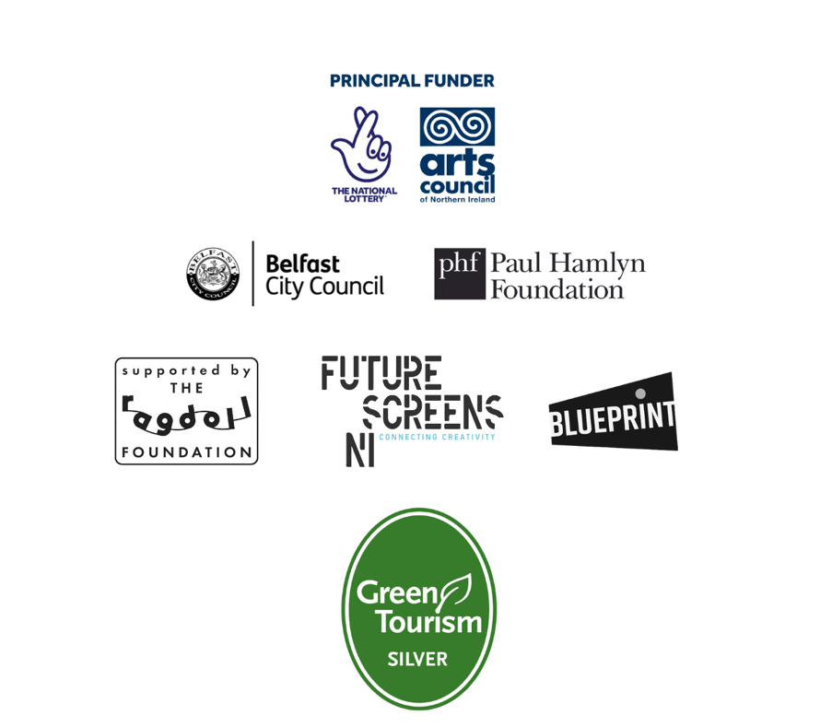

Further Details

Location: Currently Young at Art staff work hybridly, some days from our city centre office and some days from home. These are mutually agreed with the employee mindful of business delivery needs. All staff are supported to work from home. There will be additional off-site activity.
However, during February and March each year, in order to facilitate delivery of the Belfast Children’s Festival, all staff are required to work full-time from our city centre office.

Working Hours: 37.5 hours per week (full-time)
Staff work 7.5 hour days excluding lunch generally between 9am and 6pm Monday to Friday. Your daily hours of work will be agreed. Evening and weekend work and long hours should be anticipated before and during the Festival period.

Salary: £23,400 per annum pro rata (Young at Art offers a pension package in line with government requirements)

Expenses: Approved expenses and mileage reimbursed

Leave: 28 days annual leave pro rata, plus Bank Holidays. TOIL is applied where relevant.

Contract: This is a permanent, full-time position. A probationary period will apply.

Young at Art operates a range of policies that respectively promote equality, health and safety and the safeguarding of children and vulnerable adults. You must be committed to upholding these policies and additional checks may be required for the successful applicant.
All our posts are subject to the availability of funding.

Company Information

Background

Young at Art was established in 1998 to run an international arts festival for children and young people. It quickly expanded, incorporating as a limited company in January 2000, and extending to a year-round programme comprising commissioning, touring, action research, engagement and development work. The Belfast Children’s Festival (still the anchor of its annual programme) recently celebrated its 26th year. It is one of the largest in the UK and Ireland with approx. 26,000 children and adults attending both free and ticketed events within a ten-day programme each year.
The year-round programme combines education and engagement activity, special projects and commissions, artists’ development and touring.
Young at Art is a registered company with charitable status, recognised by the NI Charities Commission. It receives core funding form the Arts Council of Northern Ireland, Belfast City Council, Paul Hamlyn Foundation, Ragdoll Foundation, Future Screens NI and Arts & Business Blueprint Programme. It undertakes significant fundraising each year as well as generating earned income through its Festival and special project activity.

Strategic Framework

What do we do?
Young at Art creates and curates exceptional and innovative arts experiences for all children and young people.
Why do we do it?
Because we need creative people.
How do we do it?
Young at Art will be:
1. Risktakers
- Present children and young people with ambitious, innovative arts activities and events
- Empower children and young people to unlock, develop and express their creativity
- Lead the way in developing new creative approaches

2. Placemakers
- ‘The arts are for you’
- Enable children and young people to connect with the wider world around them
- Enable children and young people develop their sense of who they are and what they can be

3. Changemakers
- Listen, Learn and Lead
- Empower children and young people to creatively shape their futures
- Influence others to place children and creativity at the heart of what they do

Our activities are underpinned at all times by our Values:
- Child-led
- Quality and Excellence
- Accessibility
- Innovation
- Respect

Job Description – Box Office, Marketing & Administration Assistant

RESPONSIBLE TO: Marketing & Communications Manager / General Manager (overseen by Director)

RESPONSIBLE FOR: n/a

ROLE

You will provide key support to Young at Art’s Senior Management Team (Director, General Manager and Marketing & Communications Manager). While some flexibility will be required at certain times, it is expected that your tasks will divide as follows: box office and marketing (about 60% / 3 days a week) and administration (about 40% / 2 days a week).

Box Office & Marketing

You will provide key support to the Marketing & Communications Manager in the delivery of Young at Art’s marketing and audience development plan for our annual Belfast Children’s Festival and other programmes of activity. You will be the main point of contact and responsible for the festival box office.

As such, you will ensure the timely, friendly and informative processing of ticket sales requests and assist the Marketing & Communications Manager to support group bookings and the Education & Engagement team with school bookings. You will assist with copywriting and proofing marketing materials, content creation for social media, regularly update and maintain website and event listings and contribute to key messaging. You will assist with the festival launch and with the reporting and evaluation of box office and marketing/audience development activity.

Administration

You will be responsible for office reception, maintenance and supplies and general errands. You will support the SMT with clerical duties, meeting scheduling, desktop research, board administration, tracking compliance and programme delivery as needed. In fulfilling this role, you will be efficient, show attention to detail, be mindful of the need at times for confidentiality and enhance the public face of the organisation.

RESPONSIBILITIES
SALES, MARKETING & AUDIENCE DEVELOPMENT | To support the Marketing & Communications Manager in the delivery of Young at Art's marketing and audience development plan including:  - Contributing ideas on how to reach audiences and develop and promote key messages;  - Assisting with copywriting and proofing of marketing materials and the content creation for social media platforms ensuring high standard of consistency and literacy throughout;  - Maintaining the Young at Art and Belfast Children's Festival website including event listings and linking to online box office;  - Building and managing Belfast Children’s Festival events on box office software (currently Ticketsolve);  - Acting as first point of contact for public bookings and encourage ticket sales for Belfast Children's Festival and other Young at Art programmes of activity;  - Responsibility for direct marketing to groups for bookings, liaising with Education & Engagement regarding school attendances and Programming regarding international delegates;  - Processing and tracking ticket sales, producing accurate and regular sales reports, liaising with venues regarding attendees and with the General Manager about delivery of onsite box offices;  - Helping with planning and delivering of the festival launch as well as festival receptions including organising and distributing marketing collateral and tracking attendance; and  - Assisting with the collection and collating of appropriate data across multiple platforms
PROGRAMME DELIVERY | To support the delivery of Young at Art's activity including:  - Provide clerical, administrative, research, logistical and compliance support for the artistic programme and other bespoke projects;  - Liaise with board members, funders, stakeholders, partners, artists, creatives, venues, suppliers and members of the public as needed;  - Provide desktop research for and draft formal documents and reports including but not limited to fundraising applications, sponsorship proposals and tender submissions;  - Support the collection of data for funder and stakeholder reports; and  - Contribute to company evaluation, both internal and external.
ADMINISTRATION | Be the first port of call for general enquiries (phone, email and face-to-face) about Young at Art and undertake reception duties;  Support the efficient running of the company’s office and its maintenance and procedures with a view to good practice and value for money including securing supplies, filing, archiving and storage/disposal, messages, postal books and diaries;  Assist the General Manager with maintaining accurate governance and statistical records and filings;  Manage the SMT diaries and the staff meeting schedules;  Assist the General Manager with banking and financial administration where needed including debtor management.
GENERAL | Collaborate and maintain effective working relationships with fellow staff members, artists, freelancers and volunteers;  Adhere to existing work practices and procedures and to contribute to the development and respond positively to new and alternative systems;  Demonstrate commitment to Young at Art through regular attendance and the efficient completion of all tasks allocated within the deadlines required and set;  Adhere to and support the implementation of all company policies and procedures including safeguarding, equality, health & safety, data protection and all others in place from time to time;  Commit and work to Young at Art's strategic aims and objectives;  Uphold Young at Art's values of being Child-led, Quality and Excellence, Accessibility, Innovation and Respect;  Engage with their own continuous professional development to contribute to the activities, promotion and development of Young at Art.

The key responsibilities above give a broad outline of the functions of the post. However, these duties are approached in a flexible manner. The post holder will be expected to adapt to changing circumstances and undertake other duties appropriate to the post’s level of responsibility as allocated by their line manager as part of working in a small team to deliver Young at Art’s strategic aims and objectives. The outline of responsibility may change from time to time.

Person Specification

Young at Art are looking for candidates who can best meet all Essential criteria and most closely demonstrate the Desirable criteria. Applications that DO NOT MEET ALL Essential criteria will not be considered. Young at Art reserves the right to weight key skills within the selection process.

RESPONSIBILITIES | ESSENTIAL | DESIRABLE
SALES, MARKETING AND AUDIENCE DEVELOPMENT | Knowledge and experience of delivering project plans to a brief including planning, reviewing progress and adapting as necessary  Experience of maintaining and creating content for websites, social media, video channels or other communication tools  Experience of writing, editing and proofing documents to a high standard  Experience of presenting yourself or representing an organisation in a public setting | Third level qualification (degree or diploma) in a related field such as the arts or marketing  Experience of writing, editing and proofing print and web pages to a high standard  Knowledge and experience of arts marketing, particularly live and ticketed events  Knowledge and experience of video/photo editing and/ or design software for digital/online communications  Experience of liaising with members of the public and a wide range of stakeholders (eg. customers, suppliers)  Knowledge and understanding of the arts in Northern Ireland
PROGRAMME DELIVERY | Proven experience of undertaking an administrative or similar role  Experience of liaising with a wide variety of stakeholders to achieve a set goal  Experience of drafting reports or other formal writing including relating to delivery of a project | Third level qualification (degree or diploma) in a related field such as the arts, arts management, business or administration  Proven administration experience in the arts, cultural or heritage sectors  Ability to initiate and follow through on ideas
ADMINISTRATION | Experience of working to schedules and deadlines whilst managing competing demands  Ability to work with a high degree of accuracy and attention to detail  Ability to work flexible hours including evenings and weekends | Experience of box office systems  Knowledge, understanding and experience of providing excellent customer service  Experience of liaising with suppliers  Experience of dealing with confidential information or dealing with sensitive issues
GENERAL | GCSE in English and Maths (or equivalent) - minimum grade C  Excellent written and oral communication skills  Ability to build strong and effective working relationships  High degree of computer literacy including keyboard skills, use of standard office software, internet and social media | Knowledge of Young at Art and our aims and objectives

