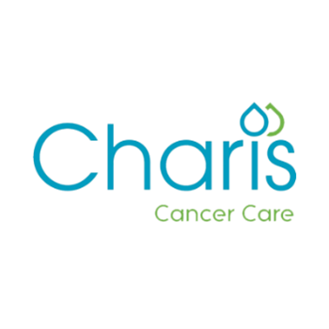

Volunteer Role Description
Role | Volunteer Beauty Therapist - Charis Cancer Care centre
Outline of role | When someone is going through treatment for cancer this can have a major impact on their skin. As a volunteer Beauty Therapist, you will work with our clients to teach them how to look after their skin, whilst talking through any side effects they might be experiencing as a result of cancer treatments - such as dryness. We will provide the training you need to understand the impact of cancer on someone’s skin. Your role as a volunteer can play a really important role in helping people with cancer to retain their sense of self and identity. The role may include:  - Educating clients about the impact of cancer and its treatments on their skin  - Listening to client concerns and helping them to address any concerns regarding their skin or appearance.  - Helping clients understand what products might benefit them.  - Teaching clients how to apply a basic, natural makeup.  - To undergo appropriate training as required  As part of this role, all Volunteer Beauty Therapists will undertake training as part of the “Look Good Feel Better” programme which will equip you with the understanding and knowledge for working with people experiencing cancer. We will cover the costs of the training.  The tasks and activities listed are intended as a summary and may be varied from time to time in consultation with the volunteer concerned. The role description is intended to clarify the tasks and activities of the volunteer and is for the benefit of all concerned. It does not form the basis of a contract of employment.
Skills, Experience and Attitude needed |  | Training for this role will build upon your professional qualifications and experience, but there is a minimum qualification/experience requirement:  Essential:  - Skin care, beauty and/or makeup qualification (NVQ level 2+ or equivalent) or trained by the cosmetic brand which you currently work for  - One year’s hands on experience in the relevant industry  - Good communication skills  - Commitment and Reliability  Desirable:  - Previous experience of working with people with cancer  This volunteer role will require an Enhanced Access NI check to be completed.
Where |  | This role will be based at the Charis Cancer Care Centre  163 Lough Fea Road  Cookstown  BT80 9TU
When |  | The Charis Cancer Care centre is open Monday - Friday from 9am to 5pm. We require volunteers at any time throughout our opening hours.  If you can volunteer every day or once a week for a few hours, we would be very glad to welcome you.  The number of days and hours will be agreed between the volunteer and the Director of Care Services.
Support |  | All volunteers will be matched to a “buddy” during their first experience of volunteering. Your buddy will support you with familiarisation of the building and venue; plans for the day, your role on the day and answer any questions you may have.  You will also be able to access any training that is required for your volunteering role.
Benefits to the Volunteer |  | As a volunteer you will have access to a number of benefits at Charis Cancer Care, which include:  - A valuable learning experience to add to your skillset, or to use existing skills.  - Free tea and coffee during your volunteering duty.  - As a volunteer you will be eligible to apply for any internally advertised vacancies which may arise, while you are an active volunteer.  - Re-imbursement of standard parking charges, or mileage during your volunteering duty (where applicable)

About Charis Cancer Care
Charis Cancer Care is a highly regarded charity in NI, and we are here to support men and women, across NI, affected by cancer at every stage of their journey. We assist and support the families and supporters of those living with cancer or any family member bereaved by cancer through a range of holistic and complementary therapies. All of our services are provided free of charge to people affected by cancer.

We rely almost entirely on public donations to fund our work across NI, and by supporting us, as a volunteer, you will be contributing to our vitally important work.

Friends of Charis charity shop is located in Magherafelt and helps fund Charis and our vital services via donation of all profit from the shop annually. Charis Cancer Care simply wouldn’t be able to do what we do, without the ongoing and continued support from our Charity shop - Friends of Charis.

Thank you for your interest in volunteering for Friend of Charis.

