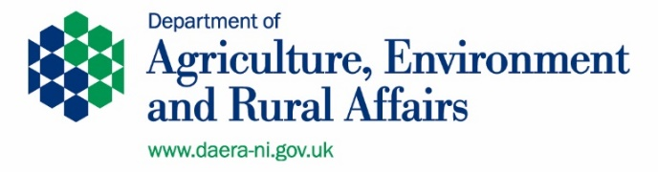
Rural Advisory Group Equality Monitoring

Questionnaire

- What is your date of birth (DD/MM/YYYY)?

- Regardless of whether they actually practice a particular religion, most people in Northern Ireland are perceived to be members of either the Protestant or Catholic communities. Please indicate the community in which you were brought up in.

Mark only one oval.

I was brought up in the Protestant Community I was brought up in the Catholic Community
I was not brought up in either the Protestant or the Catholic Communities

- Please indicate which of these describes your political opinion.

Mark only one oval.

Unionist/Loyalist Nationalist/Republican Other:
- Please indicate to which of the following group you consider you belong.

Mark only one oval.

White
Irish Traveller Pakistani
Black Caribbean Black Other Chinese
Indian Bangladeshi Black African
Mixed Ethnic Group
Other:

- Please tick which one of these best describes your marital status.

Mark only one oval.

Single
Separated, but still legally married Married
Divorced Widowed
Living with partner
In a registered same-sex civil partnership
Separated, but still legally in a registered same-sex civil partnership Formerly in a same-sex civil partnership which is now legally dissolved Surviving partner from a same-sex civil partnership
- Please tick which of the following best describes your gender.
Mark only one oval.

Male Female Transgender Other:

- Please tick which of the following best describes your sexual orientation.

Mark only one oval.

Heterosexual/Straight Gay/Lesbian
Bisexual
Prefer not to say
Other:

- Under the Disability Discrimination Act 1995 a person is deemed to be a disabled person if he or she has a physical or mental impairment which has a substantial and long-term adverse effect on his or her ability to carry out normal day to day activities. Please note that it is the effect of the impairment without treatment which determines whether an individual meets this definition. Do you consider yourself to be a disabled person?
Mark only one oval.

Yes No

- Do you have dependents?

Mark only one oval.

Yes No

