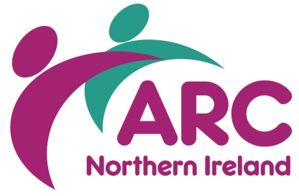
Telling It Like It Is - TILII
Membership Application Form

Interested in getting involved in a TILII group? Please fill in the form with your information.

1. Please tick which TILII Group you would like to join?
Belfast/Lisburn ☐ Bangor ☐ Downpatrick ☐
Fermanagh ☐ Omagh ☐

2. Your name
3. Your address
4. Your telephone number
6. Have you been involved in advocacy before – this means speaking out for people with a learning disability- at meetings or with another group?
Yes ☐ No ☐

Please tell us about it
7. Have you ever given a talk or presentation to a group of people before?
Yes ☐ No ☐
Please tell us about it
8. Why do you think you would be a good TILII member?
9. Can you travel to places on your own?
Yes ☐ No ☐
How are you able to travel to different places? Such as by bus, taxi , lifts etc…

10. Please tell us any medical information that we need to know to help support you?
11. Is there anything else you would like to tell us about yourself?

12. How did you find out about getting involved in TILII?
Please tick
TILII Member ☐ |  | Family ☐ | Social Worker ☐
Support Worker ☐ |  | Myself ☐
Other ☐ |  | Please tell us who?
13. Who can we contact if we need to find out more information? For example, a parent, support worker etc
Please sign your name
Signed:
Date:

Thank You!

Please return the completed form to:
Louise Hughes  ARC NI, Ash Grove  Wildflower way  Boucher Road  BELFAST BT12 6TA | Tel: 028 9038 0965  Email: louise.hughes@arcuk.org.uk

