

Job Description and Personnel Specification

Retail Development Officer

Full Time

Fixed Term Maternity Leave Cover
(October 2018 – October 2019)

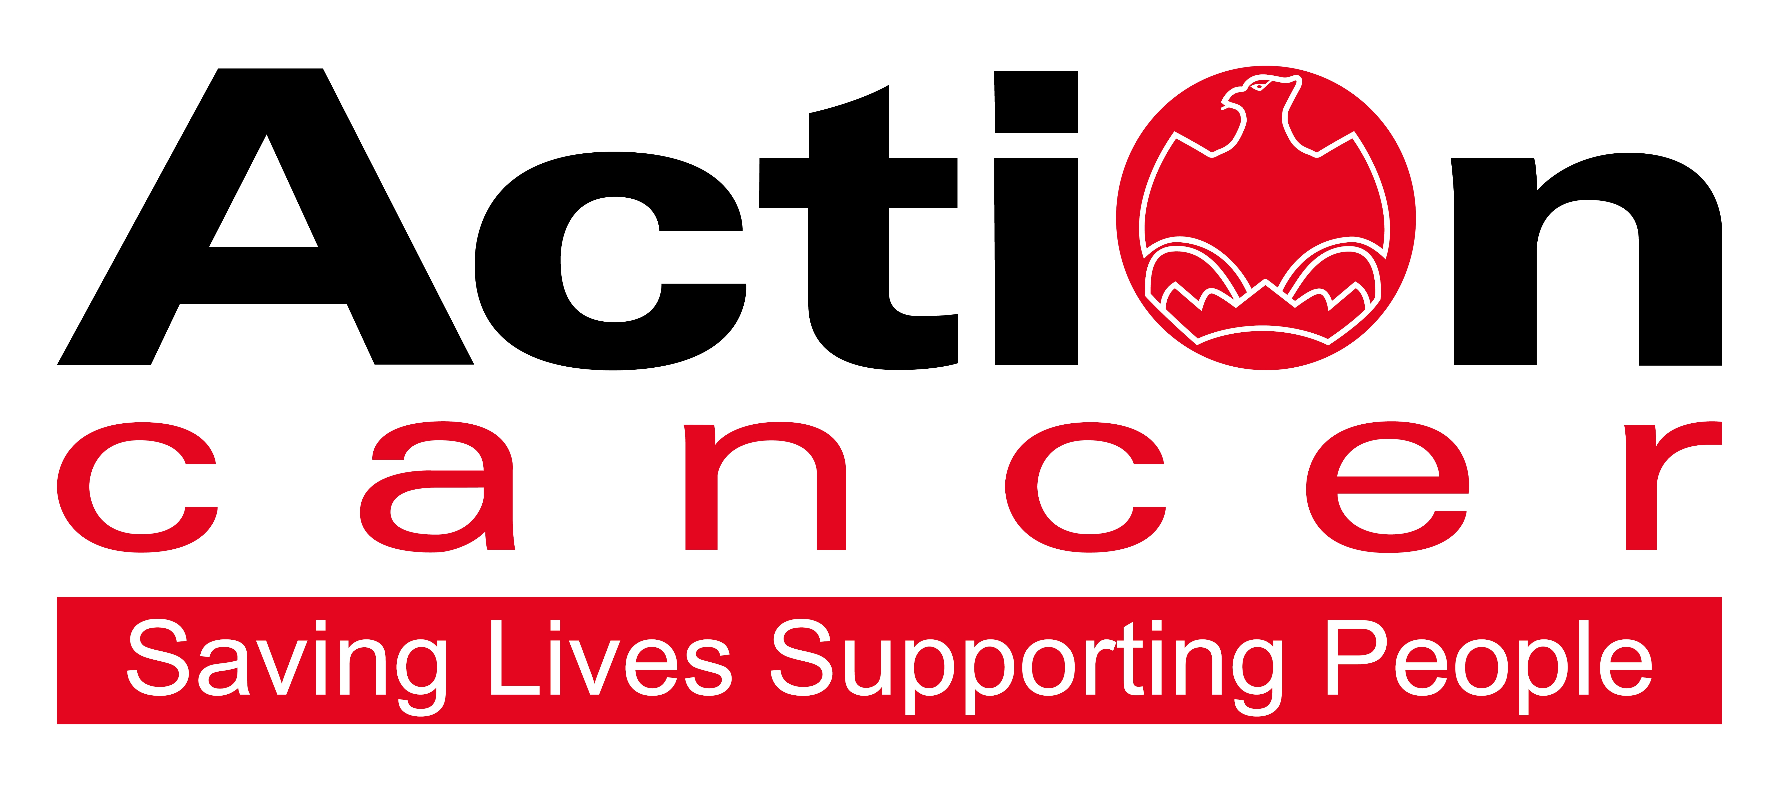

Title of Post: Retail Development Officer

Hours: 35 per week

Reports to: Retail Operations Manager

Location: Action Cancer House

Salary: NJC point 26 - 30: £23,866 - £27,358

In addition to a competitive salary, Action Cancer offer the Total Reward Package – see page 8 - which focuses on what our staff value, and includes a flexible mix of rewards designed to meet staff needs, their lifestyle, and their stage in life, including a time-off-in-lieu accrual system, training, flexible family-friendly working arrangements, pension contributions, and excellent professional development opportunities.

Action Cancer is a local Northern Ireland charity - all our money is raised to provide services for local communities. Our dedicated team of staff and volunteers work across the whole of Northern Ireland helping to save lives and support people affected by cancer. To operate our services we must raise circa £4 million every year.

We provide early detection and health promotion services, and counselling and support services for cancer patients and their families, thereby making a real difference to people who are affected by or living with cancer.

Action Cancer staff - a mix of highly skilled professionals - are the most valuable asset to our charity. We offer a wide variety of training and development opportunities, and family friendly initiatives to enhance work-life balance, and to value and support individuals and family life. In recognition of this we were awarded Best Learning and Development Organisation in Ireland - Not for Profit Sector, and were winners of The Irish News ‘Best Place to Work’ Award, Employers For Childcare “Childcare Works Award” , Employers For Childcare Family Friendly Employer Award - Social Enterprise/Charity of the Year, and Employer of the Year Award by UTV Business Eye Awards.

We are also very proud to have achieved Investors in People Gold Champion status, Investors in People Health & Wellbeing Good Practice accreditation, and Investors in Volunteers accreditation. These awards are testament to our continued commitment to “have highly valued, trained, enthusiastic, focused and committed people who work together and engage with others to make a positive impact on our community”.



Employees of Action Cancer must support its Mission, Values and Behaviours:



Values and Behaviours:

Our strengths are that we are a Values driven charity with people being at the very centre of everything we do. Our services are proven to make a difference, we are a Northern Ireland charity run and controlled by local people, raising money, spending money, and supporting people only here in Northern Ireland.

We have three stated Values which are supported by seven expected behaviours.

Value 1: Putting People First - People are at the centre of everything we do.

Value 2: Making a Difference - Having a positive impact on everything we do.

Value 3: Being Accountable - Clear, open and honest about everything we do.

Our Values are supported by seven Behaviours. We Will…
1. Treat people with respect, care, dignity and consideration.
2. Listen, hear and respond positively to what people say.
3. Support, develop and equip our people to reach their full potential.
4. Gain from our experience and celebrate success.
5. Work together, supporting, adding value, learning from and sharing with others.
6. Embrace and develop new ideas, ways of working and technologies.
7. Welcome scrutiny, taking ownership and responsibility collectively and individually for our actions

Retail Development Officer – Job Description

Overall Responsibility

Responsible for developing and implementing retail strategies and plans, specifically in relation to developing activities and functions that will increase retail income, stock donations and volunteers enabling the retail department to achieve its aims and objectives.

With responsibility to assist in increasing retail income through encouraging existing relationships, ensuring good practice and providing timely and quality administrative and practical support.

Specific Duties:

Retail Operation

- Ensuring that all retail policies, procedures and controls are being implemented at store level.
- To assist with the strategic development of the Action Cancer Retail Department.
- Project manage the opening of new stores and relocations of existing stores including ensuring the correct layout, visual propositions, stock generation, recruitment of new team and promotion of new store.
- To deputise for the Retail Operations Manager as and when requested.
- Provide support for Retail Store Managers.
- To manage the Action Cancer warehouse facility and retail fleet, liaising with key staff, addressing their needs and requirements.
Social Media

- Managing the function of social media programmes for the retail department, currently sitting at 19 platforms across Facebook, Twitter and Instagram.
- To oversee the development of the retail department’s social media strategy, leading on co-ordinating and monitoring the specific measurements to build our brand and audience engagement.
- Directing and managing the use of social media and developing and maintaining best practice guidelines and policies.
- Develop the social media presence for the retail stores. Including training and advice on the scope and format of the retail social media activities.
- Provision of social media content for retail to encourage a stronger social media presence.
- Developing social media engagement with corporate supporter and partners for the retail department.
- Attend regular E-Marketing meetings

Volunteer Engagement

- Developing partnerships with voluntary and placement organisations across Northern Ireland to increase the level of volunteers within the retail stores.
- Develop and oversee a volunteer induction process for Action Cancer retail volunteers.
- Ensuring all volunteering policies are adhered to.
- Providing support for retail managers in the recruitment and selection of volunteers within the stores.
- Develop and manage a volunteer communication strategy to keep all volunteers informed of the continuing work of Action Cancer and retail news stories across Northern Ireland.
- Sit on a bi-annual committee to organise a special recognition event for volunteers.
- To take the lead when engaging with Youth Justice and PBNI, ensuring Action Cancer shops have the potential to provide placement places across its network of stores.

Stock Generation

- Explore innovative and creative ways to generate support from individuals and companies to increase stock generation for Action Cancer stores.
- Develop and manage the Action Cancer donation stations.
- Develop initiatives to increase the supply of donated stock to support income growth.
- Manage the store stock transfer process, ensuring adequate supplies are available for store to store transfer and the Action Cancer warehouse facility.
Website

- To manage and develop Action Cancer’s retail website presence in line with the retail strategy.
- Keeping content up to date, sourcing images and ensuring the Action Cancer retail brand is maintained.
- To develop initiatives in generating incoming through e-commerce and eBay stores.
- Provide support and guidance on the use of Gumtree and other alternative selling sites.

Income Support

- Develop and meet agreed targets set by the Retail Operations Manager to generate income through the annual Action Cancer Store Challenge.
- Develop meaningful and effective relationships with individuals, companies and associations with the aim of encouraging them to participate in the Action Cancer Store Challenge.
- Provide support and backup to external parties in their planned events and marketing initiatives for the Store Challenge.

Event Management

- Manage all elements of the Store Challenge gala event
- Liaise with all suppliers and providers to ensure a successful event
- Develop the production of publications and promotional materials relating to events

Health and Safety

- Ensuring that all Health and Safety requirements are met within the retail department.
- Ensuring Action Cancer Health and Safety Policy is adhered to at all times.
- To ensure retail lone working requirements are met and are in line with Action Cancer policies.

Public Relations

- Acting as a spokesperson for Action Cancer retail and promoting the work of the charity.
- Attending annual Charity Retail Association meetings representing Action Cancer
- Sending Press Releases for retail events

Miscellaneous

- Undertake relevant training as requested.
- Adhere to Action Cancer policies and procedures.
- Observing equality of opportunity in all areas of the day to day work for which the post holder has responsibility.
- To undertake any other duties that might be reasonably required by the Retail Operations Manager.

This job description will be subject to review in the light of changing circumstances and is not intended to be rigid and definitive, but should be regarded as providing guidelines within which the individual works. Other duties of a similar nature and appropriate to the grade may be assigned from time to time. It is important to note that the responsibilities of the post may change to meet the evolving needs of the services that the charity provides.

General Responsibilities

All staff must comply with Action Cancer’s No Smoking Policy on Action Cancer Premises

All duties are carried out in compliance with Action Cancer’s Health and Safety Policy and Statutory requirements.

Action Cancer is an Equal Opportunities Employer. You are required to adhere to Action Cancer’s Equal Opportunities Policy throughout the course of employment.

All staff must comply with Action Cancer Data Protection Policy and Procedures.

To ensure the ongoing confidence of the public in the staff of Action Cancer, staff must ensure they maintain the high standards of personal accountability.

Terms and Conditions of Employment

- 2 satisfactory references are required one which must be from a current / previous employer.
- Successful applicants must evidence their right to work in the UK (under the Asylum and Immigration Act).This will be evidenced in the first instance by a passport or other forms of ID that will be outlined if no passport is available.
- 6 months probationary period.
- Evidence of relevant academic and professional qualifications.
- Evidence of appropriate vehicle documentation.
- All potential employees may be asked to attend a pre-employment medical

Action Cancer is an Equal Opportunities employer, and are proud to have achieved Investors in Volunteers accreditation.

PERSONNEL SPECIFICATION

Essential

- Three years retail management experience.
- Experience of successfully implementing retail development strategies.
- Have a knowledge and experience of retail marketing and the use of social media and ecommerce.

- Proven ability to develop staff and improve performance.
- Excellent IT skills, including retail P.O.S. systems.
- Hold a full, current driving licence with business insurance, and have access to the use of a car or some other appropriate form of transport to carry out the duties of the post in full.

Desirable

- Retail management experience in charity retailing.
- Experience of working with and managing volunteers in a retail environment.
- Experience of new shop openings

Appendix 1: Action Cancer Total Reward Statement
TRAINING AND DEVELOPMENT
- Organisation Wide Training Budget
- Paid Tailored Training and Development Support
- Comprehensive In-House Training Courses and External Development Opportunities linked to Role, Strategic Plan, Individual Requests, and Competencies
- Comprehensive Induction Programme
- One to One Coaching & Mentoring
- Personal Job Plans, Development Plans, and Ongoing Supervision
- Continued Professional Development Support
- Structured Interim and Annual Performance Reviews
- Regular Teambuilding and Staff Away Days
- Cross Departmental Working Opportunities
- Overseas Challenge Opportunities

WORK LIFE BALANCE
- Standard 35 hour working week
- Staggered start times
- Up to 25 days annual leave and 12 annual statutory days
- Flexible working (home working, compressed and reduced working hours)
- Fixed Christmas closure
- Time Off In Lieu (TOIL) in compensation of additional hours worked
- Career breaks
- Discretionary leave
- Family & People Friendly Policies
- Christmas Family Party

SOCIAL, PHYSICAL AND MENTAL HEALTH WELLBEING
- Therapeutic Supports - Counselling, Complementary Therapy, Acupuncture
- External Staff Care and Support Services
- External Occupational Health Service
- Health Checks, Screening and Flu Vaccinations
- Regular Staff Health and Wellbeing Surveys
- WPA - NHS Cash Back Plan
- Financial Workshops
- Mediation Services
- Subsidised Christmas Departmental Celebrations
- Staff Pool Car

FINANCIAL REWARD AND RECOGNITION
- Sector Competitive Salaries
- Annual Increments to Top of Scale and Cost of Living Increase
- Enhanced Sick, Maternity, Paternity and Adoption Pay
- 6% Contributory Pension Scheme
- Work Related Professional Membership Fees Paid
- Salary Sacrifice for Pension, Childcare, Bus Travel, and Bike to Work Schemes
- Celebration of Individual and Team Success
- Mileage Allowance at the Prevailing HMRC Rate
- Clear Policies and Procedures
- Enhanced Paid Annual Leave
- Additional Day Paid Leave at Christmas and at 10,15,and 20 Years’ Service
- Free Parking

