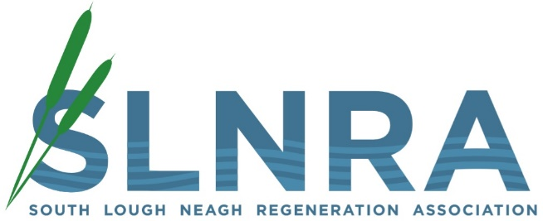

APPLICATION FORM

Job Title: Part-Time Admin / Support Officer ‘Bringing People Together’ project

Ref: SLNRA/PT/Admin02

Please complete your application form as fully and concisely as possible. You should use this form to highlight relevant and appropriate experience with regard to the Essential Criteria outlined in the Personnel Specification. Candidates will be shortlisted on the basis of information contained in this application.

If you need to continue any section onto a separate sheet, please mark that sheet clearly with the number of the section to which it refers. Do not enclose any material other than that requested.

In order to be considered for this post, a signed hard copy of your completed application form must be returned by our closing date of 12 noon, Friday 19th October 2018.

Please write legibly in black ink.

Completed application forms should be forwarded to:

South Lough Neagh Regeneration Association
Recruitment Dept
1 Maghery Business Centre
Maghery Road
Dungannon
BT71 6PA

Please Complete All Sections

- Personal Details
Surname:  (Block Letters) | Forename(s):  (Please underline name by which you are known) | Title:  (Mr / Mrs / Miss / etc)

Home Address: |  | Address for Correspondence:
Post Code: |  | Post Code:

Contact Numbers: |  | Health:
Home: |  | Please give particulars of any illness or injury which incapacitated you for a period of more than seven days over the past two years:
Mobile:

Office:
Email:

Do you hold a full, current driving licence with business insurance and have access to the use of a car or some other appropriate form of transport to carry out the duties of the post in full?

Yes / No

2. Education and Qualifications

From: | To: | School / College / University: | Qualifications:  (Subjects / Grades / Classification)

Relevant Courses Attended:

Date: | Course: | Qualifications

Membership of Professional Bodies / Associations:

3. Experience

This section should be an outline of your career to date, including your current employment (list in reverse chronological order).
Employer Name and Nature of Organisation: | Position Held and Description of Main Responsibilities: | Date  From: | Date To: | Reason for Leaving:

Employer Name and Nature of Organisation: | Position Held and Description of Main Responsibilities: | Date  From: | Date To: | Reason for Leaving:
4. Selection Criteria:

In each of the following sections, please state how you meet with the criteria sought, giving
examples and specifying dates as appropriate.
4.0 | Educated to A-Level standard or equivalent

4.1 | At least one year’s experience working in a community development related setting

4.2 | Recent and relevant administrative experience

4.3 | Proven experience maintaining databases

4.4 | Proven working experience of updating and monitoring social media

4.5 | Proven working experience of Office packages and graphic design programs

4.6 | Ability to plan work, meet targets and work to deadlines

4.7 | Working experience of developing high quality presentations e.g. marketing material

4.8 | Knowledge and experience of working within communities throughout the ABC council areas including the South Lough Neagh area

5. Information in Support of this Application:

Please provide any additional information which you feel is relevant to this application (continue on a separate sheet if necessary)

6. Additional Information:
Please give details of any convictions for criminal offences, which are not, regarded as “spent” convictions under the Rehabilitation of Offenders (NI) Order 1978 (include nature of offence and sentence)

Current Salary: |  | Length of Notice:

Referees:

Any offer of employment is subject to references. Please give below the names of two persons not related to you, to whom reference may be made. One of the referees must be your current or most recent employer and both should be able to comment on the applicant’s ability to carry out the particular tasks of the job.

Name: |  |  | Name:
Occupation: |  |  | Occupation:
Address: |  |  | Address:
Telephone No: |  |  | Telephone No:

Declaration:
I certify that to the best of my knowledge, all the information I have given is correct. I understand that any false information given may result in any job offer being withdrawn.
Signed: |  |  | Dated:

