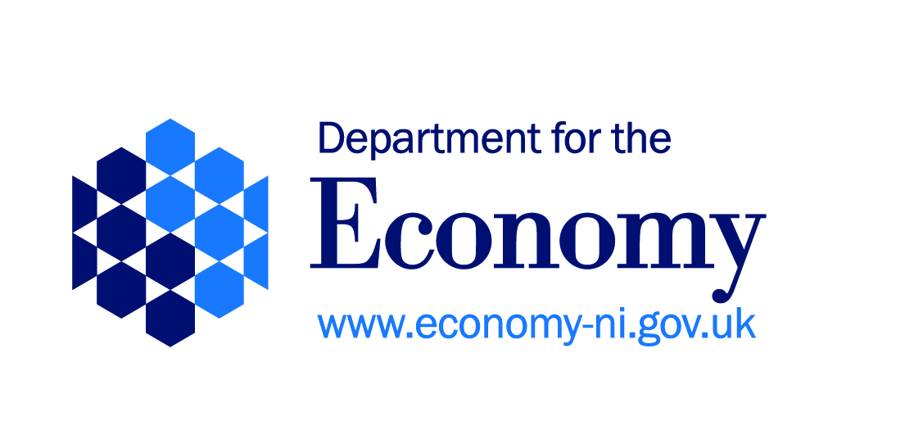
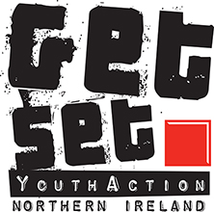
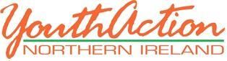

JOB DESCRIPTION

Title: Youth Worker - GET SET for Work Project
Armagh, Banbridge & Craigavon District Council

Responsible to: GET SET Project Manager Clare Conlon

Links to: GET SET team and youth work teams

Timescale: To project end date - 31st March 2022
Employment contract subject to annual targets being met
(reviewed 6 monthly)

Location: Armagh Regional Office

Project: GET SET for Work

Funders: European Social Fund (ESF) and Department for the Economy (DfE)

Hours: 37.5 hours per week

Salary: £25,678 (JNC Point 16 (2016) qualified equivalent rate) or unqualified rate

FIXED TERM CONTRACT

Description of Project

GET SET for Work is a regional youth employability project which will target, train and progress over 4 years, 900 rural/urban young people (16-24 years) who are not in employment, education or training (NEET). Operating in disadvantaged communities across the 11 Council areas the project is located in 5 key regions; Armagh, Belfast, Enniskillen, Newry and the North West.

GET SET uses a youth work approach alongside strong community and private sector partnerships to support and progress, young people into employment, mainstream training or education.

GET SET will build young people’s skills set in 3 key areas: - skills for living (tackling barriers and building confidence, resilience, motivation); skills for learning (providing accredited training leading to practical and industry relevant qualifications up to Level 1); skills for work (building employability skills in teamwork, interpersonal, communication alongside industry specific work skills through ‘taster’ work experiences with local employers/ business partners in key growth sectors).

GET SET for Work - Armagh, Banbridge & Craigavon Regional Project

To recruit, train and progress per year a minimum of 40 young people (160 over 4 years) who are aged 16 – 24 years and who are outside of in employment, education or training.

Targets and Outcomes:

Recruit and train per year a minimum of 40 young people in skills for living, learning and work and PROGRESS a minimum of 28 (70%) young people;-
- 12 (30%) young people into employment
- 16 (40% ) young people into further training or education
Through delivering the following types of growth sector programmes and demand for skills:-
- GET SET for Work in Construction
- GET SET for Work in Hospitality
- GET SET for Work in Care
- GET SET for Work in Retail
- GET SET for Volunteering through Social Action
Organise and facilitate 1 GET SET to GO employer led skills building event per year with minimum of 40 young people attending.
Job Responsibilities

PROMOTION AND RECRUITMENT

To promote, recruit and retain, the target number of 40 young people from disadvantaged communities across the council area.

To develop and implement a recruitment and marketing strategy for your area to raise the profile of the project and to ensure potential participants and key stakeholders are made aware of the project and the opportunities and programmes on offer.

To recruit participants through;-
- Using youth work methods of direct contact with young people through street based, detached youth work.
- Networking with partner organisations, community based youth projects, young adult/peer education groups etc. within the area.
- Building strong relationships with key referral agencies such as Jobs & Benefits Offices, Social Services, etc.
- Giving presentations to key stakeholders, attending seminars, key events such as employment and recruitment fairs to raise awareness of the project and to target participants.

To use our social media platforms to promote, recruit for and profile GET SET for Work programmes.

To work with our members and local community partners:

- to identify and secure local venues for delivery of the programme
- to promote the project at local level and at local community events
- to recruit young people from the local area

To develop and build strong business partner relationships with local employers to inform, shape and contribute to the design, content and delivery (provide works skills taster days) of industry specific GET SET for Work programmes.

DESIGN, DELIVERY AND RETENTION

To work as part of the GET SET team to plan, design and implement a range of programme and activities which will address young people’s barriers, build their skills and facilitate their progression into employment, education or training.

To engage young people in a co-design process to shape and inform the development of GET SET programmes.

To develop and build strong business partner relationships with local employers to inform the design, content and delivery (provide works skills taster days) of industry specific GET SET for Work programmes.

To draw on existing partnerships and develop new networks and partnerships to enhance recruitment, programme design and development.

To use a range of innovative and creative facilitation techniques to engage and motivate young people’s learning and to ensure minimum attendance rates of 85%.

To work with each participant to assess their needs and to develop with them their personal action plan for progression.

To enable young people to voice their ideas and opinions in a positive and constructive manner.

To organise and coordinate residentials and other external programme activities on a regular basis, for participants.

To deliver Money for Life and LIFEMAPS (building positive mental health programme) as part of the programme curriculum to build young people’s skills for living.

To deliver and assess a suite of accredited OCNNI training at Level 1 alongside practical and industry relevant qualifications to build skills for learning.

To organise and plan with business partners/local employers work taster days to build young people’s skills for work.

To use the Youth Achievement Awards as the quality framework to recognise and measure the achievements and outcomes for all participants.

To liaise with the Quality Assurance coordinator to ensure delivery and assessment of programmes are in line with awarding body requirements.

To undertake Child Protection and Vulnerable Adult training when requested and implement in programmes.

PROGRESSION OF PARTICIPANTS

To support each participant to progress onto an agreed progression pathway and achieve a minimum target of 30% of young people progressing into employment and 40% progressing into further training or education.

To build strong relationships with local employers, further education colleges, training providers, recruitment agencies etc to identify a range of appropriate progression routes for participants.

To provide post programme support to all participants (up to 6 months) to support them to’ stay on track’ and to monitor and track their progress.

To organise and facilitate a yearly GET SET TO GO employability skills building workshop led by our project business partners and involving local businesses.

MONITORING, EVALUATION AND IMPACT

To complete with participants, all ESF documentation and check all eligibility requirements when enrolling for programmes.

To maintain comprehensive programme files which records and documents programme plans, training sessions, evaluations, participants records, attendance, achievements and progression to meet the data requirements of the funders and the organisation.

To update on a monthly basis all participant data onto our Management Information System - Impact Tracker

To provide monthly work plans and monthly progress reports to the project manager to ensure key targets and indicators are monitored and achieved.

To actively engage in the GET SET self evaluation and quality improvement process using the ETI Inspection and Self Evaluation Framework (ISEF) and contribute to monitoring and performance audits, and external inspections (ETI).

To record, monitor and measure participant outcomes using the GET SET impact measurement tools.

To link with and contribute to other initiatives within the GET SET project and the wider organisation as required.

FINANCE AND ADMINISTRATION

To maintain administrative systems required to support the work of the project (raising cheque requisitions, purchase orders, plan ahead with administrative requirements).

To robustly manage and maintain participant details/expense records for monitoring and auditing purposes, following YouthAction’s procedures.

To take responsibility for the receipt, safe handling, and recording of monies.

To work within agreed budgets, as laid down by the GET SET project manager.

To comply with YouthAction Northern Ireland’s financial procedures at all times.

GENERAL

To support and develop YouthAction’s membership within the Armagh region.

To complete any necessary reports, evaluations and accreditation documentation as required/providing regular progress reports.

To reflect the ethos, policies and practice of YouthAction Northern Ireland at all time (adhering to the youth workers charter) and demonstrate integrity, maturity and good judgement at all times.

To comply with YouthAction NI’s “Protecting Children, young people and young adults – policy & procedures, including good practice guidelines” at all times.

To become familiar with and adhere to YouthAction’s policies and procedures at all times.

To complete any other duties as directed by YouthAction NI.

TERMS & CONDITIONS

Salary: £25,678 (JNC 16 (2016) qualified equivalent rate)
Or unqualified rate
Location: Armagh Regional Office
Hours: 37.5 hours per week
Holidays: 22 days per annum plus appropriate statutory days

Hours of Work: These will require you to be available for work not only in the evenings but also, on occasions, on Saturdays and Sundays.
You will arrange your day to day working hours in conjunction with your Line Manager to suit the varying and often changing needs and requirements for the post. (Normal time in lieu arrangements will apply).

Travel: Mileage costs will be paid for travel costs incurred carrying out the duties of the post. (This post requires that you have access to a car or other suitable form of transport as and when necessary to facilitate the requirements of the job in a reasonable and effective manner).

